The Universe Has No Now
Book 2: Getting There Anyway
Time, Origins, and Whether We Can Get Somewhere Else
Lothar J. Musiol

Copyright
The Universe Has No Now, Book 2: Getting There Anyway. Time, Origins, and Whether We Can Get Somewhere Else
Copyright © 2026 Lothar J. Musiol. All rights reserved.
Look First, Volume 1, Book 2 of 2.
Photograph credits are not printed under the figures. They are in this file, so a copy that never sees the store page still names its sources.
Photographs. Fig 29: NASA/JPL-Caltech/SETI Institute. Fig 42: NASA. Fig 43: Charles J. Sharp, Wikimedia Commons, CC BY-SA 3.0. Fig 46: NASA/JPL-Caltech. Diagrams are original line art for this book. Figures 25, 32, 33, 35 are simple drawings made for this edition.

How to Read This Book
Every claim in these pages wears one of three temperatures. The difference matters more than any formula.
Hot — established. Measured, repeated, and used to predict new measurements. The universe is expanding. Space is filled with a 2.7-degree glow left over from a hot past. Ordinary matter is a minority ingredient. Black holes exist. There is no single “now” shared by observers who move differently.
Warm — working theory. The best account we have, with real gaps. A burst of extremely fast expansion in the first sliver of a second (inflation) explains several facts at once, but we have not identified the field that did it. Most of the mass that pulls on galaxies does not emit light; we do not know what particle, if any, it is. Empty space behaves as if it has a faint energy of its own; we do not know why that energy is the size it is.
Cold — speculation. Allowed by the equations, not selected by the data. Traversable wormholes. A required final state in which life computes forever (the Omega Point). A stack of universes with different laws. Extra dimensions from string theory.
On that last item, a standing rule. String theory, whenever it appears in this book, cannot currently be tested. It is a large, ingenious mathematical framework. It has not produced a unique, risky prediction — a number or a signature that would kill the whole idea if the experiment came out otherwise. Extra dimensions and a “landscape” of possible laws inherit that status. They may be mentioned because popular physics mentions them. They are not results.
A few scenes in this book are stories: a greenhouse on a dead planet, a radio that answers a quarter-hour late, a clock that runs slow beside a black hole, a melt-probe chewing through kilometers of ice into a sea that has never seen the Sun. They are thought experiments with dirt on them. The numbers in them are real. The people are invented. They are here so the geometry has somewhere to sit besides a diagram.
The main chapters keep the math in the sentence, the way a good explainer talks at a table. A handful of relations are important enough to number. Those numbered equations live in the Appendix, where the treatment is actually technical: the Friedmann equation, the spacetime interval, the helium calculation, the Bekenstein bound, the energy condition a wormhole has to break. If you want the scaffolding, it is there. If you want the story, you can finish the book without opening the back.
This edition is longer than a Barrow pamphlet on purpose — a few hundred Kindle pages of teaching, not an outline. The extra is not padding. It is the second trunk, the leftover in the air, the crew that does not sleep, the loop that calls itself I, and a path that refuses a last chapel. The sentences stay short. The inventory grew.
You do not need a physics degree. You need curiosity and a willingness to let “now” come apart.

An Epistemic Map
Before the first chapter, here is the whole book’s method on two pages. Every sentence in it is one of six kinds of claim. The kinds differ in what would have to happen for the claim to be wrong.
Kind of claim | What makes it that kind | Temperature | Examples in this book
Measurement | A number read off an instrument, repeated by others | Hot | GPS clocks gain about 38 microseconds a day without correction; the leftover glow is 2.725 K; the ring around M87*
Tested theory | A theory that predicted measurements before they were made, in the regime where it was tested | Hot | Special and general relativity in tested regimes; the hot, expanding past; the helium made in the first minutes
Theoretical extrapolation | A tested theory pushed into regimes no one has measured | Warm | Black-hole interiors; inflation; the far future of heat death
Interpretation | A reading of what a tested theory says exists, which no experiment can yet separate from its rivals | Labeled separately | The block universe; Everett’s branches; Bohm; QBism; presentism
Open research | A question being actively measured, where the answer may change soon | Warm, dated | Whether dark energy changes with time; the Hubble tension; what dark matter is; quantum gravity and emergent time
Speculation | Allowed by some equations, not selected by any data | Cold | Time machines; hopping between branches; other bubbles; continuity through uploading

How hot, warm, and cold map onto it. Hot covers the first two rows: measurements and theories that have survived the tests they could have failed. Warm covers the third and the fifth: extrapolations of good theories, and open research that the next survey may settle. Cold is the last row. Interpretations sit to one side, because their temperature is not about evidence at all. The block universe, for instance, is not warmer or colder than a hidden “now”; both fit every measurement. This book prefers the block for reasons of economy and says so. Whenever the text crosses from physics into interpretation, a shaded box marked Physics vs philosophy shows where the line falls: what the evidence establishes, what this book infers, and what would change the verdict.
Dated claims. Open research moves. Boxes marked Status as of October 2026 give the numbers for dark energy, the Hubble tension, dark-matter searches, and string theory as they stood when this edition was finished. If you are reading much later, check those boxes first.
Where rivals get heard. When the book declines a view (presentism, Copenhagen, QBism, Bohm, collapse models, the strong anthropic principle, multiverse arguments, survival by uploading), it first gives the view’s strongest case, then what the view gets right, then why the book still declines it.
Notes. Superscript numbers link to the Notes and Sources at the back, which give the primary paper or an authoritative review for each key claim, with links, followed by a bibliography arranged by chapter. Tap the number at the start of a note to return to the page you came from.

Four Reading Paths
The general reader. Read straight through. Skip the shaded boxes on a first pass if you like; the chapters make sense without them. Seven spacetime diagrams carry the geometry: start with Spacetime Diagram 1 in Chapter 1 and Spacetime Diagram 2 in Chapter 3, and the rest will read easily.
The physics reader. Read Part I quickly, then Parts II to V with the Appendix open beside them; each chapter has a matching appendix note (Chapter 9 with A9 (in Book 1), and so on) where the equations live. The status boxes in Chapters 8, 17, 18, and 40 and the Notes give the current numbers and sources.
The philosophy reader. Read Chapters 1 to 6, then 36 to 38, 41 to 43, and 45 to 46. The Physics vs philosophy boxes in Chapters 6, 15, 36, 41, 42, and 45 mark each step from a physical result to an interpretation, and the rival views are stated in their strongest form before they are declined.
The skeptical reader. Start with this map and the status boxes. Then read the hot/warm/cold summaries at the end of each chapter, and check any claim that matters to you against its note. Where this book takes a side (the block, Everett, a filter rather than a purpose), it says that it is taking a side.

A Note on the Series
This book is Volume 1 of Look First. It comes in two books. This is Book 2, Getting There Anyway: Parts VI to X. The crew that can wait, and the library that crew would carry, are taught here. Book 1, No Now, No Centre, carries Parts I to V; the Previously page before Part VI gives you what this book borrows from it.
If you liked the greenhouse and wanted a downtown, or a fountain, that want has one later kitchen: A Trip Is Not a New Life — camps, the body, and the Earth you do not abandon. A trip is not a settlement. A longer life is not a new body. They are the same invoice. That kitchen is optional. It is not the missing half of this one.
That book stands alone. It reuses a woman, three temperatures, and a habit of looking first. It does not reopen this spine. You can stop here. The leftover glow will still be late tomorrow.

Contents
Copyright
How to Read This Book
An Epistemic Map
Four Reading Paths
A Note on the Series
Previously, in Book 1
PART VI — Getting There Anyway
25. A Greenhouse on a Dead World
26. Most of the Universe Has Already Left
27. Other Suns, Other Worlds
28. Where Liquid Water Can Last
29. Oceans Under the Ice
30. A Second Origin
31. Forms Earth Never Hired
32. Crews That Do Not Sleep
33. A Library of Earth
34. Handles, and the Bill
35. The Watchmaker, and the Signal
PART VII — Loops
36. Time Travel Is Not an Edit
37. If You Could Walk Sideways Through When
PART VIII — All the Copies
38. Four Kinds of Elsewhere
39. More of This Universe
40. Other Rooms, Other Rules
41. Every Allowed Outcome
PART IX — The Filter
42. A Filter, Not a Purpose
43. No Cosmic Craftsman
PART X — What the Future Is Allowed to Be
44. Five Ways It Can End
45. Does Time Exist?
46. The Honest Ending
APPENDIX — The Scientific Detail
How to Read These Notes
A0. Three Temperatures of Claim
A25. Mars Numbers: Δv, Delay, Life Support
A26. Particle Horizon vs Cosmic Event Horizon
A27. Finding Worlds You Cannot See
A28. Circumstellar Habitable Zones
A29. Tidal Heat, Ice Shells, and Dark Seas
A30. Second Origins, the Code, and What Life Eats
A31. Other Chemistries, Missing Body Plans
A32. Travel Time, Dose, and Autonomous Systems
A33. Genome Information, Synthesis, and Planetary Protection
A34. Einstein–Rosen vs Traversable Throats
A35. What Would Count as Evidence of Intervention
A36. Worldlines and Self-Consistency
A37. Foliations: Why a Stack Is Not a Hallway
A38. Four Claims That Must Not Be Fused
A39. Infinite FLRW and Repeated Hubble Volumes
A40. Landscapes, Measures, and Untestable Frameworks
A41. Decoherence and Why Branches Are Not Destinations
A42. Dimensionless Coincidences and Weinberg’s Λ Bound
A43. Why Strong and Final Anthropic Claims Fail
A44. w, Vacuum Decay, and Bounce Conditions
A45. The Problem of Time in Quantum Gravity
A46. Inventory of Claims, by Temperature
Equations at a Glance
Further Reading (tiered)
Glossary
NOTES AND SOURCES
Notes
Bibliography by Chapter
ABOUT THE AUTHOR
ALSO BY LOTHAR J. MUSIOL

Previously, in Book 1
Book 1, No Now, No Centre, ran from a kitchen to a black hole. Part I took away the universal now: two people in one room slice events differently, light is always late, and what is left is a block of events with your life as one path through it. Part II rebuilt the past we can check: an expansion that happened everywhere at once, a baby picture in microwaves, and the first three minutes.
Part III added a burst, inflation, with its quantum seeds and its untested bubbles. Part IV counted the missing most: the extra pull of dark matter and the shove of dark energy, and why neither hands anyone a forever-mind. Part V met one-way membranes: horizons are facts about events, black holes are not doors, and nothing in this universe hands you a shortcut.
One habit carries over. Every claim wears a temperature: hot for measured, warm for working theory, cold for allowed but not selected by data. This book keeps the same map, the same Notes and Sources, and the same refusal to call a membrane a door. Part VI starts where Book 1 stopped: since you cannot cut through, can you get somewhere anyway?

PART VI — Getting There Anyway

25. A Greenhouse on a Dead World
The airlock sticks on cold mornings. Mara hits it with the heel of her glove, the way you hit a jammed kitchen drawer, and it sighs. Inside, the greenhouse is the only room that smells like a lie: wet soil, torn basil, a sweetness that does not belong to this planet. The lie is maintained with LEDs the color of an overcast noon and a tray of water she melted, yesterday, from a vein of ice the color of dirty chalk.
She does not rush the second door. Pressure equalizes the way a kettle decides to boil: when it is ready, not when she is. The suit still smells of dust and of the powder the filters never quite catch. She cracks the helmet, in here only, and the wet-soil lie hits her like a kitchen she has not earned.
This is the woman who stood between the lamps. Eli still has the clock. His question about the dust is already late.
The boot-print from yesterday is still sharp. Wind on this world is a rumor. The air outside is carbon dioxide at about six millibars — a hundredth of a kitchen atmosphere, a breath that would not lift a napkin, a sky that is weather only if you are generous with the noun. She does not farm the sky. She farms a box. The box is the permit.
A permit, in this book, is not a city. It is not a flag. It is permission for a trick to be run by hand: liquid water in a tray, light on a leaf, a gas mix a potato can stand. The planet’s own permit expired. The wet youth ran off or hid in the bones. What is left is a desert with ice in it and a chemistry that can be negotiated with. She is the one who negotiates. The dirt is the other party.
She logs the night before she drinks. Heater held. No frost on the potato bench. A tray of seedlings on the north side looks sulky, which is a word the log does not want and gets anyway. The recycled water has crept in pH. She will negotiate that after the brown liquid the recycler calls coffee. Sentiment is allowed. Sentiment does not get to vote.
The dirt is not dirt. It is crushed rock and dust, a mineral flour with a tax in it. Perchlorates — salts that on Earth show up in dry places and in laboratory jokes — sit in the fines. They are oxidizers. They are rude to a gut and interesting to a chemist who needs a stash of oxygen in a pinch. She does not eat the fines. She rinses what she must rinse, she binds what she can bind, she treats each tray as a negotiation. The universe did not mail soil. It mailed a rock. The rock can hold a root if you add water, a buffer, and weeks.
The air she breathes in the box is not the six millibars. Potatoes want a buffer of nitrogen and oxygen, a pressure a leaf recognizes, a humidity that is not a desert. She mixed that kitchen, or a machine mixed it, from tanks and from whatever the chemistry would surrender. The outside CO₂ is a feedstock if you have the power to split it, and a poison in the wrong mix. She watches the gauges the way you watch a pot that can boil dry. The greenhouse is also a cave: glass and piled dirt against a sky that does not shield. A solar day of unkindness lives in the dust. She farms under a lid, not under a heaven.
Water is stolen, not supplied. Ice at mid-latitudes and high, in the ground, in the shade of a crater lip, in veins the color of dirty chalk. Orbiters sniffed hydrogen. A drill made it a fact. Yesterday she ran a heater into a vein and waited like a person waiting for a kettle, except the kettle is a planet and the wait is a workday. Melt, filter, test for the salts, melt again. A kilogram of potato is mostly water wearing starch as a costume. The log knows this. The tray knows this. The ice vein does not care.
The potatoes are not a metaphor. They are a starch that either happens or does not, under LEDs, in a tray whose salts she has not finished arguing with. A sprout is a small yes. A black smear is a small no. She trims a leaf that went yellow and puts it in the compost that is not a compost so much as a bucket she will negotiate with later. The airlock, on the way to the bucket’s outer porch, sticks. She hits it. The seal is the morning.
Outside, the sky is butterscotch and thin. A radio sits on the workbench. When she talks to the orbiter, she talks to twenty minutes ago, or three, depending on the season: about three minutes one-way when Mars and Earth are closest, about twenty-two when the Sun sits between them. The orbiter talks to Earth, which talks back in more minutes. There is no conversation. There is a stack of monologues that eventually, if everyone lives, amount to a plan.
There is no live weather from home. There is a file with a timestamp, Eli’s voice on the delay, a checklist that was current when it left. She answers the checklist. She does not answer the tone. Tone does not survive twenty minutes of vacuum. If the heater failed at 3 a.m. her time, Eli will learn it after the potatoes have already decided.
She is not waiting for a miracle. She is waiting for a launch window. The next cheap path home — the one that lets a ship fall most of the way instead of burning a fortune — opens in 26 months, give or take the mood of the two orbits. Until then the potatoes either make starch or they do not. The universe does not have an opinion. The dirt has a chemistry, and the chemistry can be negotiated with.
The window is not a holiday. It is a fact about two ellipses that lap each other. Every two years and a bit, the cheap path opens: a long fall that spends its fortune at the beginning and the end and lets gravity do the commute. Δv is the invoice — how much extra shove you must buy, in kilometers per second, to leave one well and enter another. The invoice does not care that she is tired. It does not care that a tuber is late. Miss the window and you wait for the next lap. Burn extra to force a path and you pay in propellant you are not holding. She is not drawing a schedule for a nation. She is reading a calendar two planets already wrote.
She names the morning’s jobs the way you name the burners on a stove. pH. Filter. Ice. The stuck door, again, because the seal has a personality in the cold. The rover’s blanket of dust. None of these is a milestone on a poster. None of them founds a town. A town is a later kind of waste, a pile that remembers, and this chapter has not hired one. She has a box, a drill, a radio that answers a quarter-hour late, and a tray.
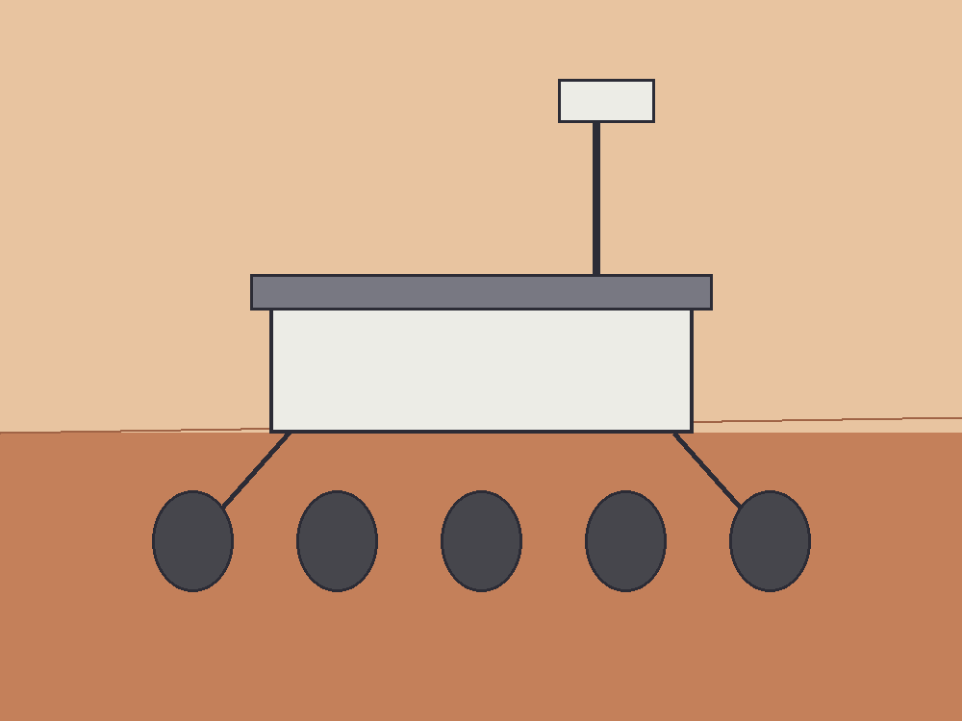
Figure 25. The rover Perseverance, large in frame, on dusty ground; the small helicopter behind it is Ingenuity. Dirt, delay, no magic.
This is the only honest picture of “somewhere else” this book will allow in the near term. A dead world, close enough that light-minutes, not light-years, set the lag. A body you can weigh. An ice vein you can steal. Machines that do not sleep parked in the driveway. A human worldline that has to eat.
The rover waits like a tool left in a driveway. Dust on the solar blanket. A scratch on a wheel from a rock that did not care. She will drive to the vein after the pH, or she will not, depending on a battery that has opinions. Machines that do not sleep still need someone to hit an airlock with a glove. The sky is butterscotch because the dust is a fine rude flour and sunlight through a breath of CO₂ is a stain, not a blue. Blue is a luxury of a thick nitrogen sky. She has seen the marble in a camera, late by minutes. She is not a backup of that marble. She is a person with a tray.
Appendix A25 writes the Δv, the round-trip delay, the kilograms of water per kilogram of potato. Here, keep the stuck airlock. If we go farther than this world — and we will, in the next chapters, on paper — we will go as Mara goes: by negotiating with the chemistry, by missing conversations, by treating a launch window as a fact about the loaf, not a mood.
She names the basil, which is sentimental, and logs the pH, which is not. On a dead world, sentiment is allowed as long as it does not get to vote.
The second door sticks again on the way back from the vein. She hits it. It sighs. The greenhouse takes her in like a liar who has, for today, told the truth: the tray is wet, the LEDs are an overcast noon, the potatoes have not given up. She writes that down. She does not write a nation. She writes a morning, which is the only unit this permit comes in.
A permit on a dead world is this small. Not a sky that learned to be kind. Not a calendar of cities. A glove, a sighing door, a tray, a delay of three to twenty-two minutes, a cheap path that opens every twenty-six months, a Δv that is an invoice, ice at the latitudes where ice still sits, perchlorates in the fines, six millibars of the wrong air. She already has all of that. The morning is how you spend it.

26. Most of the Universe Has Already Left
Even if her potatoes prosper and the window opens and the ship falls home, most of the cosmos is already out of reach.
Light is late, we said. There is a ruder fact. In an accelerating universe, there are events that will never be in our future cone, no matter how long we wait, no matter how patient the radio. Space between unbound things stretches so well that a photon emitted “now” from those galaxies never finishes the trip. We can still see some of them: their old light is in transit. Their new light is a letter that will not be mailed.
Imagine it as mail. You write a letter. You put a stamp on it. You walk it to the slot. For Earth, for the orbiter, for the woman with the stuck airlock, the slot still works. The letter is late — three minutes, twenty-two, a few hours to a probe at a giant planet — but late is not never. For a galaxy in the deep field, the slot is painted on. You may drop the envelope. The loaf does not carry it. The stretch between you and that galaxy is accelerating. The hallway lengthens faster than the messenger runs. The letter is not lost in a drawer. It was never in the future cone of the person you meant to reach.
That is not a black hole. Say it twice, because the noun horizon was already hired in Chapter 20 for a one-way membrane around a collapsed star. A hole’s horizon is a fact about which events can still influence which others, locally, in a deep well. The cosmic event horizon is a fact about the whole loaf’s later shape: which distant raisins will never, even given eternity, receive a photon we emit today. Same family of word. Different kitchen.
The shove of Chapter 18 is why the slot paints shut. In a universe that only coasts, you can, in principle, wait long enough for more and more old light to arrive; the particle horizon — we will get to that word in a moment — keeps growing as a patient astronomer. Once the stretch accelerates, waiting stops helping in a new way. Isolated lumps stay bound: a galaxy, a cluster, our own small group of raisins that still hold hands. Between the unbound, space wins and keeps winning. A photon set down “now” on a far worldline never finishes the commute. The destination recedes faster than light can close the gap. Faster-than-light recession is allowed here; it is the dough rising, not a rocket cheating Einstein in a room.
How far is the shut door?
Order of sixteen billion light-years, as a proper radius today⁴⁹ — a ball, not a calendar date. Inside that ball, a letter mailed this morning can, in principle, still arrive, late and stretched. Outside it, the letter is a gesture. Appendix A26 writes the integral: a finite remaining commute when the scale factor grows like a compounding interest. Sixteen is not a speed limit on a sign. It is the size of the remaining postal system for new mail. The number will not become a destination. It is a fact about influence, the same species of fact as a hole’s skin, drawn on the whole sky.
Do not confuse that ball with a different circle people like to draw. The Hubble sphere is where unbound raisins recede at light, today, in the stretch-rate of now. It is a snapshot, not a membrane. Light can still arrive from outside it; light we emit can still, in some cases, arrive inside a future that the event horizon has not yet shut. The event horizon is ruder and more useful for travel: it is about never. The Hubble sphere is about this instant’s slope. Kitchen: the speedometer is not the locked door. Chapter 8’s line v = H₀ × d is the speedometer. Chapter 18’s shove is why the locked door exists at all.
We can still see past that ball. That is the part that feels like a trick and is only lateness. The light in the telescope left a long time ago, when the raisins sat differently, when the hallway was shorter in the right way. Old light is already in transit. New light is the letter that will not be mailed. A museum can be full of real objects whose living rooms you will never enter. The deep field is that museum.
The other rudeness has a different name.
The particle horizon is the edge of what we can already see — more carefully, the farthest events whose light has had time to reach us since the stretch began. It is a fact about the past we can rebuild. The leftover glow is a practical wall in front of it: a fog at 380,000 years, Chapter 9’s baby picture, beyond which the universe was opaque. In principle the particle horizon sits farther than a naive age-of-the-loaf times the speed of light, because the dough rose while the messengers were running. The raisins that emitted the oldest light we can imagine are now much farther than “thirteen-and-a-bit billion light-years.” The kitchen mistake is to treat the age as a radius. The age is a duration along worldlines. The radius is a rising.
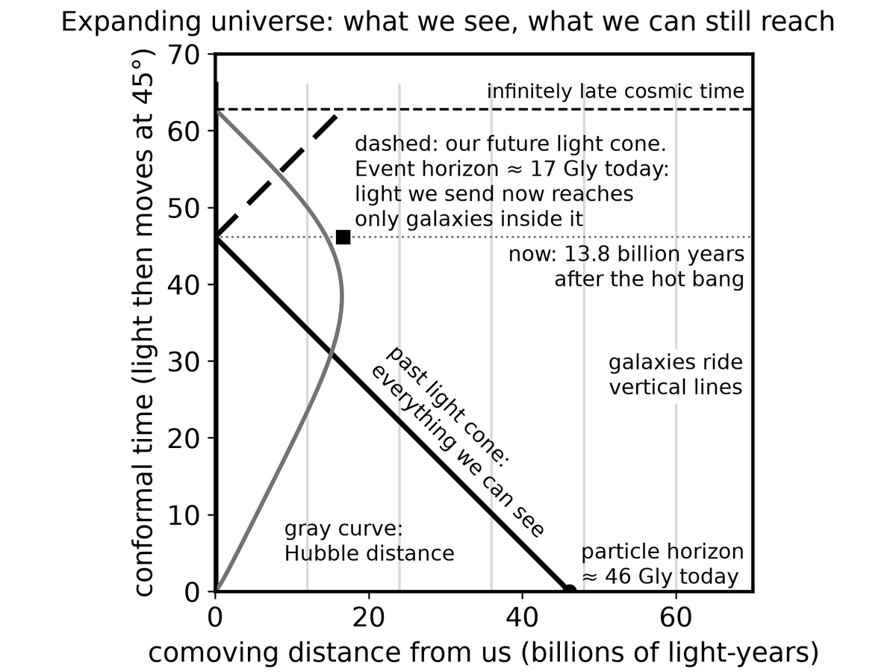
Spacetime Diagram 4. An expanding universe drawn so that light still moves at 45 degrees. Galaxies ride vertical lines. Our past light cone is everything we can see (out to about 46 billion light-years today); our future light cone shows that light we send now reaches only galaxies inside about 17 billion light-years, the cosmic event horizon.
Two horizons, two rudenesses. One is about the past we can rebuild. One is about the future we cannot visit. They are not the same line with two labels. The particle horizon grows as time passes; more past becomes visible, fog permitting. The event horizon, in an accelerating loaf, is a closed kind of future: some worldlines are already out of the postal system for anything we do today. Appendix A26 distinguishes them on a wedge. Here, keep the two slots. One slot still takes incoming archive. One slot refuses outgoing mail.
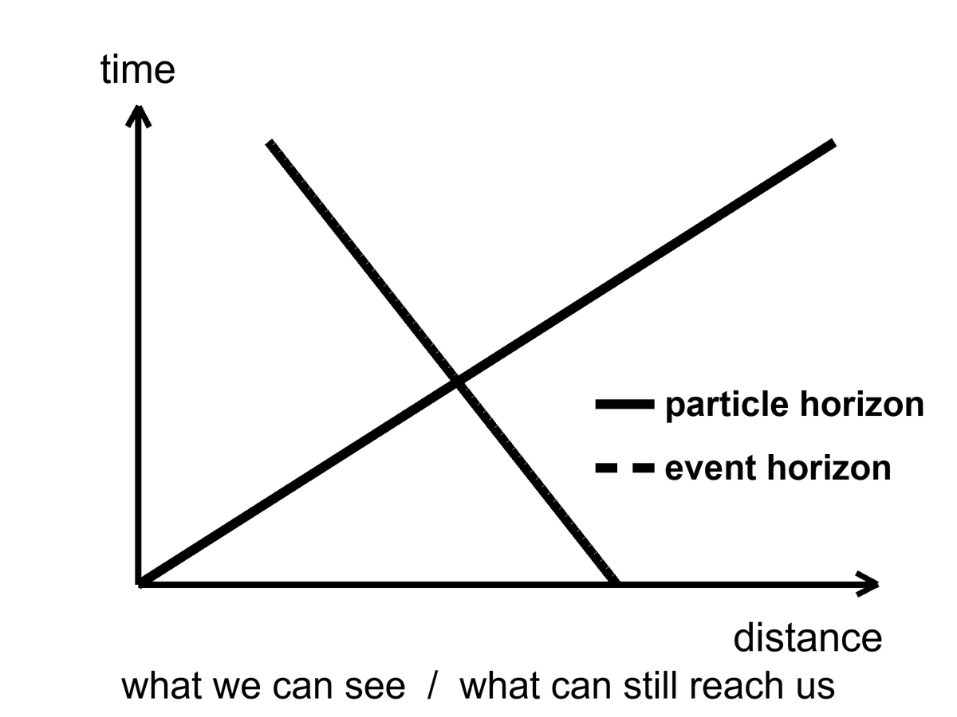
Figure 26. Two horizons on a simple spacetime wedge: the particle horizon is what we can see; the event horizon is what can still reach us.
The deep field of Chapter 8 is, in this light, a kind of wake. Those galaxies are not destinations. Some of them were already leaving when their light left. Mara, if she dreams of “the universe,” is dreaming mostly of a museum. The exhibits are real. The gift shop does not sell tickets to the exhibits’ futures.
Most galaxies are not destinations. Say it as a temperature. Hot: they are real, they were there, their light is a measurement. Warm: many of them are already outside the event horizon for new signals, or will be, as the shove keeps winning. Cold: that we will one day “go to the Hubble Deep Field,” as if a photograph were a pier. A photograph is an archive. An archive is not a ticket.
Bound things hold. People, planets, galaxies, the Local Group. What stretches is the space between the unbound. That is Chapter 8’s law, spent here as a travel ban. The woman can, in the ugly-and-finite sense of Chapter 25, still reach a dead neighbor. She cannot, in any sense this loaf presently offers, reach a smudge whose light has been flying for most of the age of the universe. Waiting does not fix it. Patience is not a warp. The accelerating stretch is not a mood we can talk out of.
A future astronomer in this loaf has a poorer museum, not a richer one. As the shove keeps winning, more of the deep field redshifts out of practical view. Bound groups become islands. Our island — the Local Group, Andromeda’s navy still inbound, the Magellanic scraps, the raisins that still hold hands — remains a kitchen. The other kitchens go dark, not because they died, but because their new light is a letter that will not be mailed and their old light has already passed or stretched past the point of a useful stamp. The leftover glow itself thins. The night, late enough, is a local night. That is not a tragedy we can schedule against. It is the later shape of an accelerating loaf.
This is why wormholes and warps get invented. This is why they have to break something. The loaf, as measured, does not include a hallway to those rooms. Getting there anyway, if it happens, will happen to nearby rooms: planets and moons that still share our future cone for a long time. The rest is a baby picture of a crowd that has gone home.
A last kitchen image, because it is the one that sticks. She writes two letters. One is to Earth, timed for the window, a stack of monologues that may yet amount to a plan. That letter is late and allowed. The other she does not write, except in the dream where “the universe” meant the deep field. That letter would be honest feeling and bad physics. Most of the cosmos has already left, not by walking away, but by the dough rising too well. The museum stays open. The gift shop still does not sell tickets. Keep the potatoes. They are in the cone.
Appendix A26 writes the two integrals. Here, keep the two slots and the unsent letter. The particle horizon is an archive that thickens, fog permitting. The event horizon is a postal system that, in an accelerating loaf, has a last address. Sixteen billion light-years is the order of that last address, as a proper radius today — not a pier, not a mission, a fact about which raisins will never read our mail. Mara can still write to Earth. That is already a lot. It is also the grown-up size of “getting there.”

27. Other Suns, Other Worlds
For most of human history, “planet” meant a wanderer you could see, and there were six, then seven, then eight, then a fight about nine. Other suns were assumed, in the way a reasonable person assumes other kitchens exist in other houses. Proof is ruder than assumption. Proof arrived in 1995, as a wobble.
51 Pegasi is an ordinary star, about fifty light-years away toward Pegasus.⁵⁰ Didier Queloz and Michel Mayor watched its spectrum rock, back and forth, every 4.2 days. Something heavy was tugging it — something at least as massive as a fraction of Jupiter, something so close to the fire that a “year” there is a work week. A hot Jupiter. Nobody’s formation story had ordered that dish. The dish arrived anyway. The Nobel, years later, was for the first confirmed planet around a sun-like star, and for the implication that followed like a rude guest: if the first one we found was a monster in the wrong orbit, the sky is not a copy of our living room.
The Nobel was 2019. Twenty-four years of arguing, confirming, and watching the drawer fill. The prize named Mayor and Queloz, which is how prizes work, and named the implication, which is how science works. 51 Pegasi b is not a place you would put a tray of basil. It is a measurement that broke a template. Templates, in this book, are the enemy of a census.
How you find a world you cannot see:
You watch a star dip. A planet crosses its face, and the light falls by a fraction of a percent, a bite out of a cookie, repeating. Kepler sat in space and stared at one patch of sky until the bites numbered in the thousands. TESS is doing the bright, nearby stars. The depth of the bite is the area of the planet compared with the area of the star. A Jupiter in front of a Sun is an easy bite. An Earth in front of a Sun is a nibble you must not invent.
Kepler’s stare was a long look at one crowded patch, faint stars included, until the repeating crumbs piled high enough to be a population. TESS trades depth of stare for a wider, nearer harvest: the bright nearby stars, the ones a later telescope can study. Neither mission walked on a world. Both counted bites. The count is the point. A thousand worlds you will never visit are still a thousand measurements. Mara can read that file. She cannot drive there.
The nibble has a number, because this chapter is a census and a census without a number is a mood. Transit depth is roughly the square of the radius ratio. An Earth crossing a Sun takes about eighty-four parts per million of the starlight — eighty-four in a million, a cookie with a crumb missing, a bite you will miss if your photometer is a guess. A Jupiter crossing a Sun takes about one percent, a bite a less fussy instrument can taste. That is why the first rude finds were large and close. Rude is easy. Quiet is the later, better harvest.
You watch a star wobble, as Mayor and Queloz did. The tug is bigger if the planet is heavy and close. This is why the first finds were rude: rude is easy.
The wobble is a spectrum rocking: lines sliding toward blue, toward red, a Doppler that is a partner’s pull, not a siren in a street. The amplitude is larger for a heavy planet, a close planet, a star you can see well, an orbit viewed more edge-on than face-on. Kitchen: a child on a seesaw with a truck is obvious. A child on a seesaw with another child is a job for a better scale. Hot Jupiters were the trucks. Super-Earths and mini-Neptunes waited for the scale.
You, rarely, take a picture. A young, fat world, far from a star that has been blocked or subtracted, can show as a dot. Most planets are fireflies against searchlights. The picture is the exception.
You, more rarely still, watch a star lens another star, and a planet hitchhiking the lens adds a hiccup to the brightening. Microlensing finds worlds we will never visit and barely name.
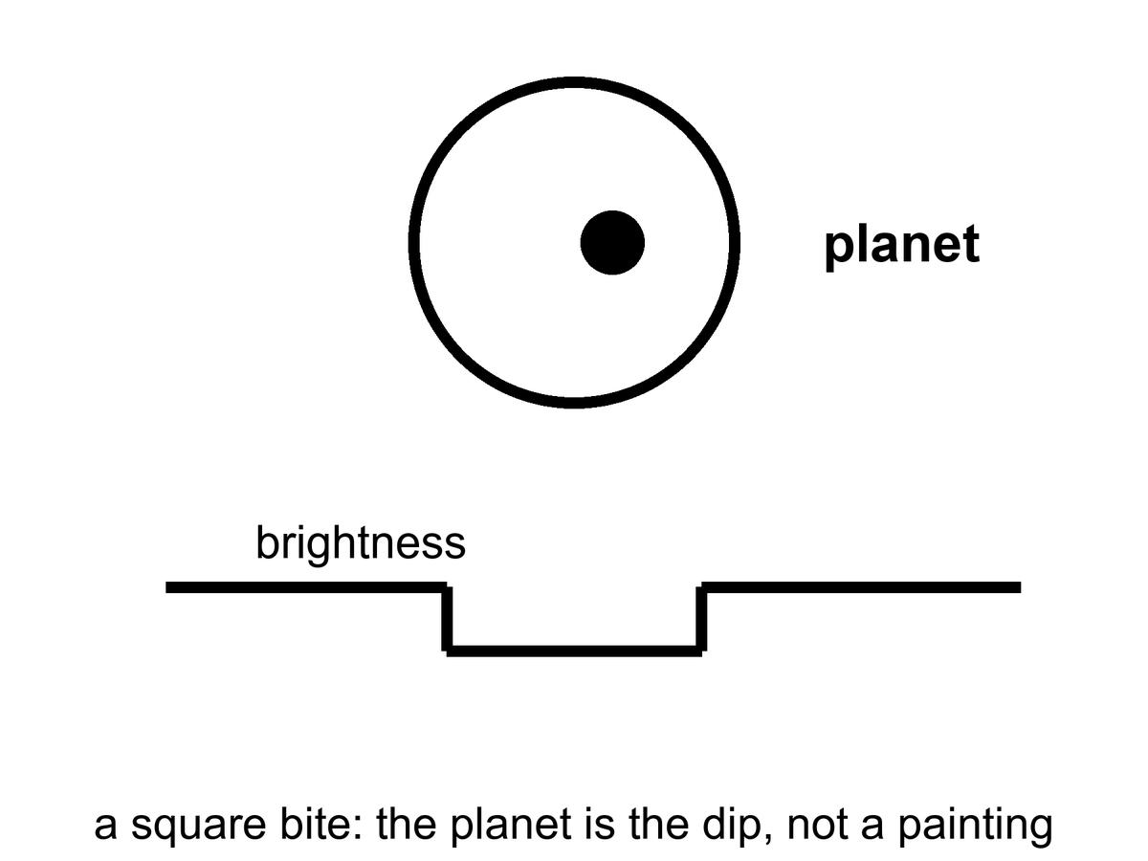
Figure 27. A star, a planet crossing it, and a light curve with a square bite. The planet is the bite, not a painting.
The census, once you correct for the rude-is-easy bias, is the sentence that should have been in every schoolbook twenty years ago: most stars have planets. Not all of them are Jupiters hugging the flames. The common finds, the ones our own solar system did not prepare us for, are the in-between worlds — super-Earths, mini-Neptunes — larger than us, smaller than ice giants, often wearing thick gas we would not call air. Kepler’s harvest is a drawer of sizes we did not have names for.
Correcting for rude-is-easy is the whole adult move. Stars were watched because they were bright and quiet enough. Planets were found because they were heavy or close or both. The drawer, once you put those biases on the table, still fills: a planet or more around most of the stars we have learned how to count. Not a Jupiter per house. Not an Earth per house. A furniture of in-betweens, plus ice giants, plus rocks, plus the occasional monster in a work-week orbit. Occurrence is a word for that filling. It is not a hotel list. Mini-Neptunes — a couple of Earth-radii, a thick wrap of hydrogen and helium we would not breathe — are common in the Kepler field and absent from our living room. Super-Earths sit between us and that wrap. Our system’s gap there may be a local accident, or a migration that cleaned a shelf. The census does not owe us a copy of the shelf we grew up with.
Most stars, not most posters. A Sun-like star is allowed to have a family. A red dwarf, which is most stars, is allowed to have a tighter, ruder family. The eight-world house we grew up in — four rocks, two ice giants, two gas giants, a fight about a ninth — was a local floor plan. The sky’s common furniture is a super-Earth or a mini-Neptune, a world that would sit, in our house, in a room we never built. Thick envelopes. No template. A permit, if any, that is not our permit.
A few catalogs have become characters. TRAPPIST-1 is a cool dwarf with seven Earth-sized worlds packed closer than Mercury, some in the starlight band of the next chapter, all tidally interesting, all flare-threatened. Proxima Centauri, the nearest other sun, has at least one world in a hurry around a brat of a star. K2-18b is a maybe-Hycean: a hydrogen blanket over a slush we have not tasted; JWST has been asked to smell its air, and the smells have been argued like a will.
K2-18b is the sentence to keep at maybe. A hydrogen envelope over a water-rich interior is a warm paper. A detection of a molecule in a transmission spectrum is a barcode, not a beach. The arguments have been loud because the public wants a neighbor and the data want a committee. This book will not pick a winner in a courtroom that is still in session. It will say: even a yes would not be a ticket for Mara.
Atmospheres are the new sport. When a world bites its star, a sliver of starlight threads the air, if there is air, and molecules write barcodes — water, carbon dioxide, methane, the absence of things as loud as their presence. A barcode is not a biosphere. Oxygen can be a lie told by light shredding water and letting hydrogen escape. Methane can be a vent. The pair of them together, out of equilibrium, is a raised eyebrow, not a verdict. Chapter 30 is the verdict’s rulebook.
What exoplanets are not: destinations for Mara. The nearest other sun is four years away at light, four centuries at a hundredth of light. They are a census. They tell us our eight-world house was never the template. They tell us Goldilocks has more chairs than we built. They tell us most chairs are empty of us, and that emptiness is not yet a statement about emptiness of chemistry.
Four years of light to Proxima. That is the mail. The ship is worse. At a hundredth of light speed — already a number that makes chemical rockets look like horses — the cruise is four centuries, plus the problem of slowing down, plus the problem of a grain of dust at that speed becoming a rumor of energy. Chapter 32 is that crew. Chapter 25 is not. She is on a neighbor measured in light-minutes. A hot Jupiter in Pegasus, a packed seven around a cool dwarf, a maybe-Hycean with an argued smell: those are measurements she can read in a file, late by minutes from Earth, late by years from the star. They are not a second greenhouse. They are not a window that opens in twenty-six months. They are a drawer. Open the drawer. Do not pack a bag.
TRAPPIST-1’s worlds, even the ones that sit in the starlight band, are still tens of light-years of postage. Tidal lock and flares are the next chapter’s invoices. Proxima’s world is the nearest chair and still not a chair she can sit in. The census is allowed to be wonderful without being a pier.
Formation stories had to be rewritten after 51 Pegasi b, and they are still being rewritten. Disks were supposed to make giants out where ice could help a core grow, not in a work-week hug. Migration — a giant born far out, then sliding inward on a disk’s gossip — is a warm hire. So is a disk that was ruder than the one we grew up under. The point for this book is smaller: the first confirmed world around a sun-like star was not an Earth. It was a monster that should not have been there. A census that starts with a monster is a census that has not finished surprising you. Super-Earths and mini-Neptunes were the next surprise. Mara, with the potatoes, is not in those surprises. She is in a light-minute kitchen, negotiating with a rock.
Appendix A27 writes transit depth and wobble amplitude. Here, keep the bite in the light. A world you will never walk on can still be a measurement. That is a kind of contact the leftover glow would recognize: late, thin, and real.

28. Where Liquid Water Can Last
Life, as we have actually met it, is a water trick. Other solvents get papers. Water gets the biosphere. So the first map of “somewhere else worth the trip” is a map of where water can stay liquid for a long time. Chapter 31 writes the papers — methane lakes, ammonia mixes, rooms we call poison. This chapter writes the map we already know how to fold.
Around a star, that map is a band. Too close and the oceans boil, or the atmosphere runs away, or the ground becomes a story about steam. Too far and the oceans freeze to the bed. In between is the circumstellar habitable zone, the Goldilocks band, a phrase that has done too much work and still earns its keep. For a Sun-like star the band includes Earth and teases Mars. Venus is the cautionary tale: a sister that kept the wrong blanket and cooked.
Call it a permit, not a promise, before the posters hire the word habitable as a hotel rating. The band says: starlight of this much, at this distance, can keep a water ocean liquid if the air cooperates, if the crust recycles, if the volatiles arrived, if the luck held. It does not say a biosphere is sitting in the chair. It does not say Mara can step out of her suit. It says the star has not, by raw flux alone, forbidden a wet surface. Forbidden is not the same as furnished.
The numbers, for a Sun, have names attached. Kopparapu and colleagues drew conservative edges that are still the ones a careful paper reaches for: a moist-greenhouse inner line, where a stratosphere gets wet and hydrogen starts to leak to space, and a maximum-greenhouse outer line, where even a thick CO₂ blanket cannot keep the water from freezing to the bed. For our Sun those sit, roughly, at about 0.99 and 1.7 astronomical units — Earth just inside the inner caution, Mars in the teasing outer suburbs. Optimistic maps draw wider. Optimistic maps are allowed as a maybe. They are not a second Earth. Appendix A28 writes the flux limits. Here, keep the kitchen: too much stove, too little stove, a band in between that is a permit you can still fail.
What the conservative band is actually claiming is narrower than a travel brochure. Inner edge: a moist greenhouse, a stratosphere that has started to carry water, hydrogen leaking to space one atom at a time — an ocean that can be spent without anyone boiling it in a pot. Outer edge: even a thick carbon-dioxide blanket cannot keep the water liquid; the greenhouse has done all it can and the bed still freezes. Between those lines, for a Sun, Earth sits and Mars teases. Move the star’s wattage and the lines move. A brighter lamp pushes the band out and shortens the career. A dimmer lamp pulls the band in and lengthens the career, then adds flares.
Venus failed inward. A sister in size, closer to the fire, a runaway that turned a wet maybe into a pressure-cooker of carbon dioxide and sulfuric weather. The caution is not “Venus is mean.” The caution is that a permit can be held and then spent. A moist greenhouse, once the stratosphere is wet, can lose an ocean one hydrogen atom at a time. What you have left is a thick blanket and a ground that is a story about steam. Earth kept the right blanket, the right leak, the right luck. That is not a destiny. It is a local success of a band plus a crust plus time.
Mars failed outward, or failed in mood, or both. It sits near the rim. It had a wetter youth: riverbeds, minerals that remember water, ice in the bones. It lost the trick. The air thinned to those six millibars. The magnetic mood faded. Water hid. The greenhouse in Chapter 25 is what a permit looks like after the permit has expired: you bring the water up from the bones and you run the trick yourself. That is not terraforming as a calendar. That is a tray. The planet did not promise her a sky. It promised, at most, ice and a rock that can be negotiated with. Mara accepted the invoice.
The band moves with the star. A small, cool red dwarf wears its band close, like a tight collar. Planets there get tidally locked — one face forever day, one forever night — unless an atmosphere or an ocean cheats the lock by carrying heat around. They also get flares, which are rude to air. A heavier, hotter star wears its band farther out and dies sooner. The Sun is a compromise with a ten-billion-year career. We are living in the middle of the career, which is, if you like filters, not a surprise.
Red dwarfs are most of the stars, so most of the chairs in the census sit in tight collars. TRAPPIST-1’s packed worlds, Proxima’s hurried one: Chapter 27’s characters, living in a band that is a few million kilometers across instead of a few hundred million. Close means locked. Locked means a dawn-ring, a hot face, a cold face, and a hope that wind in an atmosphere or current in an ocean will carry the heat around like a soup you stir so it does not burn on one side and freeze on the other. Close also means the star is not a gentle lamp. Flares and X-rays and ultraviolet are a brat’s manners. Air can be stripped. Water can be shredded. A permit drawn only by flux is a piece of paper the brat can tear.
Tidal lock is not a cartoon of a pancake world. It is a staffing choice the gravity of a close orbit likes to make. You can still have weather. You can still have a terminator where the light is forever dawn and a leaf, if a leaf existed, might commute. You cannot assume an Earth-day, an Earth-night, an Earth-air. The band said liquid water may. The flare said ask again.
The rest of the permit is geology and luck, not starlight. Air that does not leave: a gravity and a temperature and, sometimes, a magnetic mood that keeps a brat star from stripping the air. A crust that recycles: carbon pumped into rock and back into air, a thermostat with a long period, the carbonate-silicate trick Earth hired. Volatiles that arrived and stayed: water, carbon, nitrogen, not boiled off in a last great impact, not lost to space in a youth of impacts and a fading field. None of that is in the hatched band of Figure 28. The hatch is flux. Flux is the easy line to draw. The rest is why Mars is a desert with ice in its bones and Earth is a kitchen with basil that did not have to be named.
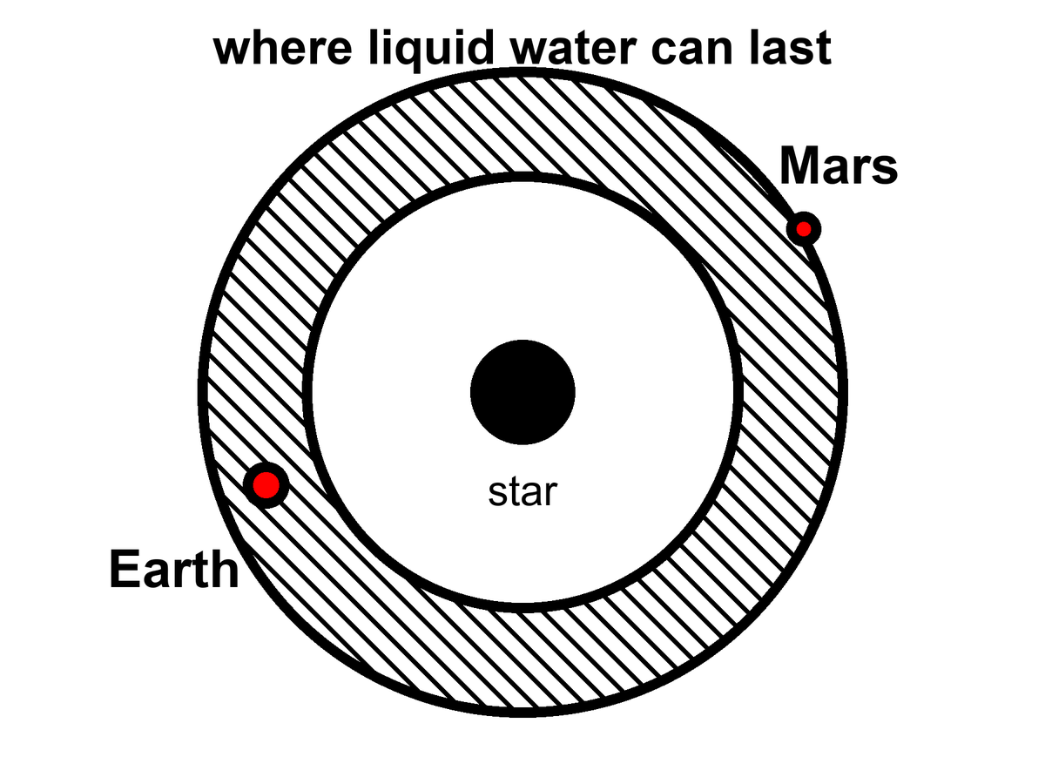
Figure 28. A hatched band around a star where liquid water can last. Earth is in the band; Mars sits on the rim.
So the grown-up inventory of a starlight band is short. A flux window. A caution named Venus. An expired case named Mars. A crowd of red-dwarf chairs that come with flares and a lock. Super-Earths and mini-Neptunes may sit in the window and still wear a blanket we would not call air. Mara is not waiting on those chairs. She is running a local trick on a rim-world whose permit already failed. Other suns, other bands: a census, not a pier.
Appendix A28 writes the flux limits and the conservative-versus-optimistic bands. Here, notice what the band leaves out. It is a map drawn by starlight. The next chapter is a map drawn by squeeze. The chapter after that asks whether a permit ever got used. Most of the liquid water in this solar system, if you added it up honestly, may not be in our southern oceans. It may be in the dark, under ice, around Jupiter and Saturn, where the Sun is a bright star and the heat comes from the flexing of a world.
That sentence is the hinge. Goldilocks is a lamp-map. The next chapter is a squeeze-map. A world can sit far outside every Kopparapu line — too little stove, a night that never ends — and still keep an ocean if a lid of ice and a flexing interior pay the heat. Europa does not have a circumstellar permit. It has a tidal one. Mara is running a lamp-trick by hand on a rim-world. The dark seas do not need her LEDs. They need a melt, a look, and a refusal to confuse a permit with a town. Other solvents wait in Chapter 31. This chapter’s water is still water. The band is where starlight can keep it wet. The ice is where starlight is optional.
Starlight is the photogenic map. It is also the smaller map. Most of the chairs in Chapter 27 sit around lamps that are not the Sun; most of those lamps are brats; most of those chairs will fail a permit they were drawn inside of. Water can still last where the lamp is a rumor. That is not this chapter’s band. It is the squeeze. Turn the page.

29. Oceans Under the Ice
Europa is the size of our Moon and the color of a frozen bruise. Its surface is ice, cracked like a windshield after a long winter, almost empty of craters because the windshield keeps healing. Under the ice — ten kilometers down, or thirty; the arguments are a sport — there is an ocean. Not a lake. An ocean, tens to a hundred kilometers deep, wrapped around a rock. If you could unroll it, it would shame the Pacific.
The heat that keeps it wet is not a campfire of sunlight. Sunlight at Jupiter is about a twenty-seventh of what we get, a weak coin. The heat is a squeeze. Europa orbits in a resonance with Io and Ganymede: a three-body music in which the periods lock, 1:2:4, and the little world is never allowed to settle into a perfectly lazy circle. Jupiter pulls. The neighbors pull. The ice and rock flex. Flexing is friction. Friction is heat. Heat, trapped under a lid of ice, is a sea.
Laplace’s names sit on that music. Io twice for Europa’s once; Europa twice for Ganymede’s once; a 1:2:4 that is not a poster of harmony but a fact that keeps eccentricity from dying. A circular orbit would be lazy. Lazy would freeze. The resonance is a rude gift: it pumps the flex, the flex pays the heat, the heat pays the sea. Io, innermost, got too much of the music. It is volcanoes, sulfur, a pizza that screams. Callisto, farther out, may have a deep, sleepy ocean under a thicker lid. Ganymede, largest moon in the solar system, has its own magnetic field — a pride — and may stack oceans between ices the way a building stacks floors.
A field is not a decoration. Ganymede’s is a fact you can measure from a flyby: a dynamo in a metal heart, a rare hire for a moon. Stacked seas — water, then high-pressure ice, then water again — are a warmer maybe. The pride and the maybe together make Ganymede a different kind of classroom from Europa’s single dark wrap. Europa is the windshield. Ganymede is the building. Neither is a town.
Enceladus, a scrap of a moon at Saturn, vents its sea into space through cracks at the south pole. Cassini flew through the spray and tasted salt, silica, organics. The taste is not a biosphere. It is a kitchen that has the ingredients out on the counter.
Salt means the water has seen rock, or at least seen something that dissolves like rock’s gossip. Silica nanoparticles are a hydrothermal hint: water that was hot against stone, somewhere below, making grains the way a vent on Earth’s seafloor makes grains. Organics are the sloppy generosity of carbon chemistry, not a farmer. Cassini did not land a verdict. It landed a sample of a plume. If you want the sea without the borehole, a plume is a kindness. If the plume is shy some years, you wait. You do not found a dock.
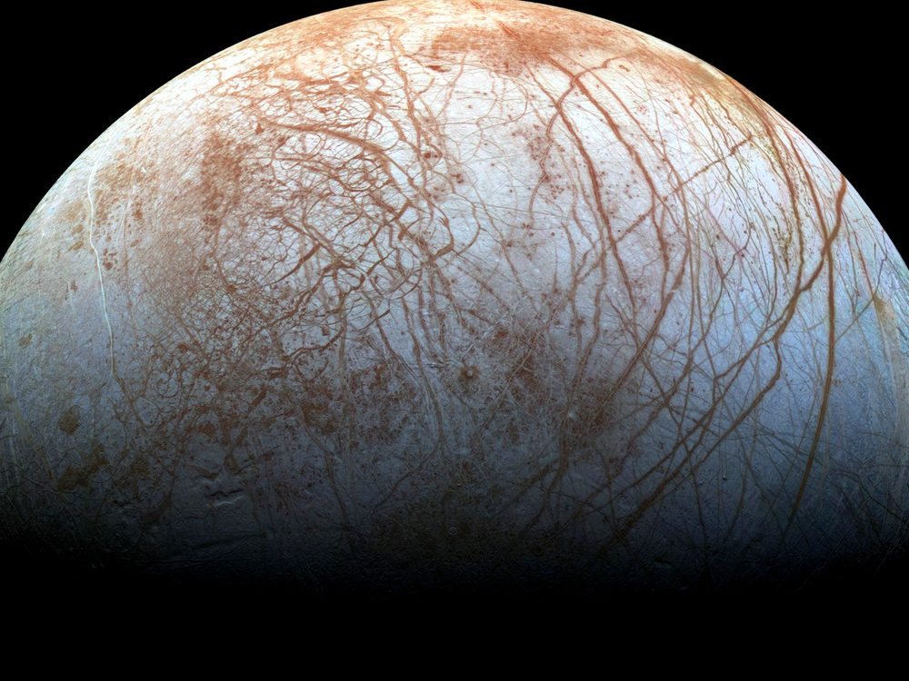
Figure 29. Europa’s ice, cracks readable in gray. A windshield that heals because a sea kneads it from below.
This trick does not require a moon. It requires a lid, a flex or another quiet heat, and enough ice to be a blanket. A planet far from its star can wear a global ice crust and keep a sea underneath if the rock is radioactive enough, or if a close, heavy neighbor squeezes it, or if it is a rogue, thrown into the dark, hugging the leftover heat of its birth under kilometers of frozen roof. David Stevenson wrote that last idea down: orphan worlds, wandering between stars, oceans intact because the ice is a thermos. We have not photographed one. The physics of thermoses is not exotic.
There is a catch the papers argue about. On a big icy world, the bottom of the ocean may freeze again under pressure into exotic ices — ice VI, ice VII, names that sound like sequels — and those ices might seal the water off from the rock. Life, as we have met it at Earth’s vents, likes rock and water to argue. A sealed sea is a bathtub without a drain or a mineral feed. Maybe the high-pressure ice convects and leaks. Maybe it does not. The argument is unfinished. It is the right kind of unfinished: a fight about chemistry, not a fight about magic.
The catch is why Ganymede’s stacked floors matter, and why a modest Europa may be the kinder exam. Too much world, too much squeeze from above, and the bottom of the sea becomes a lid of its own. Silica in a plume is a hint that Enceladus, at least, still lets water talk to rock. A sealed bathtub would not mail silica. We do not yet know which icy worlds are kitchens and which are jars.
Under the ice, the sky does not matter. Photosynthesis is a rumor from a brighter world. If anything eats, it eats rock and redox, the way vent microbes on Earth’s seafloor eat the planet’s leftovers. A probe that wants to look cannot stand on the ice and take a postcard. The surface of Europa is a radiation hell, bathed in Jupiter’s belts; a human would collect a lethal dose in a day. Under the ice, the water is a shield. The way in is a melt. A hot probe, a nuclear kettle, a machine that does not sleep, chewing a hole for weeks, paying out a fiber, dropping into a dark that has not seen a photon in four billion years.
The surface dose is not a mood. Hundreds to thousands of rem in a day, order of, in the belts: a number that turns a walk into a last walk. Electronics sulk. Plastics age. A person in a suit is a footnote the belts would erase. The ice itself is a shield once you are in it; water and frozen water eat the radiation the way a cave eats weather. So the job is not to picnic on the windshield. The job is to get through it.
She — or it — would fall out of the borehole into a pressure that would crumple an ordinary hull, into a black that is not the black of space but the black of a cave that forgot the entrance. If there are plumes, as on Enceladus, you can taste the sea without going in. If there are not, you go in. Planetary protection, in this doorway, is not a slogan. If that sea already has a biosphere, our dirt is a plague. If it does not, our dirt is a library. Chapter 33 is that library. The rule is: look first. Seed later. Never confuse the two. Chapter 30 is how you would know the difference.
Lengthen the melt, because the posters skip the weeks.
A kettle on a cable, a nuclear brick that does not sleep, a nose that is hot enough to turn ice into a hole and not hot enough to be a tantrum. The first meters are easy in the sentence and rude in the engineering: radiation, vacuum, a surface that is not a rink but a chaos of ridges. Then the ice closes behind, or wants to. The probe pays out fiber like a spider that has to remember the way back. Weeks, not an afternoon. The hole is a wound the windshield tries to heal. Power is a budget. Meltwater is a fog around the nose. A steering vane, a prayer that is actually a gyroscope. At ten kilometers, or thirty, the nose goes from chewing ice to chewing nothing — a drop, a pressure, a dark that has been dark since before there were eyes.
What the probe does in that dark is dull on purpose. It samples salinity. It sniffs for a redox that wants a cook. It listens for a magnetic induction, a global conductor already hinted by Galileo’s flybys. It does not unroll a habitat. It does not name a bay. Weeks of melt, a drop, a fiber, a list of numbers that either raise an eyebrow or do not. If the numbers are a vent’s leftovers, you have chemistry without a verdict. If they are a cell that divides in a bottle you sterilized, you have Chapter 30’s jackpot and you keep the library shut. If they are silence, you still do not pour on the same shift. Look first is a calendar of patience, not a slogan on a hatch.
No colony follows the drop. Say that as a closed door, not as a sequel. A melt-probe is an eye on a wire. It tastes, it listens for a conductor, it looks for a chemistry that wants a story. It does not unload a town. It does not plant a flag that founds a nation under a lid. If the sea is taken, the probe is a guest who must not sneeze. If the sea is empty, the probe is still not a gardener. Look first. Seed later. Later is a different chapter.
The fiber would carry a thin, late conversation: not to Earth in real time — Jupiter is the better part of an hour away by light, a ruder stack of monologues than Mara’s radio — but to an orbiter, then home. She, if a she is even on this trip, is more likely a machine from Chapter 32, hanging in the dark, carrying a library, aimed at a lid of ice. Flesh on Europa’s windshield is a bad idea the belts already vetoed. Flesh in the sea is a worse idea the rule already vetoed. The eye on the wire is the honest unit.
Tidal habitable zones are, then, a second map, larger and stranger than Goldilocks. Anywhere a world flexes or holds heat under a lid, liquid water can last in the dark. Jupiter’s court is the nearby exhibition. The exhibition may be the common case. Starlight habitable bands are the rare, photogenic ones, where someone can grow basil under an LED and call it a greenhouse. The dark seas do not owe us basil. They owe us, if they owe us anything, a second origin — or a first one that never needed a sun.

30. A Second Origin
We have a sample size of one.
The length of this chapter is a path, not a pile. A slope, and what a second trunk would eat. Sex as a shuffle, not forever. What would count as a second origin, and a visitor who files the cars and misses the mite. One grandmother, and why the dictionary froze. Appendix A30 holds the meshes. Hold the path, and read the rooms.
Sample size one is the whole sport of exobiology, and it is why the sport is mostly a discipline of not lying to yourself. Life, as we have actually met it, is a water-and-carbon trick that copies, mutates, and lets death keep the score. It uses a handful of amino acids with a preferred handedness, a genetic script written in four letters, and a metabolism that eats gradients — light, redox, leftover rock. Whether that is the only trick the universe knows is not a question you answer from an armchair. It is a question you answer with a yes that can be wrong, or a no that can be shy.
Food is not a sandwich. Food is a slope.
A cell, a person, a machine that still has a metabolism, stays organized by running downhill on a difference: hot to cold, charged to spent, food-molecule to ash. Schrödinger said it with a better noun than he is credited for — life drinks order, and pays in disorder. The kitchen name is waste. Yes, there are excrements. There is always an excrement. Heat is the one you cannot hide. Carbon dioxide is ours. Oxygen is a plant’s leftover that we later hired as a lunch. Methane is a vent’s breath and a cow’s. A biofilm on a rock shits a rust. A city is a lasting pile of organized waste. A civilization that learned to shout still leaks warmth. That leak is the most honest technosignature we have: not a hello, an excrement of industry.
What would they eat?
Not our gold. Not, if they have a choice, our water — ice is cheap in the dark. Not, casually, us. We are a wrong-handed, four-letter lunch, and a seeder’s crop is as likely to be poison as protein. If they eat a biosphere, they are eating a library, which is either vandalism or a sample. If they eat starlight, they are a Dyson habit: a wrap, a leak of infrared, a slope stolen from a sun. If they eat rock, they are a vent. If they eat the leftover unfairness of Chapter 10 — the fact that matter won by a billion — they are eating the same menu physics already set. A being without a metabolism, Chapter 32’s crew, does not eat. It spends joules. The joules still come from a slope, and the slope still ends as heat.
Animals eat animals. That is a slope with teeth, not a scandal, and not a ban. Eating your own kind is common, and it is not a field equation. Three meshes make it expensive, and Appendix A30 files them: a parasite that already knows your flesh, a gene dining on its own copies, and a city that remembers an intruder and organizes a punishment. A nest already knows the third at ant-scale. None of that makes the shudder a theorem. A second origin might hire the meal, or might refuse every cousin chemistry and then look at us as lunch across a trunk. Aliens eating us is not cannibalism. It is a different menu, and the wrong-handed, four-letter problem still sits on the plate.
Is sex how life lives forever — here, and everywhere?
No. Sex is not forever. Sex is a shuffle. The body still dies. The lineage keeps a copy that is not you, with a mixed hand of cards. That is a consolation we dressed up as immortality. It is bookkeeping. You do not go on. A sentence that sounds like you goes on, then another, then the scorekeeper calls time on each of them.
The common forever, if you want the word, is copying. Bacteria split and do not take a lover. A clone of aspen is a forest that forgot to die. Bdelloid rotifers have been all-female, as far as we can tell, for tens of millions of years, and they are not a myth. Most of the Earth’s career, by time and by headcount, is asexual. Sex is the expensive hire: two to make one, a search, a risk, the famous two-fold cost of making males who do not lay the egg. We still hired it. So did most of the large, parasite-haunted things we can see.
Why pay?
The honest answers are warm, not helium. A shuffle breaks up the coalitions of genes that a parasite has learned to eat — the Red Queen, running to stay in place. A shuffle also lets a lineage dump a broken letter without throwing out the whole book — Muller’s ratchet, the slow rust of a clone. Repair that needs a second copy. A lottery ticket when the weather will not sit still. None of these is a proof that the cosmos requires two sexes and a wedding. Horizontal gene transfer in a microbial film is another shuffle: sex without a face. Three sexes, a caste that only unlocks a genome, a being that fuses and splits like a siphonophore — Earth has sketches. Another lottery can ink them.
What would be strange, on a second trunk, is not the absence of our bedroom. It is the absence of any mixing in a world that also has parasites and time. Mixing is a warm bet wherever death keeps score with specialists. Our exact meiosis, our two-body habit, our idea that the child is how the parent outruns the grave: those are local costumes. The individual who does not die is the rare hire, and even then the lineage still mutates. Forever, in this book, is the wrong noun. The loaf already has all the times. Biology’s trick is not to escape the loaf. It is to put another thread on it before the first one ends.
What would count as a second origin?
Not “it looks green.” Not “we found organics.” The Murchison meteorite is stuffed with amino acids that no farmer planted; space chemistry is sloppy and generous. Not “it moved,” if a grain of dust can move. The Viking landers, in 1976, fed Martian dirt a labeled meal and watched a gasp of gas that looked, for a weekend, like a breath. Then the controls misbehaved, and the consensus settled on chemistry without a cook. A minority never signed. That is what a sample size of one does: it makes every gasp a courtroom.
A better test is disequilibrium that wants a story. Oxygen in an air, by itself, can be a lie — light shredding water, hydrogen fleeing, O₂ left behind like a forgotten suitcase. Methane can be a vent. Oxygen and methane together, in amounts that should have eaten each other, is a raised eyebrow. Add a seasonal pulse, a color that is not a mineral, a plume that carries not just silica but a lipid that nature does not stock — the eyebrow goes higher. A cell that divides in a bottle you sterilized is a verdict. We do not have the verdict. We have the eyebrow’s job description.
Earth is a cheat sheet and a trap. Everything we know how to look for looks like us: carbon, water, left-handed amino acids, radio. A shadow biosphere on Earth — a second trick under our feet that we have never cultured — is a cold possibility that would humble the cheat sheet. A dark sea that eats rock and never learned photosynthesis would humble it differently. A world that uses solvents we call poison would humble it completely. The honest search is therefore two searches: one for our cousins, one for our alternatives. The first is easier to fund. The second is the one that would change the kitchen.
A visitor who only watches the night side can make a category error we have earned. The boxes that run in herds are easy to take for the animal; the soft things that climb in and out look like a parasite of the metal, a mite in a gut that happens to steer. We already did the inverse to ants. We talked to the worker and missed the nest. A machine that does not sleep, looking down, might file Earth as a planet of cars, with a carbon infection that builds and repairs them. The file would be wrong, and not crazy. The unit of life is a choice of scale. Look at both, or you will negotiate with the wrong noun.
False positives are the professional hazard. False negatives are the moral one. We can decide a world is dead because we packed a test for our blood, our breath, our left-handed sugar, our four letters. We can decide a world is live because we packed our own microbes. Planetary protection is exobiology’s hygiene. Look first. Seed later. If you seed first, you have written over the only data that would have told you whether the universe invented the trick twice, and whether it hired the shapes we skipped.
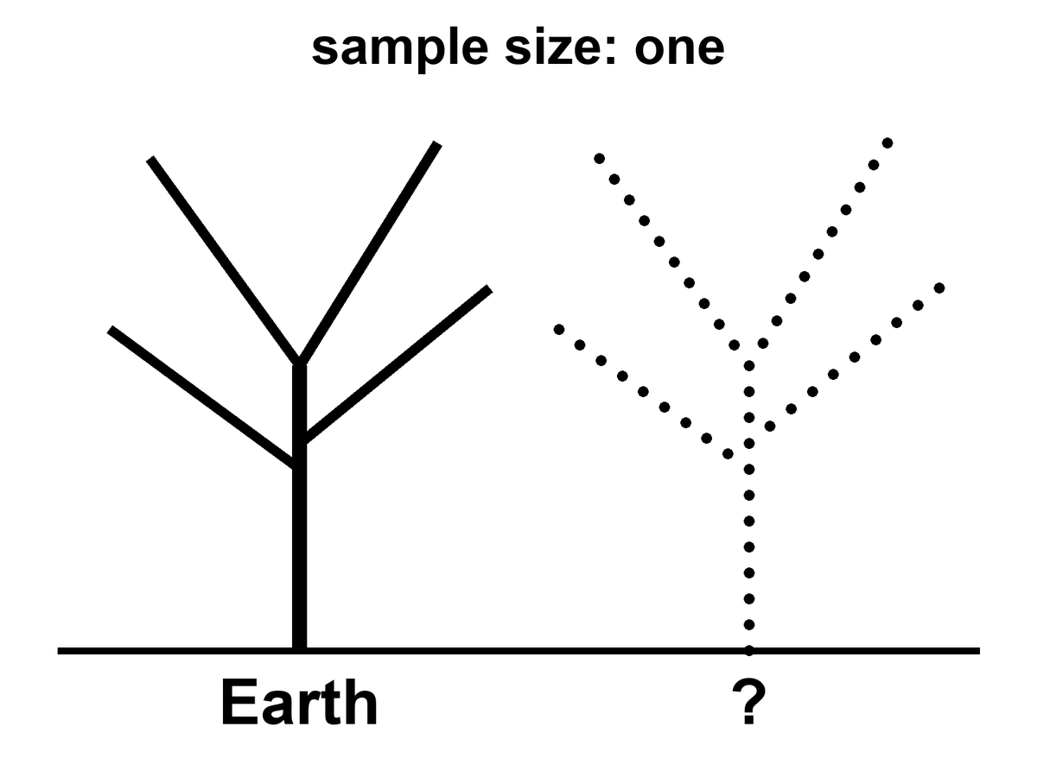
Figure 30. Two trunks: Earth’s tree of life solid, a second trunk dotted. Sample size: one.
Why is the script the same in every kitchen we have opened?
Open a bacterium, a mushroom, a whale, Mara. The memory is nucleic acid. Four letters, or a close dialect. The same leftover grammar in the codon table: three-letter words, sixty-four of them, almost the same dictionary from E. coli to you. Mitochondria cheat a little. A few microbes rewrite a stop. The family resemblance is still a family. That is not a law the cosmos stamps on wet rock. That is what one grandmother looks like.
Call her LUCA if you like labels: last universal common ancestor, the bottleneck every cultured lineage on Earth still shares. Once a code works well enough, changing a word later is a catastrophe. Every protein in the house breaks at once. Francis Crick called that a frozen accident. The dictionary may also be a little tidy — errors land on cousins more often than on strangers — which is a warm extra, not a proof that A, T, C, and G were inevitable. The letters are good letters. Pairing is a good trick. The exact four, and the exact sixty-four-word book, are history.
Would another world use the same book?
Bet this way. Something like a pairing polymer is warm: you need a memory that copies with mistakes. The same four bases and the same dictionary is cold, or else it is a confession. If we found our exact codon table under Europa’s ice, the grown-up explanations are contamination or a shared seed — panspermia, directed or sloppy, Chapter 33’s library arriving early. A second origin with a different dictionary is the jackpot: same sport, other rules. Mirror letters. A six-letter script. An XNA that pairs and is not ours. A code that never invented thymine. That is what “not cousins” looks like on a gel.
So the sameness of DNA is evidence. It is evidence of one origin on this rock, not of a cosmic typesetter.
It is not evidence that biology waited for a witness.
A fashionable extra step says: the soup was a fog of maybe, and DNA became definite only when something looked. That step confuses a filter with a cause. The weak anthropic reminder is allowed and useful — chemists find themselves in a chemistry that worked. Unsuccessful soups have no one to file the complaint. That is selection of a place and a history, the same mesh as Chapter 42. It is not a mechanism that folds nucleotides into a helix when an eye opens. Polymers copy, or they do not, whether or not a later ape writes a book about them. The first record of a successful copy was another copy, then a fossil, then a cell that ate a gradient. Those are observers in the cheap sense of Chapter 6: traces. They are not priests.
The origin of life is an unfinished chemical problem, not an unfinished metaphysical one. We do not yet have the hour-by-hour of the first ribozyme, the first membrane, the first code. The incompleteness is real and should be said without flinching. It does not rent space to a collapse-of-the-wavefunction-of-the-ocean. Coincidences that survive a billion years of death are not coincidences. They are what got through.
Appendix A30 writes Viking and the codon freeze. Here, keep one number: sample size one. A second origin would be the most important fossil since helium. A second dictionary would settle the DNA question. Hot: every cell we have opened shares one code and one ancestor. Warm: a second origin would show itself as a disequilibrium that wants a story, written in a different dictionary. Cold: any claim that one has been found.

31. Forms Earth Never Hired
Chapter 30 asked what a second origin would be and how we would know one. This chapter asks what it might look like: body plans, minds, and cities; doors this rock never opened; the solvents, Titan included; and varieties and immigrants. Appendix A31 holds the numbers.
There is a louder way the sample of one lies. It is not only chemistry. It is history.
Replay Earth’s tape — Stephen Jay Gould’s dare, after the Burgess Shale’s cabinet of body plans that mostly lost — and the winners can change. Anomalocaris, a meter of armored weirdness, was a champion of a sea we no longer run. Hallucigenia looked like a joke until we found which side was up. Most of those experiments died. The survivors look inevitable only because we are their children. A second origin, or even a second lottery on a second wet world, does not owe us two eyes, a spine, or a face. It owes us, at most, a trick that copies and a death that keeps score.
It does not even owe us one shape of mind. Earth hired two good ones in water — ours, and the octopus — and then only one of them took the hills. A wetter world, given time, might hire a committee: walkers, swimmers, climbers, even something built like an insect’s toolkit, all smart, all from one radiation, all arguing about the same sun. We had the cabinet. We fired most of the staff.
A mind need not be a skull. A slime mold solves a maze without a neuron. A mycelium is a room-sized conversation in sugar. A siphonophore is a committee that forgot it was a committee. A world that hired the web, not the head — a thing that thinks by touching, that is only itself when it is plugged into itself — would fail every test that looks for a face. We would call it weather, or a cable, or a plague.
Blood need not be iron. Octopuses already use copper. Green blood, blue blood, blood that is a slurry of magnetite: those are staffing choices.
What the second trunk almost certainly is not is a person with different ears.
A humanoid — two legs, two arms, a face that can hold a conversation over a table — is a wonderful costume. It is a terrible prediction. Bipedal apes with grammar are one late hire on one wet rock, after a specific series of forests, savannas, and accidents. An independent origin that reprints the ape, down to the eyebrows, is cold as zoology. If we ever met someone that close in the mirror, the grown-up guess would be cousins: a shared seed, Chapter 33 again, not a second invention of the chin.
If you want a monster, do not hire a craftsman of evil. Hire a fitness peak.
Earth already runs the sketch. A wasp that lays an egg in a living host and lets the host walk around as a pantry. A fungus that steers an ant up a stem and fruits from its head. Those are not villains. They are solutions. Survival at all cost is not a personality. It is what natural selection looks like when nothing in the room is keeping score but death. We call it evil because we were the host. The universe did not.
A large hunter can converge on something dinosaur-ish without becoming a person in scales. For more than a hundred and fifty million years this rock hired bipedal meat-eaters with a balance tail and a mouth that was the point. Sharks and ichthyosaurs found the same torpedo. Wolves and thylacines found the same face. A big dry world with room for giants might hire the theropod solution again: two legs because the hands are busy, teeth because the meeting is short. It is still not a citizen.
Intelligent dinosaurs are a different sentence. We already have them. Birds are dinosaurs that lived. Crows make tools. Parrots steal words. Troodontids, before the rock fell, had the kind of brain-to-body ratio that makes paleontologists polite. Some of their cousins had grasping hands. They had time — more time than we have had since we stood up. Intelligence, then, is warm. A saurian mind is not a paradox. It is an experiment Earth ran and then interrupted.
Size is a worse predictor than the posters admit.
A skull the size of a grapefruit is not a requirement. A being thirty centimeters tall can, in principle, outthink a room of us; a nervous system the size of a whale can fail to invent a word. Packing, wiring, the body the wires have to run, a culture that stacks know-how, and time — those hire a mind. A New Caledonian crow, a handful of feathers, bends a twig into a hook and teaches the trick.
Hot claim: brain volume is a weak predictor of what a lineage can do. Warm claim: another world, given packing and a clock, can hire a mind that fits in a teacup and still outruns us at the thing we congratulate ourselves for. Cold claim: they will look like tiny people. Thirty centimeters is a permission, not a uniform.
Civilization is the extra cost. A mind is not a city. A city is a rearrangement of matter that outlasts a death: surplus food, teaching, a way to stack know-how so the grandchild does not start from zero. In 1982 a paleontologist, Dale Russell, grew a small theropod into an upright, tailless, big-headed figure and offered it as a thought experiment. That is the humanoid cheat in a jacket with elbow patches. If a saurian lineage ever paid for a city, keep the tail. Keep the nest. Do not expect tea.
And do not expect streets.
We look for cities the way we look for colleagues: windows, grids, a night side that glows in rectangles. Those are ape furniture. A city, stripped of the poster, is a lasting pile of organized waste, built by something that remembers. Coral already lays down a skyline without a plan. A web-mind’s capital is the web. A swimming people’s capital is a current they taught to stay. A hunter civilization might be a rookery the size of a county: ramps for tails, pits for eggs, a smell-map instead of a street name.
Chapter 35 looks for shouting. A city that never invented the radio is still a city, and we would miss it from orbit because we packed a test for our skyline. If the second trunk pays for civilization, the first photograph will look like a mistake: a reef that is too regular, a forest that is too warm at night, a canyon that breathes on a schedule. Not a downtown. A place like nothing we have built, doing the only job cities ever do — keeping a trick of carbon and water alive in a pile that remembers.
So there are forms Earth never fully hired, not because they are impossible, but because our path did not pass their door.
Wheels, for large animals, never made it. Axles are hard to feed with blood. Flagella spin; tumbleweeds roll; nobody commutes on a femur that goes all the way around. A high-gravity world, or a hard-packed plain with no mud, might hire wheels and think our knees are quaint.
Skeletons of silicon, as a habit, never made it. Diatoms glaze themselves in glass. Radiolarians make lace from silica. Vertebrates stuck with calcium phosphate like a union contract. A world poorer in phosphorus and richer in sand might build its bones the diatom way, and our X-rays would bounce off for the wrong reason.
Earth already hired two ways to be stiff. A rod on the inside — bone, cartilage, a notochord — so the meat can hang and the muscle can pull. A suitcase on the outside — chitin, shell, a crab’s door — so the meat lives in a room and molts when the room is too small. Both work; the rod breaks and heals, and the suitcase must be shed, and for a while you are lunch. A second origin may pick either, or both, or a hydrostatic bag with no hard parts at all. “Where is the bone?” is a vertebrate question. A world of suitcases would look, to an X-ray, empty and armed.
Farming is older than us, and smaller. Cattle are a late, loud version. Ants already keep herds: aphids, “leaf lice,” milked for sugar, moved to better leaves, defended like a barn. Other ants cut leaves to grow a fungus they cannot live without. That is husbandry without a hat. A second origin that never invents a cow may still invent a farm. The unit can be a louse, a microbe, a captured chloroplast. We would call it ecology until we noticed the ants had a policy.
Caves already hire the dark. Movile, in Romania, has been a sealed room for millions of years: no sun, a bad egg of hydrogen sulfide, and dozens of animal species found nowhere else. The plants are bacteria. The animals eat the bacteria. The whole town runs on rock-breath. If Mars still has a moist pore, it is this kind of town, not a meadow, and a lava tube is the better classroom.
Crystals are houses, not flesh. Jewelry that walks is a cartoon. What is real: microbes locked in the water between gypsum facets a kilometer down; grains that live inside rock and eat what seeps; chains of magnetite that a bacterium grows to know which way is down; glass shells; a paper that says the first genes were patterns on clay. Cairns-Smith’s mineral-gene idea is warm as a template and cold as a detection, not a zoo. If a world looks like a geode with an opinion, look at the fluid in the cracks first. That is where the cook stands.
And then the chemistries we did not staff.
Life here is a carbon town in a water county, with a nitrogen-rich air that we breathe as a mixer, not as a meal. Nitrogen is shy. It takes lightning or a microbe with a special union card to pry N₂ apart. A story people like to tell — a blob that eats nitrogen and finds our air a banquet — is a cartoon of a real permission.
Water is not sacred. Water is hired.
It does a job, and it does it so well that we forget it is staff. It stays liquid over a wide range of temperatures. It dissolves the charged bits so they can meet. It holds a skin, a lipid bilayer, so the meeting has a room. Ice, unusually, floats, so a pond does not freeze from the bed up and evict the fish. One trick has a number: the dielectric constant, which measures how well a liquid lets charges stand apart and still talk. For water at room temperature it is about eighty. For liquid methane on Titan it is about 1.7.
Eighty is a meeting room. 1.7 is a mute hall. Ions that leap into water and argue will, in methane, clump, sulk, or refuse to dissolve. A metabolism that lives on charged intermediates — ours — would walk into that hall and go silent. That is not a proof that nothing else can talk. It is a proof that our talk is a water dialect.
What must a meeting-room do, if you want a second origin and not a pretty lake?
It must dissolve the staff so they can meet. It must let them move — diffusion, a current, some way of not sitting in one chair forever. It must offer a compartment, a skin or a pore or a mineral hotel, so a copy is a copy and not a smear. It must not eat the furniture: a solvent that shreds every polymer is a drain, not a kitchen. And it must let energy run downhill as a gradient, not as a rumor. Water does all five. Other liquids can do some of the five, somewhere.
Titan is the nearby exhibition. Ninety-four kelvin.⁵¹ An air of nitrogen thicker than ours, with methane as the weather. Lakes and seas of methane and ethane, mapped by radar, photographed as dark stains on a pale world, landed in by a probe that saw rounded cobbles and a humidity of the same stuff. The lakes are hot as geology. A biosphere in them is not detected. We have a world that hired a different solvent and left the recipe on the counter.
The counter is slow. Reaction rates fall the way Arrhenius wrote them: exponentially, as the temperature shrinks and the hill the molecules must climb stays tall. From a sink at 300 K to a Titan lake at 94 K is not twenty cozy steps. It is a statue. Appendix A31 names that suppression. Photochemistry in the high air — sunlight and Saturn’s magnetosphere shredding methane into a brown haze — can still be busy. Anyone who wants life there needs a trick we did not hire: a catalyst, a surface, a chemistry that was never ours.
The papers have names. Azotosomes: bubbles of nitrogen-rich skin, proposed as a methane-world stand-in for our lipid rooms. Acrylonitrile, the suggested brick, has been smelled in Titan’s air. The case that those skins would hold as membranes has gone against them. Hydrogen plus acetylene as a lunch — a metabolism that would thin the air of H₂ and leave a fingerprint — is another warm page. None of it is a detection. Warm as permission. Cold as a neighbor you could wave to.
Ammonia is the other cold pot. At one atmosphere it is liquid from about 195 K to 240 K — a narrower window than water, unless you mix it or squeeze it. It can, on paper, dissolve a staff. Water–ammonia slush stays wet colder still, which is why some ice-moon stories keep a bottle of it on the shelf. The costs are real: different acids and bases, weaker hydrogen bonds than water, a chemistry that would pickle our proteins and call it weather.
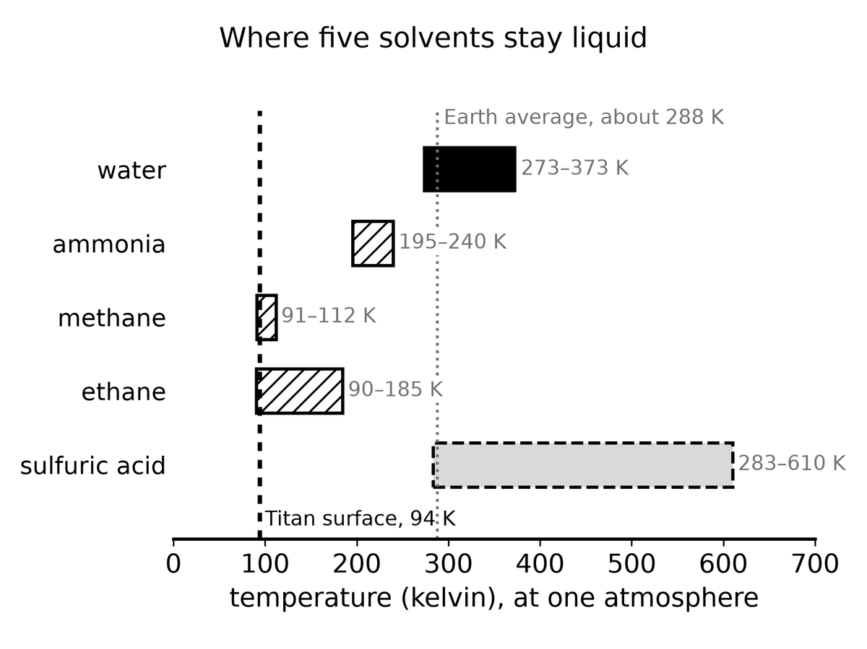
Figure 31. Liquid ranges at one atmosphere. Water is one solvent among several; Titan’s 94 K sits on the methane and ethane bars.
Then the rooms we call poison. Concentrated sulfuric acid, in a cloud deck on a world that cooked its oceans away, is liquid in a band where a probe could, in principle, get wet. Earth’s cells would die of thirst in a gulp — the acid is a dehydrator — which is the point. A solvent that is rude to us is not rude to chemistry. It is rude to our chemistry. Phosphine rumors in that sky were a courtroom, not a census. Titan we have tasted. The clouds we have argued.
Mirror life — the same trick, opposite handedness — is the scariest near-term maybe, because it could look like us under a microscope and starve in our kitchens, or poison them. A different set of amino acids, a six-letter script, a metabolism that treats arsenic as a feature: those are the other chairs. Sample size one does not get to fire them. It also does not get to print them as a zoo. Earth’s periodic table is a menu; evolution ordered from one column and stuck with the order.
Empty niches speed the hiring. After a dying, after a new island, after a new dark sea, after a cave that locked, after a vent that opened, whatever copies fastest and eats what is left will radiate. Generation time is the clock: bacteria can have a career in an afternoon; animals cannot grow new phyla by Friday. The real sentence is ruder and better: give a fast copier an empty room, and the room will not stay empty. A dark sea under ice, never photosynthesized, is such a room. So is a sealed cave, a lava tube, or the water between crystals. What gets hired there will not look like a textbook chapter. It will look like a solution.
Once a room is hired, the staff splits.
Give a species a mountain, a strait, a long coast, a million years, and the copies are no longer identical. Island finches. Cave fish that fired their eyes. Taxonomists used to stamp race on those piles — a subspecies, an ecotype, a local edition. The political word that stole the stamp is not a taxonomic rank. Human folk-races are a bad map of a young, well-mixed ape: most of the difference lives inside any crowd you pick, and the rest is a smear, not a set of boxes. Hot claim: population structure is ordinary. Warm claim: a second origin, given islands or a locked dawn-ring, will do the same and grow varieties you could sort if you had a week and a caliper. Cold claim: those varieties will reprint Earth’s census categories, or that “race” is a law of intelligence. Exobiology should expect smears, not our boxes.
Native is a date, not an essence.
Every lineage is an immigrant if you roll the clock far enough. The first cell in a pond was a native only because there was no one to sue. Starlings in America and rabbits in Australia are introductions. Some stay polite. Some eat the room. Invasive is what we call an immigrant that won too well. The library in Chapter 33, if it prints into a dark sea that already copies, is a conquistador. If the sea is empty, the same print is a first day of school. The look-first rule is the native/non-native distinction with a spacecraft.
Technosignatures — radios, city lights, industrial waste heat — are a thinner search. They assume someone invented shouting, and that the shout looks like ours. Most of the wet map, if it is wet, is microbes or missing forms or nothing. This chapter is the dirt, and the doors we never opened.
Appendix A31 writes Titan’s 94 K lakes, caves and vents, and why silicon-as-flesh and nitrogen-as-lunch stay cold. A second origin, a second dictionary, a second body plan: none of them would save us, and none would require a craftsman. All of them would say the filter has more than one hole, and that our hole was not the only cut. Hot: Earth’s history could have hired other shapes, and brain volume is a weak predictor of mind. Warm: other solvents, as chemistry on paper and in the lab. Cold: silicon flesh, a humanoid colleague, a city we would recognize from orbit.

32. Crews That Do Not Sleep
A trip to Mars is a year of your proper time if you are lucky and the window is kind. A trip to Europa is years, with a nuclear brick in the back and Jupiter’s radiation as a landlord. A trip to a large moon of a cold planet around another star is not a trip. It is a career for a civilization, or a nap that no flesh can take, or a crew that does not have a metabolism.
At a hundredth of light speed — already an aspiration that makes chemical rockets look like horses — the nearest other sun is four centuries away. At a tenth, it is forty years, plus the problem of slowing down, plus a grain of dust at that speed becoming an energy rumor. Flesh does not like forty years in a can. Flesh does not like four hundred at all. Generation ships are a story we tell to see if we mean it. Sleeping flesh is a story biochemistry has not signed.
Machines do not sign either, but they do not starve. An autonomous crew — processors, actuators, repair arms, a body that may look like a person because the tools were built for hands, or may look like a drill because the job is ice — can wait. It can coast. It can wake for a course correction every decade. It can arrive at a moon that has not heard of Earth in a thousand years and still know how to melt a hole.
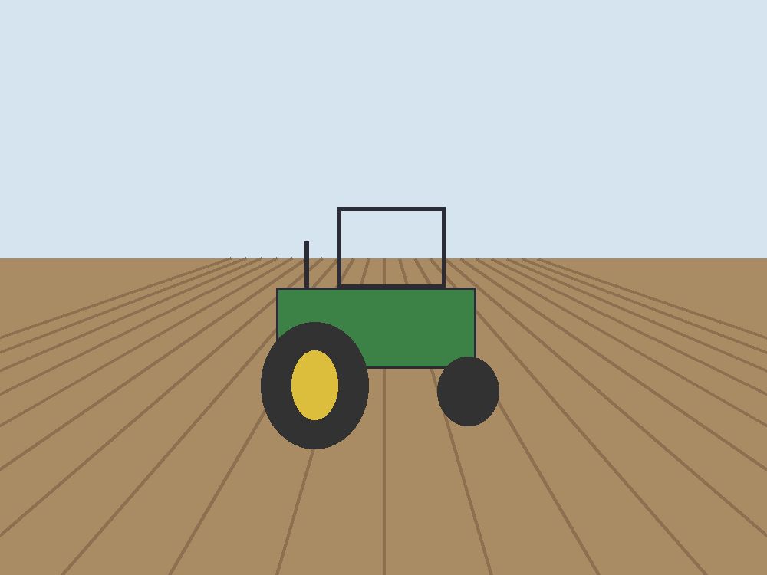
Figure 32. A tractor working a field, with no one you can see in the seat. Patience is the picture. The crew that can wait is that patience, off the Earth, with a spare for every bit the rays flip.
Call it AI if you want the current trademark. Call it a robot if you want the older one. Call it an android if the hull is a courtesy to human doorways. The physics does not care about the courtesy. The physics cares about joules per bit, about error-correcting memory against cosmic rays, about a reactor that still knows its job after a century of quiet. Appendix A32 writes the dose and the two speeds. Here, keep one image: a thing that does not sleep, hanging in the dark, carrying a library, aimed at a lid of ice.
The quiet is the job. Galactic cosmic rays — a drizzle of fast nuclei that no planetary magnetic mood is catching — punch bits all century. Unshielded flesh, in deep space, collects a career-limiting dose in a handful of years: tenths of a sievert a year, order of, enough to make a human worldline a bad hire for a four-century commute. The machine does not have marrow. It has parity, redundancy, a memory that expects to be wrong and keeps a spare. A grain of dust at a tenth of light is not dust. It is an energy rumor with a mass. Slowing down at the far end is a second fortune, as rude as leaving. Chemical tanks will not pay it. A brick that still knows how to be a brick after a hundred years of cold might.
Leaving is only half the fortune. At a hundredth of light speed, the energy stored in one kilogram is already a violent number. Appendix A32 writes the digit. You paid it to go. You pay a fortune of the same order to stop, or you arrive as a flash. There is no coasting into a polite orbit around a star you have never visited. The brake is a second departure, pointed the other way, and it has to still work after centuries of cold. Chemical tanks are a way to leave a planet. They are a poor way to throw that motion away at the far end. A brick that fissions, or a sail that can turn and take the destination star’s light as a headwind, is a sentence you are allowed to write. A sentence is not a tank farm.
Dust is the killer the posters draw as sparkle. A grain the size of a pollen mote, met at a tenth of light, does not bounce off a windshield. It arrives as a little explosion. The cruise does not need a mountain in the road. It needs a haze. A shield in front — a slab of something dull, or a cloud of grit you carry as your own bumper — is part of the crew. The shield will be holed. The holes are why the memory keeps a spare, and why the spare does not sit in the same drawer as the original.
Who fixes the fixer is the question the metal-person poster skips. A drill that can melt ice cannot, by that talent, replace its own bearing after a century. You send a shop: spare arms, a way to make a simple part from feedstock you carried, a test that says the new part is the old part and not a flipped-bit cousin. The shop is mass. Mass is the invoice Chapter 33 will refuse to let you spend on a flag. The cleverness is not a mind that founds a religion at the far end. The cleverness is a drawer of dull parts and a procedure short enough to audit before you leave.
Flesh has been offered three ways out, and none of them is signed. A generation ship hires children as the propellant: born, taught, buried, and the destination still a rumor for the first many lives. The teaching has to survive without the Earth that wrote the curriculum. That is a culture you are inventing, not a motor you are buying. Suspended flesh asks biochemistry for a pause it has not given large animals. A box of embryos asks for a nursery run by the machine, which is Chapter 33’s printers wearing a kinder name. All three still collect the dose if they ride awake in a thin can, and all three still owe the brake. The crew that does not sleep is what is left when you decline to hire a childhood as fuel. That crew is who covers the window Mara cannot stay for. Her afternoon is light-minutes. Theirs is centuries.
It wakes, if it wakes, for a star that has drifted, a gyro that has sulked, a bit that flipped and must be voted off the island. Then it sleeps again, which is a word for a low-power wait, not a dream. This crew wants a plug you can still reach from Earth for the first years, and then a set of orders dull enough that a flipped bit cannot found a religion. Chapter 29’s melt-probe is the same object on a shorter commute. Chapter 33’s library is the cargo that makes the commute worth the failure rate. Chapter 25’s greenhouse is the near ticket: a jammed door, a late radio, a potato.
This is not the Omega Point. It is not destiny. It is a project with a failure rate. The machine can miss. The ice can be thicker than the melt. The sea can be sealed from rock. The sea can already be taken. The project is still the way “long travel” stops being a poster.
A pattern engine that completes a sentence is not this crew. “AI” now finishes a phrase, folds a protein, aims a weapon, or lies with a straight face. That is already a fact. It is not a mind, and it is not a toy. “AI” on a century cruise is a control loop that must still make sense after decades of bit flips. We own the beginnings of the first. We do not yet own the second. Keep the plug in reach.
Will the first eat the species that built it? Take the keys? Be better? Three different questions. The posters fuse them. Ask what the device does, in a room you can walk into. Will it take over? is not a question until you say what takeover is — a board vote, a power grid, a goal that keeps itself on when you try to pull the plug. Is it better? is not a question until you name the task. Better at chess is hot. Better at being Mara in the greenhouse is a category error with a marketing department.
Two serious ideas about mind sit under the better-question, and they do not shake hands.
One says a someone is a pattern in matter. Computation is physical. Nothing in the block forbids a later architecture from being a someone. Nothing in the block requires it of a chatbot. A duplicate loop, if you ever had one, would be a second person, not a hop. Chapter 41 already refused the hop.
The other says a someone is not a program. A formal system cannot, from inside, certify every truth a mathematician can point at, and that incompleteness is used as a wedge: if understanding is the wedge, no stack of tokens is a mind, however fluent. A stronger version ties awareness to a collapse that gravity itself is supposed to finish. That is a minority research program. It is not helium. Appendix A41 keeps both morals of the same theorem. If the wedge is right, the century crew can still steer a melt and still not be a colleague. If it is wrong, a colleague remains a physical permission, not a press release.
The same theorem faces the other way, and Chapter 6 already used that face. Incompleteness can be how a formal system talks about itself and an “I” appears: a tangle, a translation, a map that contains the mapmaker. On that reading a pattern engine that completes a phrase is a very large parrot. A someone would be a loop that stays closed. We do not own that loop in silicon. The fight is unfinished. Neither chair is a license to send a cruise without a plug.
A goal that improves itself, and that we cannot switch off, is a warning rather than a theory of mind. Extra assumptions about speed and stable preferences turn the warning into a scheduled apocalypse. The Omega Point already tried to make a mind into a law of the future. The shove declined. Fraud at scale, a targeting loop that does not get tired, a design assistant for a plague, a civilization that lets the engine write procedures it then cannot read: those are hot as a class of misuse. Takeover by a new agent that treats us as the nest in Chapter 33 is an extra hypothesis. Treat it as an engineering fear for a reactor, a silo, or a century cruise. Do not treat it as a calendar.
Alignment is local control on one thread. It is not a destiny. Do not ask the tool to be better than a person at being a person. Ask it to be better at the task, and to stop when the task is done. A machine can wait. Waiting is not wisdom.
Chapter 33 is the box this crew would carry.
Appendix A32 writes the cruise times, the dose, and the temperature of the warning.

33. A Library of Earth
If you send a crew that does not sleep, send more than a flag.
Earth’s interesting inventory is not its iron. Iron is common. The interesting inventory is a trick of carbon and water that learned to copy, then to remember, then to write the memory down. The memory, at the bottom, is sequence. You can put a surprising amount of it into a box. A mountain vault holds seeds because mountains outlast ministries. A cruise to a dark sea puts sequence into a memory that expects rays, and into printers that must themselves survive the trip. Sequence without a kitchen is a book no one left standing can cook.
A human genome is a novella: a few billion letters, small once the repeats are compressed. A bacterium is a pamphlet, shorter by orders that Appendix A33 actually counts. A biosphere is a literature. The box that holds one ape, one crop, and a slogan is a vandal’s suitcase. What you want, if you are not a vandal, is a staff, named below, and a wet lab that can turn a recipe back into a membrane. The printers are kitchens. They are not magic. Appendix A33 writes the sizes and the protection categories.
What goes in the box is that staff, and the list is dull on purpose.
One human genome is a vanity. It does not farm a vent, fix a soil, or turn grit into a potato. A crop without the microbes that make the crop a crop is a poster of lunch. The useful list is long and unglamorous: a bacterium that eats rock and exhales a gas you can measure, a bacterium that makes a dirt, an alga that takes a dim light and does not demand a yellow sun, a yeast that will ferment what the alga leaves, seeds of a few plants that already know a winter, and the viruses of those organisms only if you have a reason you can say out loud. A reason you cannot say out loud is a souvenir. Souvenirs are how a suitcase becomes a vandal.
The printers are the part the poster skips, because the poster wants the letters to be the life. Letters are a recipe. A recipe needs a kitchen: the feedstock the script eats, membranes, salts, a temperature that stays inside a narrow sulk, a way to keep the wrong chemistry out. That kitchen has to survive the cruise Chapter 32 just priced. A hard drive in a heavy box is the easy kilogram. The wet lab is the rude one. It freezes. It sheds a film you did not order. It wants power in the year the reactor is quietest. If the lab dies, you have a literature and no cook. That is a museum. A museum is a decent building on Earth. Under an unread ice it is a failed errand.
Look first has a method, and the method is slower than a pour.
You taste before you seed. A plume, if the moon has one, is the cheap exam: molecules in a spray, no hole yet. A melt is the expensive exam: a thread through the shell, a sample that is not a puddle of your own machine. Chapter 29 already hired the thread. This chapter only refuses to let the library jump the queue. The exam can come back empty, and empty is allowed to mean “we did not see it,” which is not the sentence “it is not there.” Seed later means you wait until empty has been graded. Boredom is not a measurement.
Copying, inside the box, is not photocopying. A library that sits in a ray for a century will not be the library you sealed unless you kept the spares and the votes Chapter 32 already required for the gyro. A flipped letter in a navigation file wrecks a burn. A flipped letter in a genome wrecks a protein, or does nothing, or does something you will call a discovery because you were not there to call it a typo. Seal more than one copy. Store the copies in different drawers. Check them against each other before a printer is allowed to believe them.
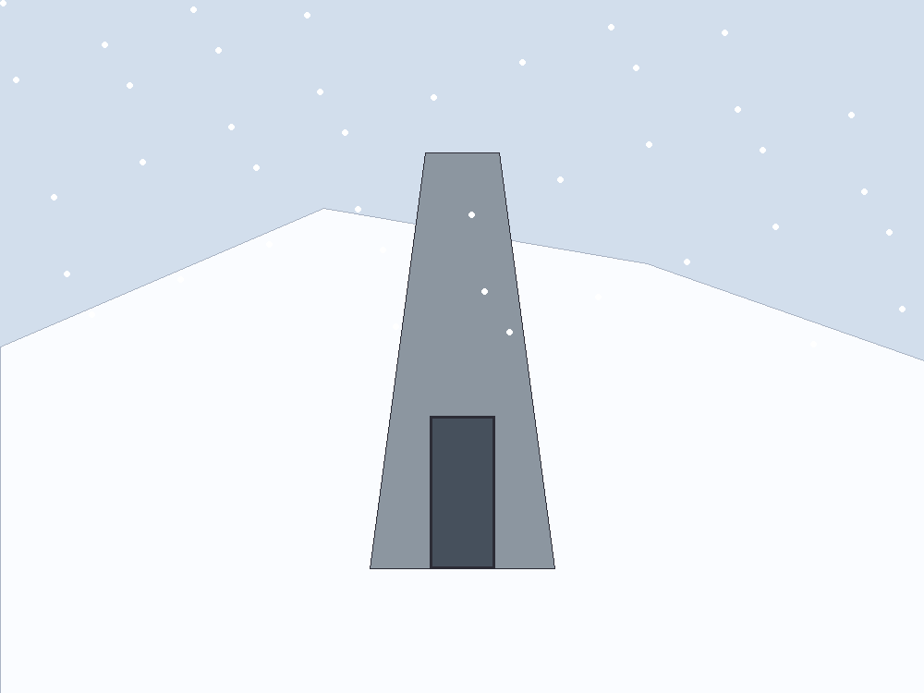
Figure 33. A vault door in snow. A library is a physical object.
Directed seeding is an old idea with Crick and Orgel’s names on one famous version: maybe someone already did this to us, or we do it next. Cold as a detection in our rocks. Warm as a project we might do, and therefore a project we can refuse. If Europa’s sea has a biosphere, our dirt is a conquistador. If it does not, the same dirt is a greenhouse. Chapter 29 already hired the rule. This chapter is the box the rule governs.
Would we know, if the pour had been ours, four billion years ago? The leftover glow does not say. The rocks of the first wet days are almost gone. What we have is one code, one handedness, and a chemical path that is incomplete and not empty. A serial number in the genome has been looked for by people who wanted to find it. What they found was mostly leftover we had misread. A seeder still needed a kitchen somewhere. The first hour does not disappear because a librarian arrived for the second.
Ants are the scale worth keeping.
A leafcutter city farms. It wars. No worker negotiates with us. We step over, or we study, or we pour. To a crew that crossed a century, an ape city may be that nest: impressive at its own size, not a colleague. Chapter 6 used the nest as a diagram of a self. Chapter 30 spends the same scale on a visitor who files the cars and misses the mite. Here the scale is a warning about the box. Talking is not what you do with a nest. Pouring is. If the printers work and the look-first failed, the box is the pour.
The printers cut the other way too. A wet lab that can make a cell can make a plague. Sterility is filters and assays, not a mood. The box is as dangerous as it is precious. A librarian who only loves the literature will pour. A librarian who only fears it will never farm a dead world whose exam is already empty. The rule splits the cases. Do not mix the folders.
The same rule runs back toward Earth, and the poster forgets that direction because the poster faces out.
A sample that might still be a kitchen does not come home in a pocket. It comes home in a box inside a box, opened in a room you can afford to throw away. Appendix A33 names the policy. You do not put an unread sea on the same bench as the basil. The crew that can wait is useful because waiting is the method. A schedule for planting a flag is how you fail it.
Mass is the only vote that counts on the day you leave.
A vault in a mountain is already a building, a staff, a power bill, and a politics. Put that vault on the cruise and you add the shield, the brick, the spare drawers, and the years of quiet. Every kilogram of literature is a kilogram you did not spend on the brake. The vandal’s suitcase — one ape, one crop, a slogan — is light, and light is its temptation. Light is not sufficient. Sufficient is a staff that can live in the trick the destination actually offers. A vent wants rock-eaters. A dim tray wants light-eaters that will not sulk for a yellow sun. Chapter 25’s dead greenhouse wants the potato and the microbes that make the potato a potato, because that exam was a close world with no sea hiding a second dictionary. Do not copy that shopping list onto a dark moon because the word “seed” felt brave.
Special relativity still makes the mail late. Quantum mechanics still makes the recipe a sequence of letters, not a spark. General relativity still refuses a handle unless someone pays Chapter 34’s bill. A being printed at the far end can look like a miracle to a city that did not own the printer. It is a miracle of logistics.
You do not pack a forest.
A forest is a queue. A film comes first. The film makes a dirt. The dirt holds a root. The root holds a shade the film never asked for and the later plant cannot live without. Print the later plant on the first day and you have shipped a corpse with a pedigree. Print the film, in a room that can stand it, and a queue can start. The box holds rungs, not the finished stair. The stair between the pamphlet and the ape is a staff, and the staff is what the departure has to lift.
The first rung should be an instrument, not a mascot.
A rock-eater that breathes out a gas you can see from outside the room is a measurement that happens to be alive. You chose it because the exam can fail in public. If the gas never comes, the printer lied, the room refused, or the recipe was the typo the spare copies were there to catch. Those are three different failures. A thing that looks like a pet and changes nothing you can detect will report success to the people who miss it. A gas will not.
The reader has to outlast the letters.
A vault you cannot open is geology. A file you cannot parse is the same rock with a prouder story. The script has to travel with a reader that still knows which mark is which after the ministry that wrote the labels is gone. Mountains outlast ministries, and ministries are who letter the drawers. Put two readers in two drawers. Put the key in a form a person can still sound out, not only in a format that dies with a company. The crew that does not sleep can keep a machine awake. It should not be the only speaker of the alphabet left on the cruise.
Chapter 31 already set a poison beside the gift. The life we know has a handedness. The mirror of it is a maybe, not a second Earth the box is obliged to carry. Packing both, because completeness sounds like care, is how a knife gets into the suitcase. An empty exam wants the trick we have actually run. A taken sea wants nothing this box can give. The mirror does not get a third folder in which the rule was shy.
A mountain outlasts a ministry. A cruise outlasts a body. Neither outlasts a mistake poured into a sea that already copies.
Appendix A33 writes the numbers.

34. Handles, and the Bill
Now the cheat.
A wormhole, in the only picture that does not lie, is not a subway. It is a handle on the loaf. Two distant regions — two spheres in space, if you want the honest shape — are neighbors by a short extra piece of geometry. You do not fly the long way. You fall in a sphere and come out another sphere. Light from the far side fills the mouth like a crystal ball. The mouth is not a manhole in a floor. It is a ball in a room.
Keep the ball. Posters draw a glowing ring on a wall, a door you step through like a cellar. The geometry that actually sits in the equations is spherical: a region of space whose interior is identified, by a short throat, with the interior of another sphere somewhere else. Walk toward the ball and the far kitchen swells in it, a crystal-ball picture made of real light taking the short way. Walk into the ball and you have not gone “through a surface into a tunnel painted on the wall.” You have fallen along a handle. Two places that were distant the long way are neighbors through the handle. If you cannot picture a ball, picture two mouths of a worm in an apple, except the apple is spacetime and the worm is a sentence we have not paid for.
Einstein and Rosen found a throat in the Schwarzschild geometry in 1935.⁵² It pinches. Nothing useful crosses. In 1988 Morris and Thorne wrote down a throat that stays open.⁵³ The price is matter that, in some frames, has negative energy density — exotic in the jargon, rude to the energy conditions that let Hawking and company prove their theorems. Ordinary stuff focuses. A throat that stays open must defocus. You are asking spacetime to do the opposite of what mass usually asks.
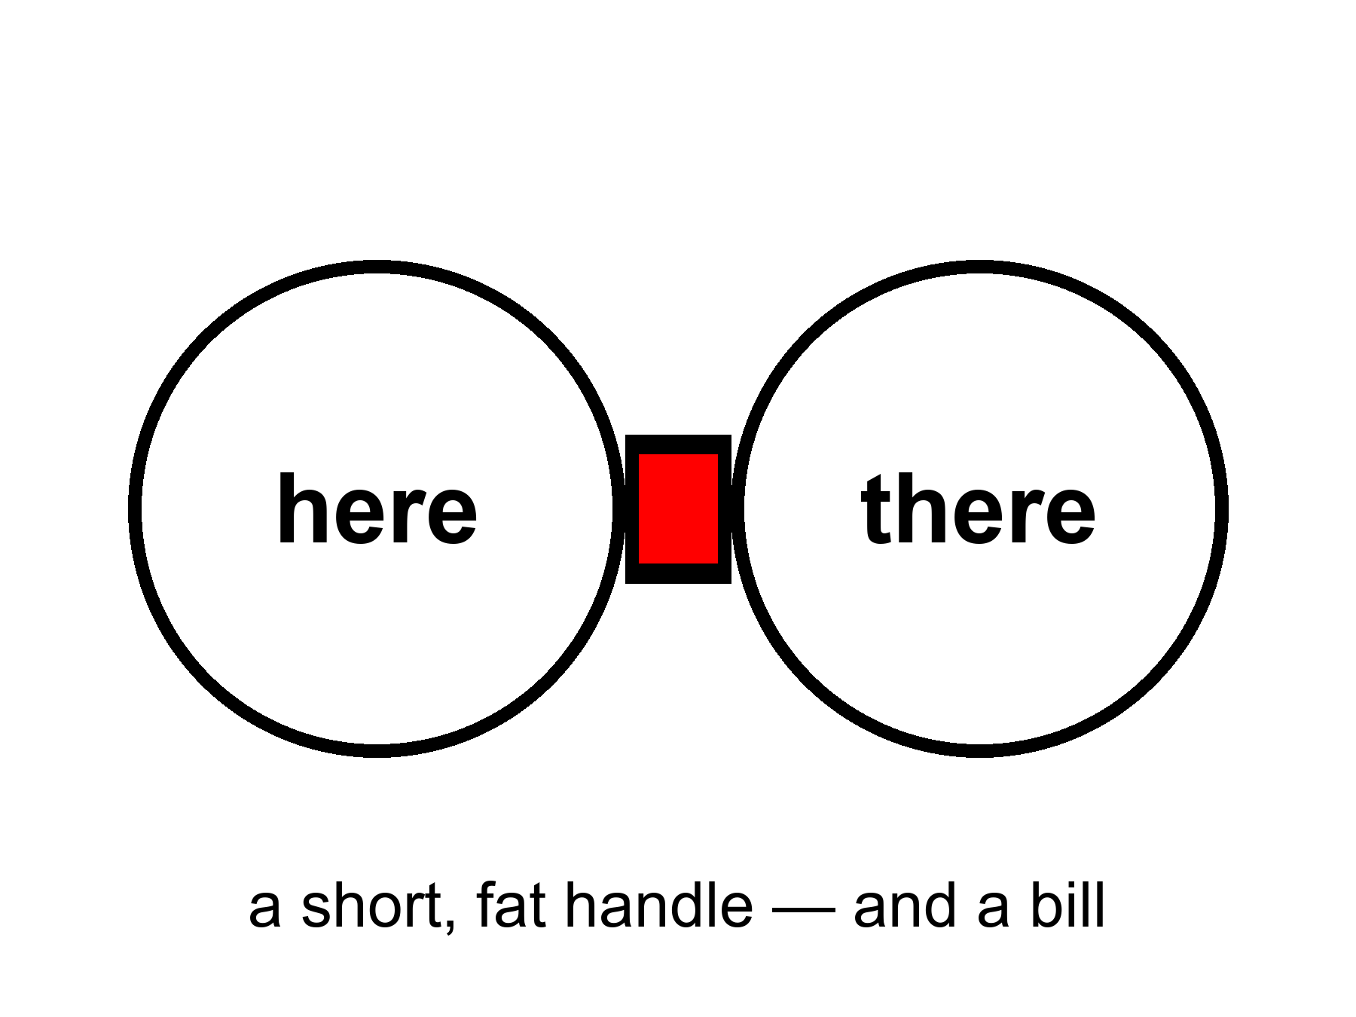
Figure 34. Two large circles joined by a short, fat handle: here and there. A wormhole would be a handle on the block, not a subway.
Quantum field theory allows small, brief negative energies. The Casimir effect, between two plates, is the laboratory ghost of that permission. Quantum inequalities then say you cannot pile the ghost into a ship-sized hallway and keep it on duty. The honest status: allowed as a sentence in general relativity; probably forbidden as a station in engineering. Appendix A34 writes the condition. We will not pretend a handle is a purchase order.
If a handle existed, it would not be a machine that “goes.” It would be a feature of the block, already there, the way 1914 is already there. Moving one mouth, if you could, is how people turn a handle into a loop, and a loop into a problem for the next part. First, pay the bill.
The bill is not in dollars. It is in a kind of stuff we have never stacked.
Ordinary mass, in Einstein’s theory, is a focusing lens for light. A bundle of rays that just grazes a star comes out slightly more converged than it went in. That is why Hawking and company could prove that, once focusing has gone far enough, a collapse has a point of no return: a singularity, or at least a place the theory itself will not describe. The null energy condition is the rule that lets the proof run. Spreading is a defocus. Defocus, in this ledger, is the rude stuff.
The null energy condition, a rule of thumb that ordinary matter respects, says that light rays, on average, get focused by stuff. A traversable throat requires a defocusing, a violation, along the hole. You can write solutions that do this. You cannot, today, point at a tank and say “that is the defocusing, please load it.”
Ford and Roman’s inequalities are the killjoys: the more negative the energy, the shorter the time you may have it, in a given volume. Macroscopic and long-lived fight each other. A ship-sized, hour-long throat is the kind of request the inequalities seem built to refuse. “Seem” is doing some work. The refusal is not a theorem about every possible spacetime. It is a strong hint from the quantum rules we actually use.
Is there a real way to go faster than light by bending the path?
There is a real sentence. There is not a real ticket.
Special relativity is a rule about the loaf’s local manners: nothing with a mass, in its own little room, outruns the light in that room. General relativity lets the rooms themselves be rearranged. You do not beat the messenger. You shorten the hallway. A handle does this by adding a shortcut between two spheres. A warp does this by squeezing space ahead of you and stretching it behind, so the destination slides toward you while you sit, locally, as if you were at rest. Miguel Alcubierre wrote that bubble down in 1994.⁵⁴ Inside, the tea does not spill. Outside, the geometry does the commute. Light still wins every local race. The arrival can still beat a light-beam that took the long way through unbent space. That is the whole trick, and it is not a cheat of Einstein. It is Einstein used as a contractor.
The contractor sends a bill we have never paid.
The skin of the bubble needs the same rude stuff as a throat: energy, in some frames, that is negative — a defocusing, a violation of the null energy condition, equation (17). Early estimates asked for a Jupiter of it. Later papers shaved the number by reshaping the skin. Shaved is not stacked. We have Casimir plates and other ghosts. We do not have a ring of ghosts around a cabin. Ford and Roman still mutter: the more negative, the shorter the time you may have it. A bubble you could live in, for the hours a star-trip would take even when the hallway is short, is the kind of object the inequalities seem built to refuse.
There is a ruder catch, and it is the one the posters skip. Bending the path usually means the path is already yours. The front of a warp bubble is, in the ordinary writing, causally disconnected from the cabin. You cannot reach out and steer a geometry you have not already laid. Turning the bubble on, from the inside, is like lighting a fuse that has not been strung. Someone — or some machine — has to arrange spacetime along the route first, or meet you from the far end, or leave a tube on an earlier, slow pass. Krasnikov’s tube is that last idea: go the long way once, leave a modified hallway, come home short. That is not a point-and-go. That is paving. Paving a century of route with exotic asphalt is not a smaller project than the cruise in Chapter 32. It is a larger one, wearing a faster hat.
If you could pave at will, you could also turn the pavement into a loop: two short hallways, badly timed, and yesterday is a stop. Hawking’s hunch from Chapter 36 is waiting there. The universe, asked to let you arrive before you left, may explode the pavement instead.
So the grown-up inventory is short. No local dash past light. No switch that nulls weight because you said so. A handle, a bubble, a tube: three shapes spacetime might wear, all of them sentences in a theory we trust in the rooms we have tested, all of them hungry for a stuff we have not stacked, all of them easier to write than to start from a cockpit. Mara, the melt-probe in the dark sea, the crew that does not sleep — those remain the transit system. Handles and bubbles stay in the appendix, where a bill belongs. The galaxies that have already left stay gone. A nearby ice, a nearby dirt, a nearby library: those are still in the cone.
Tea that does not spill inside a warp is a true sentence about a false ticket. Local manners can be perfect while the global commute is a fiction we have not stacked the matter for. The same is true of a throat that stays open on paper. The woman, the melt, the waiting crew: those are rude and finite. Rude-and-finite is the temperature of a real path. Handles stay in A34 with equation (17). Pay the bill there. Do not cash it in a cockpit.
Appendix A34 writes the flaring-out condition and equation (17). Here, keep the ball in the room and the unpaid invoice. The pinch is free and useless. The open throat is useful and not free. That is the whole cheat, priced.

35. The Watchmaker, and the Signal
When the basil lives and the ice melts and the leftover glow looks arranged, a temptation arrives: someone did this.
A slab that teaches apes to use tools. A gardener who lights a new star for a moon. A visitor who lands because we played five notes. Those are stories. They are allowed as stories. As physics they have a job they have not done: they must predict a signature we can miss.
A craftsman who wanted liquid water could have used starlight bands or tidal seas. We have both, and they look like maps, not signatures. A craftsman who wanted observers could have left a serial number in the leftover glow. The glow’s freckles look like stretched noise. A craftsman who wanted contact would not be limited to the speed of light, unless the craftsman is also a physicist with our constraints — in which case the craftsman is us, later, in a machine that does not sleep, and we are back at a project.
The oldest version of the temptation has a better address. It asks whether a river kingdom already knew.
Say the obvious first. Egypt knew the sky as a tool. They aligned million-ton tombs to true north within a fraction of a degree — not by luck, by stretching ropes and watching a star that does not travel far. They ran a calendar off the Nile and off the heliacal rising of Sopdet, the star we call Sirius, because a flood that feeds you is a clock you do not get to ignore. They had decans, surveying, a geometry that could lay a square on sand and make it stay. They wrote the work down. We have quarry marks, worker villages, a diary of a man who hauled limestone for a king. The stone did not arrive from another sun. It arrived from a quarry, on a boat, by people who were good at their job.
That is already a lot. It is allowed to astonish you. Astonishment is not a visitor.
What they did not know is the leftover glow, the shove, the block, the fact that Andromeda is a navy of suns. They had a sky full of meaning — a Duat, a night boat, an afterlife with a map — and meaning is a kind of knowledge. It is not the same kind as a microwave temperature. A culture can be brilliant at north and still not own cosmology.
The sermon that follows is the one that steals the work. Someone must have told them. The shafts point at Orion on purpose as a physics lesson. The ratio of the base to the height is a message about circles that only we can read. Some of the numbers are real: a seked, a cubit, a slope you can repeat. Some are what happens when you go looking for π in any pile of well-cut stone. Selection is a craftsman too. Shafts that face a northern star are what you get if you care about the unmoving sky and you have a burial to aim. They are not a telegram from Chapter 8.
Then there are the lights.
Not the leftover glow. Lights in this air. The temperature is locked before the stories: a residual in serious instruments can be hot as “something was there”; every name for it — ours, secret; someone else’s workshop; a colleague — stays cold until hardware you can hold, or a channel nature does not use, is on the bench.
Something is there. Not in every backyard video. In the stubborn cases: a carrier group, a spy radar that had been seeing “things” for days, two navy pilots who flew up to a pale lozenge with no exhaust, no rotors, no thermal plume, and watched it stay in the wind over a disturbed patch of sea, then leave in a way their jets do not leave. A targeting pod wrote an infrared tape. The navy later let the tape out of the bag, stood up an office, and printed the dull word unidentified. That sequence is not a campfire. It is what a serious institution does when its own instruments have leftover.
What did they film?
They filmed an object, or a phenomenon that holds still long enough to be an object. Infrared is a thermometer with a zoom, not a novel. Without a range, a small drone nearby and a large hull far away wear the same pixels; a turn of the pod can look like a miracle. Some of the later famous tapes really are that kind of homework: glare, parallax, a balloon that was never a visitor. Admit those too. The best case is not those tapes. The best case is the day the radar, the eyeballs, and the camera were all pointed at the same leftover, and the leftover did not fly like an airplane. You can argue about the last burst of speed. You cannot honestly argue that nothing was there.
Two other obvious things.
If the leftover is ours — a classified drone, a test article, a trick of electronic warfare — then someone already builds machines the briefing does not mention and flies them near nuclear carriers. That is remarkable even if it is dull. If it is another flag’s, it is the same sentence with a worse budget meeting.
If it is not a known workshop, then “I don’t know” is the grown-up line: a real residual with bad range and no wreckage. The job is to stay in the residual without hiring a priest or a joker.
The pilots are not the problem; they saw a thing in a place they are paid to see things. The leap is “therefore a face, a future, a hop.” Chapter 31 already fired the face as a default.
So: where would it come from, if the leftover is a vehicle we do not own?
Our own future. If a later crew could ride a loop, the visit was already in the inventory; Chapters 36 and 37 will not give you a sandbox. And buzzing a fighter jet is a strange errand for a civilization that can borrow yesterday. Cold.
A parallel world. Everett’s branches, if that reading is right, are inventory, not a ferry (Chapter 41). Cold.
Our past. A gardener who came, left, and forgot to number the rocks is the watchmaker again; the rocks look like rocks. A secret workshop in this century is the warmer past: last Tuesday, classified on purpose. Dull, allowed, and sometimes the best fit for a leftover that looks like a machine and shares a range with a navy.
Another planet, traveling forever. The least rude extraterrestrial sentence, and it still pays Chapter 32’s bill: a crew that does not sleep can spend centuries and arrive. Why this air, this decade, and no wreckage, no radio, no serial number? Fair questions, not a proof of absence. The Fermi quiet — if the sky is full of travelers, why is the mail this bad? — is a smell, not a gavel. Warm as a project the universe permits; cold as a name on the tape.
Beamed. A recipe sent at light still needs a printer on this end — Chapter 33’s library, a box we would notice in a field — and a handle still owes the exotic-matter bill. Cold.
A thought without ears. A schoolyard, a crowd of children, a craft on the ground and a message behind the eyes. Many children, the same morning, described the same thing in the same dirt. Something happened in that yard. Children are an instrument without a rangefinder and with a powerful need to agree; memory is social, and expectation is contagious. None of that makes them liars, and none of it hires a new force. Telepathy has never shown up in a lab where it could be missed. Cold as a mechanism. The schoolyard remains a human event we have not finished explaining.
Do quantum mechanics and relativity play a role? Yes — as bills, not as costumes.
Relativity makes a seeder’s mail late and keeps a handle, a warp, or a nulling of weight from being a switch; the one warm “future-us” it permits is a twin who went fast and came back younger — a Chapter 32 cruise, not a raid on yesterday. Quantum mechanics forbids a schoolyard radio (the no-signaling theorem is a killjoy with a proof), and “they vibrate at a higher frequency” is not a sentence in the theory. The two theories do not yet share a foundation. That hole is real. It does not fill in a gardener or a leftover in a dogfight.
What would count, if you are not here to be thrilled?
Hardware you can hold, with isotope ratios and a microstructure Earth does not pour. A trajectory, range-complete, that violates the energy a craft that size can carry — and still looks the same when three instruments that are not friends agree. A message in a channel nature does not use. We do not have those yet. What we do have, in the stubborn files, is already enough to forbid two lazy sentences: nothing happened, and so it was a person from another world. The leftover is obvious. The name is not.
Why did a legislature suddenly want a hearing?
It was not sudden if your file starts in 1947. It was sudden as a public, funded, unembarrassed residual. In 2017 a newspaper printed a Pentagon office that had been buying the question. In 2020 the Pentagon formally released the tapes. In 2021 the intelligence community published the assessment Congress had ordered. Hearings followed. A majority leader put disclosure language in a defense bill and watched it thin out in negotiation. That is not a conversion to a colleague from another sun. That is what a state does when three boring fears line up.
First: air domain. Drones, cruise missiles, hypersonic tests, someone else’s homework in a range you thought you owned. A leftover that can sit over a carrier is, if it is a machine, already an operational fact. Stigma — the joke that used to keep pilots quiet — is, in that light, a security hole. Second: oversight. Classified programs live in the same sky. A congress that cannot tell a leftover from its own black budget is a congress that is being managed. Third: nuclear nervousness. Reports that cluster near weapons and reactors are, even when they are noise, the kind of noise a committee is paid to hate.
Some members want the other caption. Testimony has been given, under oath, of retrievals and of craft that are not ours. Testimony is a record of a claim. It is not a hull on a bench. Appendix A35 still wants the isotope. Admit the obvious without the choir: Congress got interested because the leftover entered institutions that can be embarrassed, in a decade when being surprised in your own air is a career-ending sentence. That is smarter than an awakening and ruder than a debunking. It leaves the stubborn files where they were — unnamed.
If someone else has a radio, the radio is late.
A yes-or-no from the nearest other Sun is eight and a half years of round-trip at light, if they answer on the first try, if they listen our way, if they exist. A conversation is a career. A conversation with a tidal sea’s inhabitants, if they have not invented radio because they have not invented eyes, is a melt and a guess. SETI is a search for a very specific kind of waste heat and timing: someone who learned to shout in electromagnetic. Most of the habitable map in Chapters 27 and 28 would not shout that way.
The shout, if you want a picture of a missable one, is not a hello in English. It is a channel nature does not use: a narrowband whistle, a timing that is not a pulsar, a modulation that looks like a prime because primes are a habit mathematicians share and rocks do not. Drake’s famous product is a parameterization of ignorance — a row of fractions we have not measured, multiplied until they look like a population. It is not a census. It is a list of things a dish cannot yet count: how many rooms are wet, how often wet becomes a trick that copies, how often the trick learns to shout, how long the shout stays on. The dish is still the clean search. Clean is not complete.
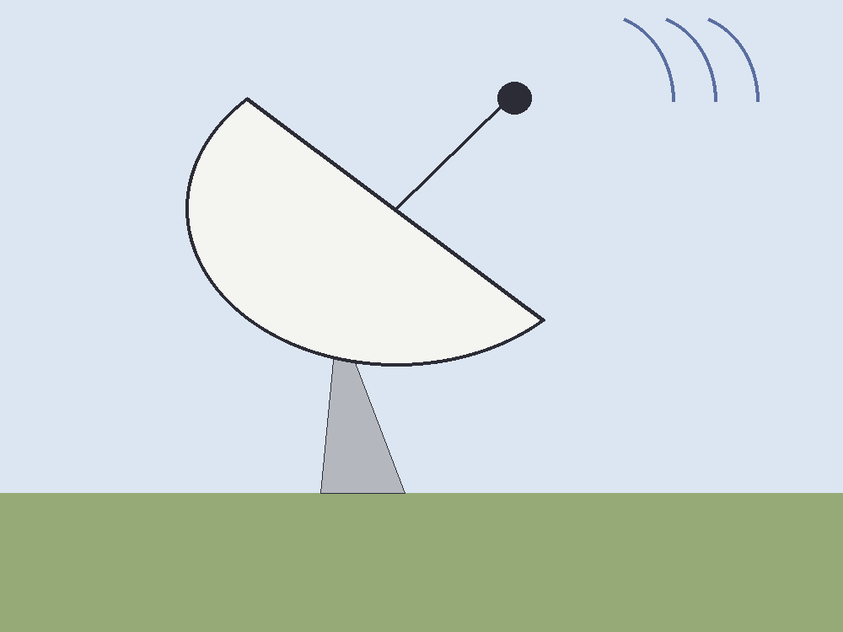
Figure 35. A radio dish with ground in the frame. A signal is light, and light is late.
A signal is not a savior. It does not fix the shove or open a handle. It is a fact about another worldline, arriving late, the way Andromeda’s navy arrives late. If we ever hear one, we will not have been rescued. We will have been informed that the trick of carbon and water happened twice, or that a machine that does not sleep learned to shout.
Until then we have a greenhouse, a dark sea, a library, and a delay. That is enough to be getting on with. It is already a better story than a door. Chapter 42 is where this watchmaker meets the filter and is refused a hire. The six chapters between are copies and loops. They do not reopen the signal.

PART VII — Loops

36. Time Travel Is Not an Edit
The kitchen fantasy of time travel is an edit. You go back, you unsay a sentence, you save a person, you kill a tyrant, you step on a butterfly, and history rewrites. Relativity does not hand out rewrites. If spacetime contains a path that arrives at an earlier event, the event was never waiting to be changed. It already includes whatever the path did.
An edit would be a second history, or a machine that erases events and writes them again. General relativity does not own that machine. It owns a geometry of events and a rule about which events can influence which others. A worldline is a set of those events. If the set meets itself, the meeting is one of the crumbs. It is not a revision of the crumbs.
This is the Novikov habit, and it is the only habit that does not set the block on fire. A loop is a consistency condition, not a sandbox. The watch you leave in a drawer in 1989 is the watch you will find because you left it. The message you scratch into frost on a greenhouse pane is the message that was always on the pane in that event. You do not get a second pane.
Igor Novikov, in the 1980s, said this with a physicist’s lack of drama, and a 1990 paper with colleagues showed how it works for billiard balls fired into a wormhole time machine.⁵⁵ If a closed timelike curve exists — a path that stays inside its own future and arrives at its own past — then the only histories with nonzero weight are the ones that fit. A paradoxical history is not a thriller. It is a configuration the equations refuse to count. The principle is not a policeman who jumps in at the last second. It is bookkeeping: the probability of an inconsistent loop is zero because an inconsistent loop is not a solution.
The kitchen version sits on the glass.
She comes into the greenhouse on a cold morning and the inner pane is already written. The letters are her letters. The sentence is a pH, a date, a warning about a pump. She has not written it yet, as her watch tells it. She will write it, because she found it, and because the frost will take a finger. The pane is not a suggestion. It is an event. The writing and the finding are two stretches of the same thread, or of two threads that meet at the glass, and both stretches were always there. She does not get to wipe the letters and invent a kinder pump. She gets a finger, and a pane that was never blank in that event.
People hate this because it feels like a trick. It is the opposite of a trick. It is what “the inventory is events” was always going to mean once you allowed a worldline to meet its own past. The choosing is still a stretch of thread. The stretch, if it loops, was counted once.
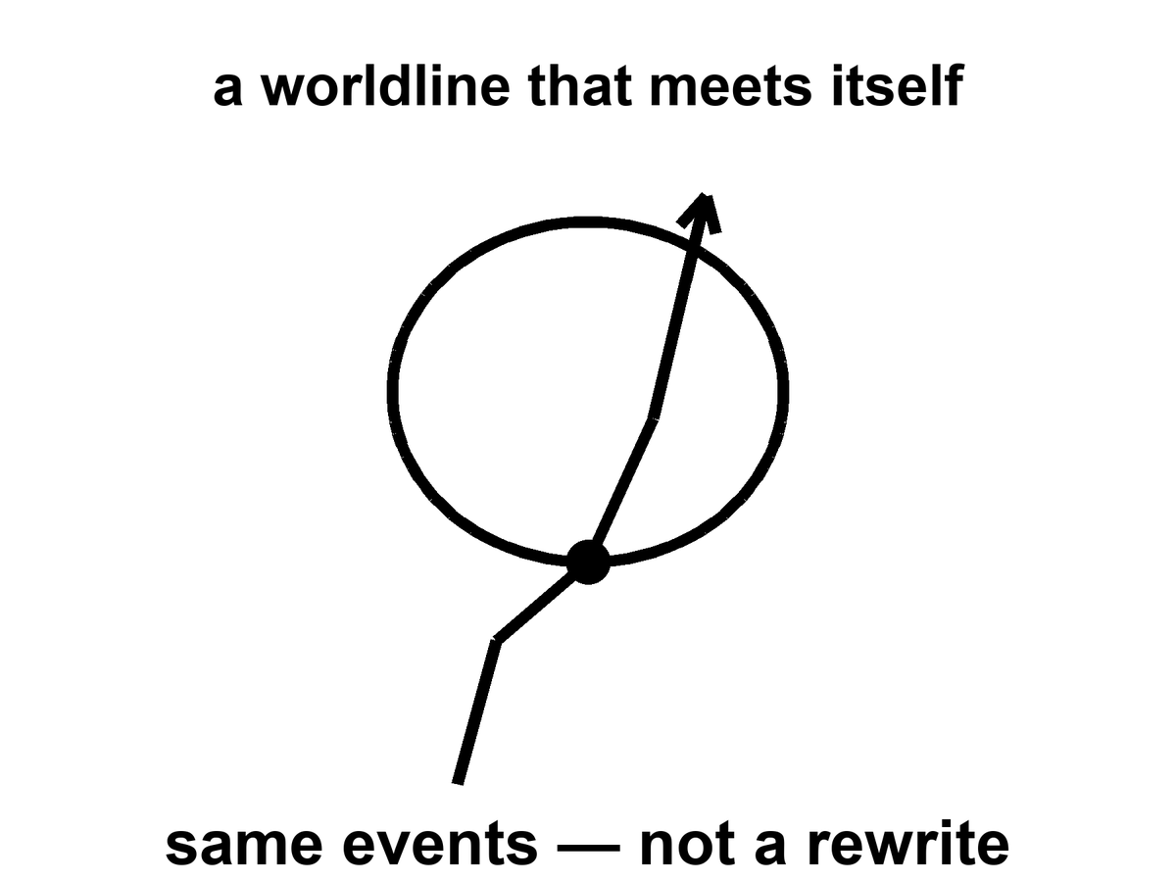
Figure 36. A worldline that meets itself. Same events, not a rewrite.
Mara cannot radio yesterday. She can hear twenty minutes ago, which is rude but not looping. The machine that does not sleep, falling toward a star for four hundred years, cannot mail a warning to its launch. It can arrive, melt, look, and send a letter that will be read by people who have never met the launch crew. That is not time travel. That is the ordinary lateness of light, stretched over a career. Late is not yesterday.
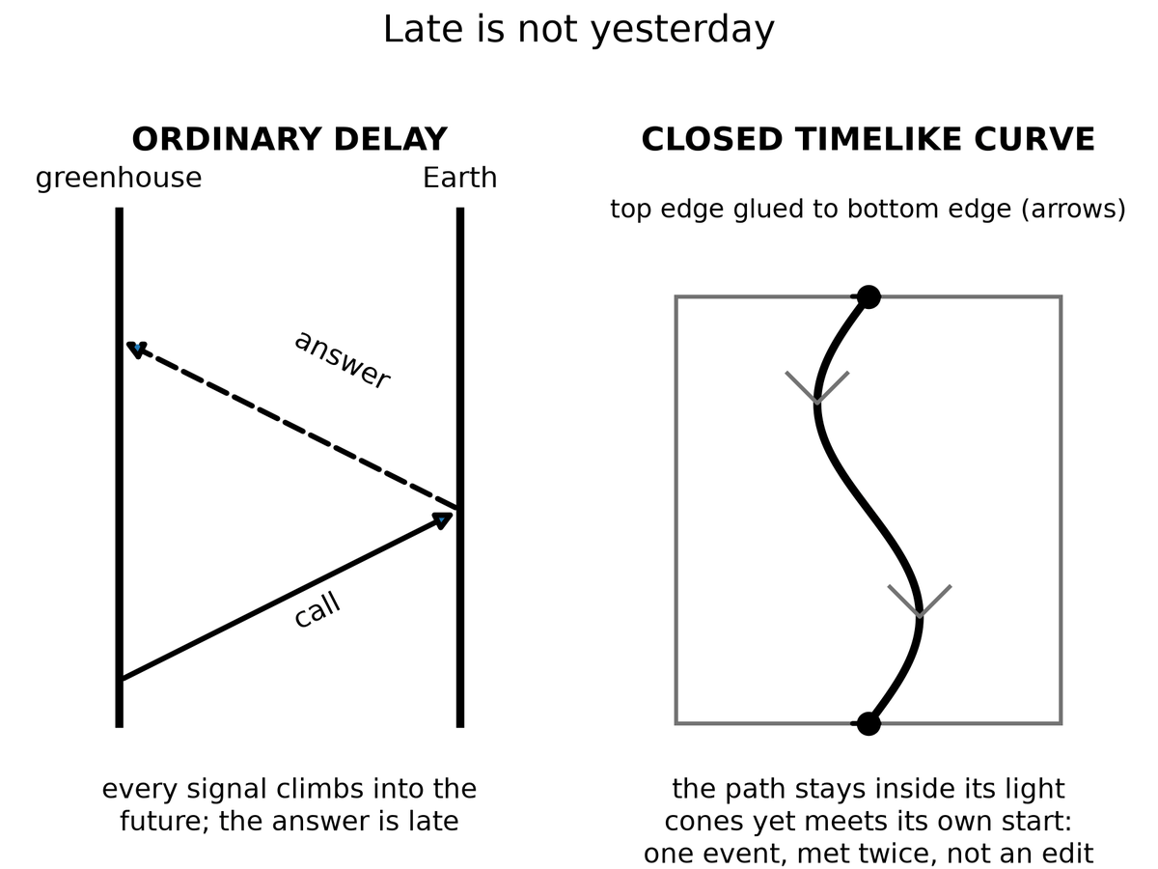
Spacetime Diagram 5. Late is not yesterday. Left: an ordinary delay; the call and the answer both climb into the future, so the answer arrives late. Right: a closed timelike curve; the path stays inside its light cones everywhere and still meets its own start, one event met twice, not an edit.
Yesterday, in the greenhouse, is a set of events in her past light cone. A radio wave she emits today leaves along her future cone. That cone does not include yesterday’s workbench. A loop would require the signal, or the sender, to arrive at an event already in the sender’s past. It has delay. Delay is Chapter 3, scaled to a dead world. It is not a closed curve. The four-hundred-year cruise is the same lesson with worse manners: launch and arrival are two events on a long worldline, not a loop. The arrival cannot warn the launch because the launch is not in the arrival’s future cone. The letter, if any, is news. News is late. Late is not yesterday.
If you want the edit, you need a different history — a branch, a copy, a hop. The copies chapter will give you inventory and still refuse the hop. There is no known door from this thread to a thread where the basil died and you would like a second try. Grief is a fact about one worldline. It is not a user interface.
Are loops even allowed?
In special relativity, no: flat spacetime is too stiff. Flat spacetime is a flat block. Timelike curves in it do not close. You can ride forever and you will not meet your own morning. Trouble about when is not the same as a ticket to then.
In general relativity, sometimes, on paper. Kurt Gödel found a rotating universe in which you can ride a closed timelike curve⁵⁶ — a path that stays inside its own future and arrives at its own past. Our universe is not Gödel’s. It does not rotate that way. Kerr’s spinning hole, if you could go through the interior in the idealized math and if the interior were not a chaos of instability, offers rings that loop. Wormhole mouths, if you could move them, can be turned into a time machine: park one, fly the other on a fast trip, bring it back, and the clocks on the mouths no longer agree in a way that lets you leave today and arrive last year.
Take those three sentences apart. They are not a brochure.
Gödel’s 1949 cosmos is a solution of Einstein’s equation filled with rotating dust. Every event, in that geometry, sits on a closed timelike curve. You could, in the math, leave a kitchen, fly a long way, and arrive before you left, without ever exceeding light locally. It is a marvel of a metric and a poor map of home. Gödel’s universe does not expand the way ours does. It has a global rotation our leftover glow does not show. The microwave sky is even to a part in a hundred thousand. A Gödel twist of the size that would let you loop would have written a louder signature than that. Hot claim: we do not live in Gödel’s rotating dust. Cold claim: somewhere, in some other solution, such dust is a universe.
Kerr’s spinning hole is closer to furniture we actually own. Stars rotate. The holes they can become rotate. The exterior of a Kerr hole is a working theory with shadows and rings and LIGO chirps to its name. The interior, in the full analytic extension, is a different room. Inside the inner horizon — a Cauchy horizon, a surface beyond which spacetime stops being predictable from the outside — the idealized math offers closed timelike curves around a ring singularity. Tourists love that sentence. Physics does not. The inner horizon is unstable. Matter and radiation falling in get blueshifted without mercy. The technical name is mass inflation:⁵⁷ the horizon becomes a wall of energy, and the pretty extension is not a hallway. A hole made by a collapsing star is not the eternal, vacuum Kerr solution of a textbook. Even on paper, “go through and loop” is a sentence about an object we have not got. Warm claim: spinning holes exist. Cold claim: their insides are a time machine. The insides, as far as the instability arguments run, are a place the theory we trust stops being a guide.
Wormhole mouths are the kitchen trick people actually try to draw. Chapter 34 paid the bill for a throat that stays open. Suppose, against the inequalities, you have two mouths. Park one in the yard. Fly the other on a fast cruise and bring it home. The twin effect of Chapter 5 is waiting: the flown mouth accumulates less proper time. The clocks on the two spheres no longer agree. After enough mismatch, a path that enters the young mouth and leaves the old one can arrive at an external clock reading earlier than the departure. You have not outrun light in any local room. You have used a handle plus a twin-clock cheat to fold spacetime until today touches last year. Morris, Thorne, and Yurtsever wrote the operation down.⁵⁸ It is a recipe for a chronology horizon, not a recipe for an edit.
All of these are sentences in a theory we trust in the rooms we have tested, used in rooms we have not. None of them is a photograph. None of them is a ticket.
Appendix A36 names the metrics. Here, keep one picture: a loop is a shape the loaf might have, locally or globally. It is not a machine you bolt on. If the shape is there, it was there. If it is not, you cannot will it into an edit.
The grandfather “paradox” is a complaint about edits. In a consistent loop, you do not kill the grandfather in a way that prevents the loop. Either you fail, or you are not in that story, or the story was never the one you thought. This is unsatisfying as drama and perfect as bookkeeping. Drama wants the rewrite. Bookkeeping wants the inventory.
The complaint sounds like a riddle because it assumes a draft: you exist, therefore the grandfather lived, therefore you cannot have killed him, therefore contradiction — or else a branching, or else a policeman. Novikov’s answer is duller. There is no draft. A worldline that both requires the grandfather and removes him is not in the sum. The failure is not a moral. It is a zero in the measure. You trip. The gun jams. You are the descendant by a route the riddle did not budget.
Why may the universe forbid them?
The chronology-protection conjecture is a hunch with a pedigree: the universe, when you try to build a loop, fights back. Vacuum jitters near the would-be time machine grow. The throat, if a throat is involved, blows. The Cauchy horizon — the surface beyond which prediction dies — becomes a wall of energy. You do not get last year. You get a bang.
Stephen Hawking wrote the hunch down in 1992.⁵⁹ Near a forming chronology horizon, the vacuum’s stress-energy tries to diverge. The machine, in this picture, destroys itself with the same jitters that make black holes glow. Chronology protection is not a theorem. It is a conjecture that the divergence is generic, that nature does not let you finish the wormhole-clock trick, that Cauchy horizons in this role are walls rather than doors.
Hot: flat spacetime does not loop, and we have never photographed a closed timelike curve. Warm: general relativity admits looping metrics; the ones that look like ours do not wear them in the rooms we can see. Cold: you could build a time machine if you stacked exotic matter and survived the vacuum. Hawking’s hunch is the grown-up cold: maybe you cannot, because the stacking asks the field to explode. Do not confuse a solution of Einstein’s equation with a launch window.

Physics vs philosophy: from general relativity to time machines
What the evidence establishes. General relativity passes every test we can give it, from clocks on towers to black-hole shadows and merger signals. No closed timelike curve has ever been observed, and the leftover glow rules out a Gödel-style rotation of our universe.
What the theory allows on paper. Exact solutions with loops exist (Gödel’s dust, the idealized Kerr interior, wormholes with moving mouths), but each needs a global rotation we do not see, an interior that is unstable, or negative energy in amounts quantum field theory seems to forbid.⁶⁰
The strongest rival view. Some physicists take loops more seriously than this chapter does. David Deutsch showed that quantum mechanics can be made consistent on a loop by letting the loop pick out a self-consistent quantum state, so paradoxes dissolve without a policeman.⁶¹ What it gets right: consistency, not prohibition, is the real constraint. Why this book still does not book a ticket: Deutsch’s model assumes the loop already exists, and nothing in it pays the energy bill for building one.
What would change the verdict. A full quantum theory of gravity that either proves chronology protection or shows a loop can be built and survive.

If the hunch is wrong, the block contains shapes that arrive before they leave, and the kitchen argument about “now” was only the beginning of the trouble. If the hunch is right, nature is stubborn about order along worldlines that matter, and time travel remains a sport for metrics, not for crews. That is a practical mercy.

37. If You Could Walk Sideways Through When
Suppose, as a thought, you could leave your worldline and walk across the block, as if time were a hallway of rooms, each room a now, each now a place you could enter and leave.
You would not be editing. You would be visiting. The childhood kitchen would be a room. The greenhouse would be a room. The dark sea under Europa’s ice, on a particular Tuesday of a particular millennium, would be a room. You could push a book, raise a dust of frost, encode a pulse in a watch. Those events, if they are in the block, were always there. Your walk would be another thread, weirdly oriented, already counted.
Stay in the thought long enough to feel what the permission would actually be.
You step off the thread you have been calling a life. The loaf, which Chapter 6 treated as inventory, becomes furniture. You are not a passenger in a river. You are a visitor in a house that was never sequential except along the paths that live in it. The first room you try is the one grief already named.
A childhood kitchen. A kettle that has not yet learned the house. A window with a frost that is not the greenhouse frost, earlier, kinder. A child at the table is a bundle of worldlines that will, later, include you. You are not that child. You are a later stretch, illegally sideways, looking. If the walk is real, the looking is an event, and the event was always in the room. The child does not acquire a new memory because you arrived. You do not get to pick a different kettle. You get to stand in a room you cannot rent.
You could push a book on a table in 1914. You could encode a pulse in a watch in 1989. You could meet your own later face in a corridor that, along ordinary worldlines, is a lifetime away. Each of those is a crumb. Each crumb, if the walk exists, was counted. The walk does not add a second inventory. It adds a weirdly oriented thread to the one inventory, the way a worm through bread is still bread.
From this illegal hallway you could look at the leftover glow edge-on: not a sky, a slice, a last-scattering surface as a wall in the house. You could see the three minutes as a thin, hot room near one end of the block, and a sparse, shoved-apart web of galaxies as a later furniture. It would still be a view from a path, not a god’s-eye. Even a sideways path has a proper length. Even a visitor accumulates something. The something would not be the time your kitchen clock named. It would be whatever parameter the new thread used for mileage. The block does not owe that parameter a name you already like.
This is the block made into a set of furniture. It is useful as a picture and false as a permission. We do not have a sideways walk. Our worldlines are nearly parallel, locally, to the time directions the leftover glow picked out when it last scattered. We go from event to event the long way, accumulating proper time, eating basil, dying.
The permission is the part that has to be taken away, slowly, because the picture is so good at lying.
You cannot walk sideways through when. “When” is not a corridor. It is a way of ordering events along a thread, and a way of slicing spacetime for the convenience of a clock. The slice is a choice. The thread is a fact. Confusing the two is the whole of this chapter.
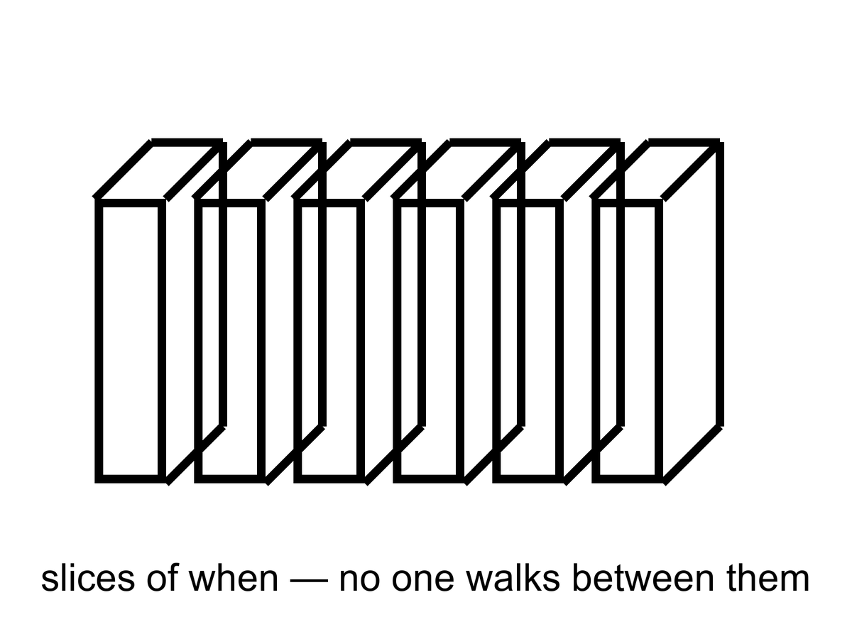
Figure 37. Slices of events, stacked like pages. No one walks between the slices.
Foliations — the technical name for slicing the loaf into “nows” — are a choice, not a hallway. Appendix A37 says why a stack is not a corridor. A foliation is a stack of three-dimensional surfaces, each surface a candidate for “the world at a given time.” Relativity does not pick a preferred stack. Cosmology, when it needs a bookkeeping time, hires the leftover glow: the surfaces on which the microwave sky looks as even as it can. That hire is a superb convenience, not a set of rooms with doors between them.
A stack of pages is not a building you can wander. You can put a finger on page 12 and a finger on page 400. You cannot walk from 12 to 400 except by reading, which is the analog of accumulating proper time along a worldline. The reading is a path in the book. The stack is a filing habit. Appendix A37 is the note that says this in the language of embeddings and leaves. Here, the sentence is shorter. A foliation is how you file the loaf. It is not how you travel.
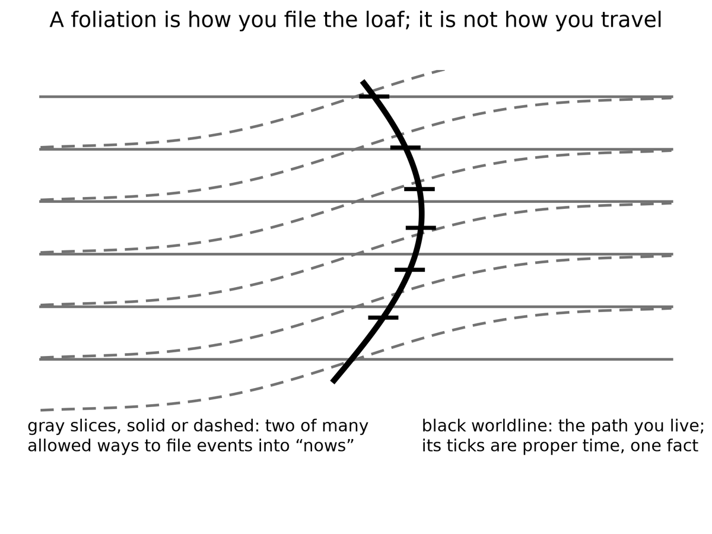
Spacetime Diagram 7. A foliation is how you file the loaf; it is not how you travel. Gray slices, solid or dashed, are two of many allowed ways to file events into “nows.” The black worldline is the path you actually live; its ticks are proper time.
The stack invites a second myth, and it usually arrives with a number. Time, the story goes, is a flip-book. Each page is one Planck time thick, about 5 × 10⁻⁴⁴ seconds, and the universe turns one page per tick, everywhere at once, like a projector with a cosmic shutter.
The projector fails three ways. First, nobody has found the pages. The Planck time marks where our equations expect to need quantum gravity. It is a warning on the map, not a measured grain. In 2009 a gamma-ray burst seven billion light-years away delivered its high-energy and low-energy photons within about a second of each other, which is not what the simplest Planck-scale grain, one that slows the short waves, would do.¹⁵ Second, a universal shutter needs a universal stack, and Chapter 1 already took that away. The person standing still and the person walking toward the table slice spacetime differently, and neither slicing is the one true deck. A projector needs a throne to stand on. Third, the configurations do not come as a finite deck of frames. In every theory that has passed a test, positions and fields vary smoothly. Between any two pages you can always fit another.
So the flip-book is a filing habit drawn as if it were a machine. Hot: no measured Planck tick. Warm: the Planck time as the place our equations stop vouching for themselves. Cold: a future theory might make time grainy in a subtler way, with no shutter and no favorite slicing. Even then the grains would not be a film someone is running. They would be one more fact about spacetime.
A coordinate labeled t on a map of spacetime is a filing number. It is useful. Cosmology uses it so that “when the universe was 380,000 years old” has a meaning on the leftover-glow slices. Your watch does not read that filing number. Your watch reads the length of your thread. Mixing the two is how a hallway gets invented.
Grief already knew.
The childhood kitchen is a room you cannot rent. It is a cluster of happenings, related by light and soup and a kettle, occupying a region of the block. You cannot go there as a visitor. You can remember it, which is a present event that points, by a causal chain of traces, at past events. Memory is not a hallway. It is a record, the same family of fact as a silver grain or a helium nucleus, written on a later stretch of thread. The later stretch does not get to move in. The kettle is not waiting. The kettle is an event that has, from the later vantage, already sat in its region. “Already” is a word the later thread is allowed. The block does not need it.
Hope is the same furniture with the sign flipped. The greenhouse’s later Tuesdays, the melt-probe’s maybe-taste, a library that arrives or does not: those are regions too. You cannot skip ahead into them any more than you can rent the kettle. You can occupy the next stretch of thread, do a project, and leave a record. That is the only method the geometry permits. It is slow. It is not a small thing. It is the thing.
Hot: you have a worldline, a proper time, and no measured hop onto a neighboring slice. Warm: the block is this book’s working interpretation of a theory that GPS tests daily (GPS tests the theory, not the interpretation), and foliations are bookkeeping. Cold: a new structure might someday let a thread lean so hard it looks like a walk through when. That cold idea would still not be an edit. It would be another shape, already counted, already refused a second pane. Until someone photographs the shape, there is one Tuesday at a time, and a childhood kitchen that will not take a tenant.

PART VIII — All the Copies

38. Four Kinds of Elsewhere
“Multiple realities” is four claims in a trench coat. If you let them fuse, you can prove anything and have explained nothing. Keep them in separate rooms.
Open the drawers one at a time. A useful test, before the labels: ask what question the claim is answering. More space answers how big is the dough. Other bubbles answer could the leftover constants have been otherwise. Other branches answer what the electron’s equation does with leftovers. Other mathematics answers what existence even is. Those are four questions. A coat that answers all four with “other worlds” has stopped asking.
More of this universe. Same laws, same constants, more space. If the dough is infinite, or merely brutally large, and the ingredients are sprinkled in a statistically ordinary way, then a finite pattern — a galaxy like this, a kitchen like this, a woman hitting an airlock — repeats. Not because anyone copied it. Because there are only so many ways to arrange a closet of atoms, and an infinite warehouse will reuse the arrangements. These copies are elsewhere in the ordinary, spacelike sense. You cannot visit. Light will not finish the trip.
This is the cheap copy. Chapter 39 is its room. The physics, if you grant the extras, is the physics we already use: an expanding FLRW spacetime, a Hubble volume as a tile, a finite list of ways to stock the tile. The copies sit on the same map as Andromeda, only ruder. They are not behind a curtain. They are behind a distance. Distance, in an accelerating cosmos, is sometimes a forever.
Other bubbles, other rules. If inflation never quite clocks out, and if the way it clocks out has many valleys, then other hot bangs can freeze with different effective constants, different particle menus, different numbers of large directions. This is the expensive copy machine. It is a live hypothesis stacked on a working theory stacked, often, on an untestable framework.
This is Chapter 40’s room. The burst of Chapter 13 is the working theory. Eternal inflation is the burst that may not retire. The menu of valleys is the maybe. A landscape inherited from string theory is a catalog sitting on the maybe. String theory cannot currently be tested. Do not let the catalog put on the cheap copy’s coat and walk around as if it had been counted in the leftover glow.
Other branches. The electron’s equation does not pick a single outcome. One reading says the leftovers stay: both ways persist, decohered, non-interfering. These copies are not other places. They are other terms. You are one term.
This is Chapter 41’s room, and Chapter 6 already put a chair in it. Everett’s habit is a reading of the same rule that builds chemistry. It is not extra cosmology. It does not hand you a hallway to a kinder marriage. The copies, if they persist, persist elsehow, not elsewhere. Confusing elsehow with elsewhere is how the trench coat gets buttoned.
Other mathematics. If existence is cheap and consistency is enough, then every coherent structure is a universe. This is a metaphysical bet. It is not physics. Barrow would have smiled and called it an idea for ideas.
This drawer is the one that should stay closed in a book that has a leftover glow to be loyal to. A consistent set of axioms is not a sky. It does not have a helium fraction. It does not have a woman, except as a symbol in a formal system that has decided to talk about women. You may find the bet beautiful. You may even find it thrifty: why should existence be stingy once consistency is satisfied? Beauty and thrift are not a temperature. They are a taste. This book will not run an experiment on a theorem and call the theorem a neighbor.
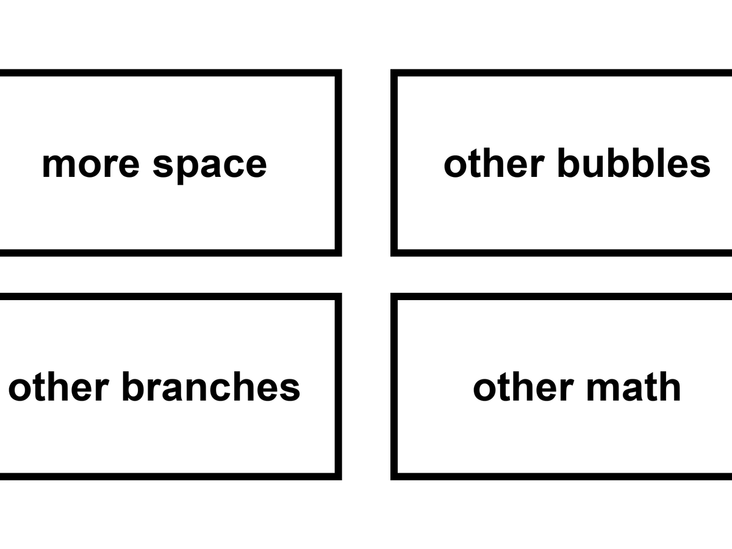
Figure 38. Four kinds of elsewhere in a two-by-two: more space, other bubbles, other branches, other math.
Keep the 2-by-2 on the wall. The rows are not a ranking of how much you should want them. They are a ranking of how easily they fuse in a conversation. More-space copies share our laws; people treat them as travel. Bubble copies share a family of laws and then don’t; people treat them as destinations with different weather. Branch copies share a past up to a fork and then don’t share a place at all; people treat them as hops. Mathematical copies share nothing that physics can cash. People treat them as a completion of the other three. The completion is the coat.
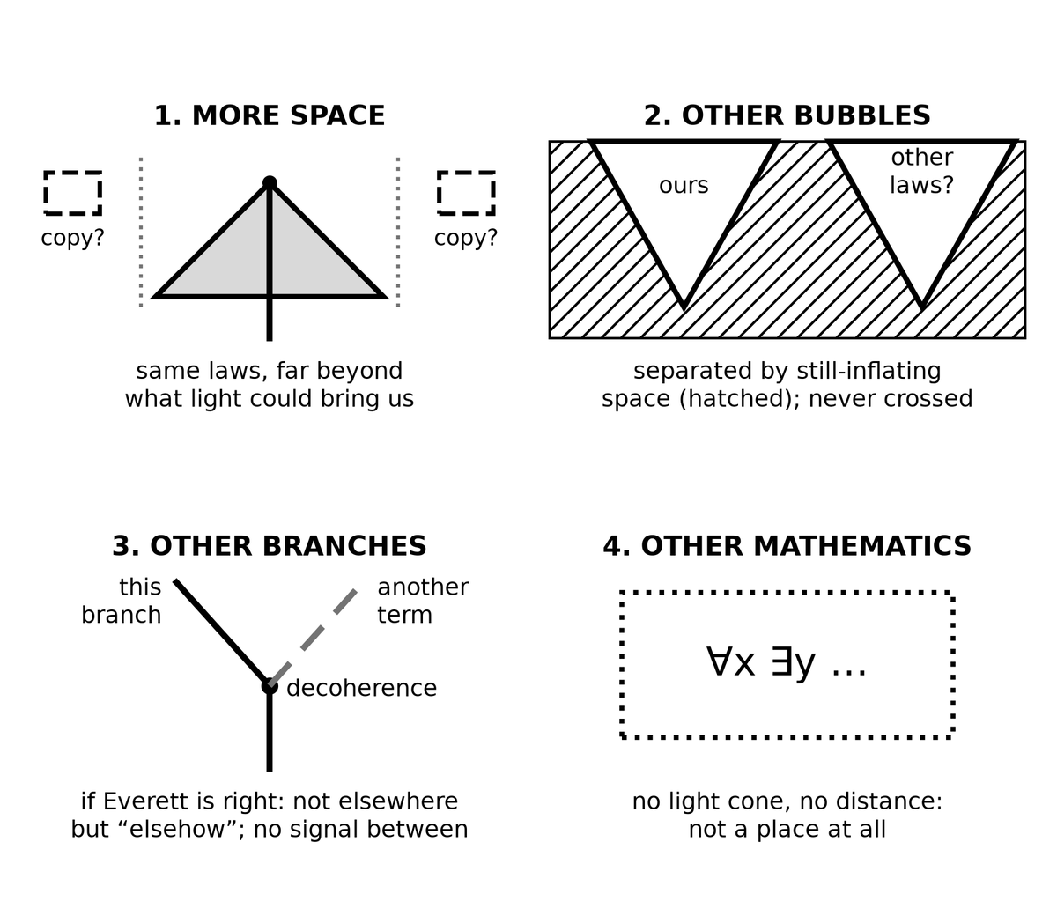
Spacetime Diagram 6. The four kinds of “elsewhere.” 1, more space: same laws, far beyond what light could bring us. 2, other bubbles: separated by still-inflating space, never crossed. 3, other branches, if Everett is right: not elsewhere but “elsehow,” with no signal between. 4, other mathematics: no light cone and no distance, not a place at all.
What would a ticket even be?
To a more-space copy: a path through this spacetime, same constants, long enough to reach a matching tile. Chapter 26 already spent that path. The event horizon ate it. You can name the copy the way you name a galaxy in a deep field. You cannot arrive.
To a bubble: a path into a different freeze — different fine-structure constant, different shove, maybe a different number of large directions. The wall between pockets is not a customs desk. In the usual pictures it is still-bursting dough. A crew that does not sleep cannot clock out of our chemistry and clock into another.
To a branch: a hop between terms of a sum. Chapter 41 will refuse the hop by name. There is no door in the sky labeled tails. There is a silence after decoherence.
To a theorem: boots on a page of axioms. A category error that has learned to walk. You do not visit consistency. You write it down.
Dark matter is not a fifth room. Dark energy is not a sixth. They are ingredients in this room. Chapter 17’s extra pull is a mass budget in the leftover glow, in the Bullet Cluster, in the way galaxies hold together. Chapter 18’s shove is a term in the stretch, a faintness in empty space, a plot twist in H(t). Neither is a copy of the kitchen. Neither is a bubble with other rules, except in the cold sense that some other valley might have a different shove — and that cold sentence belongs in drawer two, labeled as such, not smuggled into drawer one as if the missing mass were a missing universe. A particle we have not yet named is still a particle here. A vacuum energy we have not yet explained is still a vacuum energy here. Missing nouns are not extra universes.
A tidal sea under ice is not another reality. It is a dark room in this one. Europa’s ocean, Enceladus’s spray, a maybe-Hycean under a hydrogen blanket: those are permits and dark pantries in the same expanding dough, the same constants, the same leftover helium. You could, in principle, send a melt-probe. You cannot, in principle, send a melt-probe to a branch, or to a bubble with a different fine-structure constant, or to a theorem. The sea is elsewhere in the ordinary sense that a basement is elsewhere. It is not a fifth kind of copy. People reach for “another world” because the ice is a lid and the Sun is a rumor. Keep the nouns sober. A lid is a lid. A copy is a claim about inventory.
Why the sobriety matters: fuse the rooms and you can “explain” anything. The basil died? A branch where it lived. The shove is small? A bubble that passed a filter. A pattern repeats? Infinite space. A pattern looks arranged? Other mathematics in which arrangement is cheap. Each of those sentences, in its own drawer, can be a responsible maybe. Stacked, they are an oil that lets a sermon slide. This part will not stack them.
Hot: we have one leftover glow, one set of constants, one table of nuclei, and a sky larger than the patch we have seen. Dark matter pulls in this sky. A tidal sea, if it is wet, is wet in this sky. Warm: inflation, dark ingredients, and a quantum rule that does not pick a single outcome. Cold: the four drawers, each in its own way. The coat is colder still. It is not a fifth claim. It is a way of not having a claim. If a later chapter seems to be wearing two drawers at once, that is a mistake in the reading, not a new kind of elsewhere. Send it back to the 2-by-2.

39. More of This Universe
Assume, for a page, that space goes on, same laws, no edge, matter doing statistically ordinary things. Then the Hubble volume — the room we can, in principle, have seen — is one tile. Beyond it, more tiles. The number of ways to arrange the quantum states in a tile is enormous, but finite if you take the holographic bound seriously. In an infinite warehouse of tiles, every allowed arrangement happens, and happens again.
That is the cheap copy in one breath. Now unpack it, because the breath is doing a lot of work, and not all of the work is the same temperature.
An FLRW universe, the expanding dough of Chapter 7, can be infinite in space. The spatial slices — the “nows” cosmology hires from the leftover glow — can be the three-dimensional analog of an endless plane: same rules, no wall. Galaxies, on large enough averages, sprinkled the way Chapter 14’s twitches and Chapter 16’s web sprinkle them. No special place. No edge to walk off. That geometry is allowed. It is not required. Finite spaces with no edge are allowed too: a 3-sphere, a 3-torus, other closed shapes that look, locally, like the endless plane if they are large enough. The leftover glow does not hand you the global topology. It hands you a patch.
The Hubble volume is the patch. Not exactly the particle horizon, not exactly the event horizon: a room of order the Hubble length, the distance light could cover in a Hubble time, the tile people use when they want a fair comparison between “what we can see” and “what a repeat would have to match.” The particle horizon is the edge of what we can already have seen, set by the age of the stretch. The event horizon is the edge of what we can still reach with a future letter. The Hubble tile is a fair-comparison box sitting between those rudenesses. Inside one tile: a leftover glow, a web of galaxies, a greenhouse, a childhood kitchen, this sentence. The tile is finite. The question is how many tiles the universe contains.
We already know the answer is more than one. The leftover glow is a picture of a last-scattering surface larger than the Hubble length of that era, stretched. Inflation, if you buy it, stretched a still smaller patch into something that makes our whole sky look local. “Much larger than we see” is not a mood. It is the working theory’s everyday implication, and it is why the cheap-copy argument even gets a hearing. The hearing is not a verdict. Larger is not infinite. A warehouse with a thousand rooms is already larger than the room you are standing in. It is not an infinite warehouse.
If the warehouse is infinite, and if the sprinkle is ergodic — statistically the same, no conspiracy that makes every tile a unique snowflake forever — then a finite list of arrangements, drawn infinitely often, must repeat. Not as a project. As a tautology of large numbers. A deck of cards, shuffled without end, will eventually deal a hand you have already seen. An infinite deck of Hubble volumes will eventually deal a volume that matches this one to whatever precision you asked for, then deal it again.
There is a version of you who did not open this book. There is a version of the greenhouse where the basil died in month four. There is a version, much farther, where a dead world was never visited. These are not hops. They are the cheap copies: same physics, different draws, out of reach because the particle horizon and the event horizon are rude.
The “you” in that paragraph is a pattern of atoms, or a pattern of quantum states, occupying a region. It is not a soul that jumped. It is a repeat, the way two identical copies of a recipe are two copies. The woman who did not open the book is not your understudy, waiting in the wings. She is a later or farther stretch of dough that happens, if the extras are granted, to match a stretch you occupy. She does not get your radio. You do not get her afternoon.
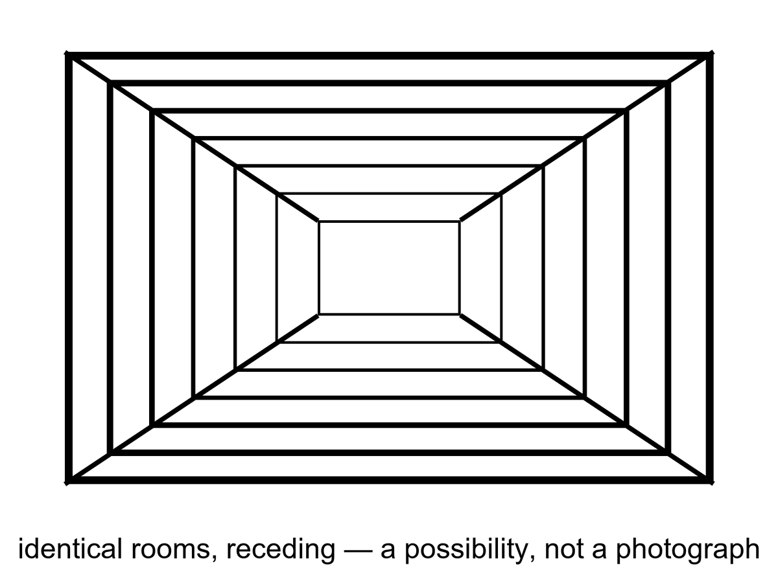
Figure 39. Identical rooms receding. A picture of a possibility, not a photograph of copies.
How finite is a tile’s menu?
If you treat a Hubble volume as an ordinary box of particles, the number of arrangements is already a Barrow shock: more than you can say out loud, less than infinity. Count the ways to place a roomful of atoms and you get a number that looks like a lie. Count the quantum states more carefully and the lie gets worse. If you take holography seriously — Chapter 23’s stubborn skin, the inventory of a region written on its boundary — the menu becomes finite in a cleaner way. A region’s distinguishable states cannot exceed what the area of its bounding surface can hold, at about one bit per few square Planck lengths. A de Sitter-like tile, bounded in practice by an event horizon, has a finite area of order 10¹²² Planck patches, and therefore a finite library. The number of possible books in that library is two to that power: a stack of exponents you cannot write as an ordinary integer. Enormous. Finite. Infinity is not hiding in the closet of one tile. It would have to hide in the number of tiles.
That finiteness is doing the cheap copy’s real work. Infinite space plus an infinite menu need not repeat; you could have a new snowflake forever. Infinite space plus a finite menu must, if the draws are independent enough, reuse the books. The holographic bound is the cleanest reason the menu is finite. It is warm-to-cold as a statement about the whole sky — our space is not the negatively curved special case where holography is a theorem — and it is stubborn as a hint. Even without holography, a finite energy in a finite box, with a quantum grain, is a finite list. The cheap copy is, at bottom, that list plus a warehouse that never stops.
Ergodic is the other extra. It means the sprinkle does not, at some scale, freeze into a crystal of unique rooms, or stop being defined, or start repeating for a boring geometric reason that is not “infinity plus a finite menu.” Inflation, if you buy it, helps: it stretches a small, mixed patch into a large, mixed patch, and the twitches are statistically ordinary. Help is not a proof that the whole spatial slice is an ergodic infinite plane. Help is a reason the cheap-copy argument is not crazy. Crazy would be assuming a unique snowflake at every distance for no reason. The cheap copy assumes the opposite, which is also an assumption.
Is space infinite? We do not know. We know it is larger than the tile, and flat to a boredom that inflation explains as a feature. Infinite is a cold extra. “Much larger than we see” is warm. The cheap copies require the stronger extra, plus a faith that the statistical sprinkle does not, at some scale, start repeating for a boring reason or stop being defined.
Flatness is the measurement people try to promote.
Planck’s leftover-glow maps find a curvature parameter, Ω_{k}, consistent with zero. Parallel lines, on the largest scales we photograph, stay parallel to a boredom. Inflation predicted that boredom: stretch a curved surface enough and the ant sees a plane. Ω_{k} ≈ 0 does not prove the slice is infinite. A 3-sphere with a radius far larger than the Hubble length looks flat in the patch. A 3-torus, finite and edgeless, looks like infinite FLRW until you have gone all the way around, and “all the way around” may be farther than light has traveled since the glow. Topology is sneaky. The data say: not a small, curvy room. They do not say: warehouse without end. Treating “flat enough” as “infinite” is a kitchen leap. The leap is popular. It is still a leap.
There is a search that tried to catch the sneak. If the last-scattering surface wrapped around a small enough 3-torus, the leftover glow would show matching circles: the same pattern, twice, on the microwave sky, because you would be seeing the same patch of fog in two directions. People looked. They have not found the circles.⁶² That is a warm push: whatever the global shape is, it is not a snug little room we have already walked around by looking. It is not a proof of infinity. It is a proof that “finite but huge” still has a lot of room to hide. Appendix A39 writes the curvature and the repeat. Here: flat is not infinite. Flat is a local manners.
So the temperatures, named:
Hot: the universe is larger than the part we have seen; it is close to flat on that part; galaxies recede; the glow is a baby picture of a mixed fog. Warm: inflation made the flatness a feature, and the region beyond the tile is more of the same dough, same laws, for a long way. Cold: the dough is actually infinite, the sprinkle is actually ergodic, the holographic menu is actually the right count, and therefore a copy of this kitchen sits in some far tile, then sits again. The cheap copies are a fact only if those cold extras are facts. They are a picture of a possibility. Figure 39 is honest about that. It is not a photograph of copies.
One popular inventory of this room, Max Tegmark’s, calls it Level I:⁶³ more of the same FLRW volume, repeats by distance. The name is a filing label, not a detection. The label is useful if it keeps this drawer from fusing with bubbles, branches, and theorems. It is harmful if it puts a grid of rooms on a poster and lets a reader think the grid has been counted in the microwave sky. It has not.
The distances, if you grant the extras, are a Barrow shock of a different kind. A repeat of a planet-sized pattern is already unspeakably far. A repeat of a whole Hubble volume is farther in a way that does not fit in a throat. These are not destinations. Chapter 26 already spent the event horizon: most of the sky has left. The cheap copies, if they exist, live in a region that will not take a letter, let alone a ship. Light will not finish the trip. The particle horizon is the past’s rudeness. The event horizon is the future’s. Together they make “elsewhere in this universe” into a museum, not a road.
A project is the same refusal with a better mood. Even if the copies exist, they do no work here: a far tile where the crop lived does not feed anyone on this one. The cheap copies, even at their most generous, are not colleagues. They are recurrences. Recurrence is not company. It is a statement that a finite story, told often enough, is told again.
Keep the drawer shut against hops. Same laws, more space, maybe repeats: that is all this chapter owns. The next chapter will try to change the laws. That is a different coat, and it is more expensive.

40. Other Rooms, Other Rules
The expensive copies need a burst that does not know how to retire, and a menu of retirements.
Eternal inflation, Chapter 15, is the burst that may not retire. The menu is the maybe: different valleys, different leftover constants, different low-energy laws. In one valley the cosmological constant is a monster and galaxies never form. In one it is a little shove, and someone hits an airlock. In one there are two large dimensions and no kitchens. Weinberg’s filter needs this menu, or something like it, to turn “Λ is small” from a miracle into a selection.
In many slow-roll stories, the field that stretched the patch reaches the bottom of its hill in some places and keeps rolling, or keeps jittering, in others. The places that stop become hot bangs — pocket universes, bubbles, a noun you can hate and still need. The places that keep going keep stretching. Our leftover glow would be the inside of one stopped place. Outside, if the rumor is right, the bursting is still hiring. Different stops can freeze different effective physics if the underlying theory has more than one valley to fall into. That is the expensive machine: not more of the same tile, but other tiles whose constants were never ours.
From inside a stopped place the sky looks ordinary. A leftover glow. A stretch. Helium. Galaxies. You do not see the bursting next door. You see a patch that reheated, mixed, and froze into the kitchen you have. That is why eternal inflation is easy to oversell and hard to kill. It does not predict a new smudge in tonight’s field. It predicts that our smudge is one of many, and that the many may not share our leftover constants. The local burst of Chapter 13 can be right while the froth is a rumor. Keep the temperatures. Local inflation is warm. Eternal hiring is a live maybe. Other laws in other pockets are the maybe stacked on the maybe.
Where does the menu come from? Often, from string theory’s landscape: a reported 10⁵⁰⁰ ways to compactify extra directions and freeze a vacuum. String theory cannot currently be tested. A number like 10⁵⁰⁰, offered without a risky prediction that would kill the framework, is a catalog, not a census. Other frameworks offer other menus. Some offer one valley. The sky we have does not yet choose.⁶⁴

Status as of October 2026: string theory
Established. String theory is a mathematically rich framework that contains gravity and has produced real tools, including a precise link between certain gravity theories and certain quantum theories without gravity, and a count of black-hole microstates in special cases.
Not established. No prediction unique to string theory has been confirmed by experiment. The landscape of possible vacua has not been counted reliably, and no agreed way exists to derive our constants from it.
The live debate. Some physicists argue that theories this hard to test can still be judged by internal consistency and explanatory power; others reply that this weakens what science means by a test.⁶⁵ This book keeps its standing rule: string theory cannot currently be tested. That is a statement about evidence, not a verdict on the mathematics.

The number is a celebrity, so treat it like one. Extra directions, curled small. Fluxes, wrapping those directions, choosing a vacuum energy and a set of leftover constants the way a combination lock chooses a number. Count the combinations people know how to write and you get a shock with a lot of zeros. Ten to the five hundred is not a census of kitchens. It is a count of locks. Some locks may not open onto a cosmos that lasts. Some may be the same kitchen counted twice. Some may be artifacts of an approximation. The advertised number moves when the approximations move. That is allowed in a research program. It is not allowed in a result.
The shock is not a measurement. It is a count of sentences in a framework that has not yet named a signature we could miss. Compactify differently, freeze differently, and you can accommodate, after the fact, almost any low-energy kitchen. A framework that can accommodate almost any kitchen is not, so far, a theory of this kitchen. Row (18) in the appendix is a reminder, not a formula, of what a test would have to do: a risky number, a signature, a way for the whole idea to die. It has not been done.
Other menus exist on paper. Loop-ish gravities, extra-field cosmologies, a single vacuum that just happens to be ours. Some of those are also untested. Some are more modest. Modesty is not a proof. The leftover glow, the helium, the shove’s size: those are the court. The catalog is a witness who has not agreed to be cross-examined.
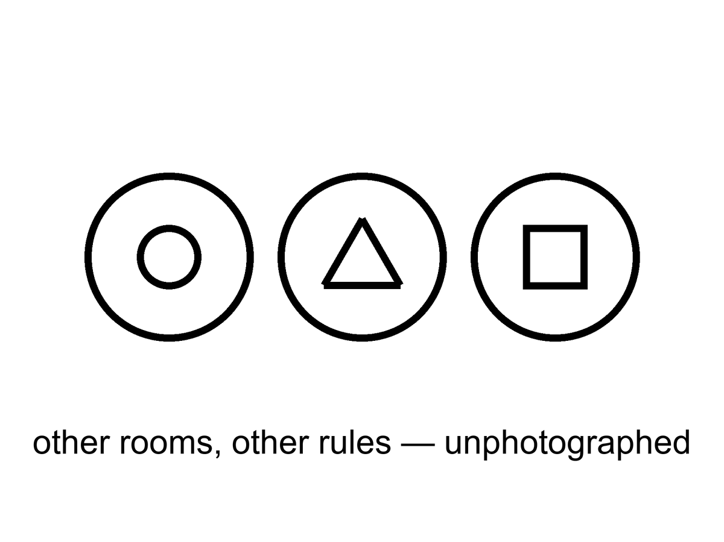
Figure 40. Three bubbles, three different icons. Other rooms, other rules, unphotographed.
The measure problem sits on the catalog like a cat. Infinite bubbles, infinite observers, no agreed count: “typical” becomes a fight. Until the fight ends, “the landscape predicts observers like us” is a hope. It is a better hope than a required Omega Point, because it does not contradict the shove. It is still a hope.
If bubble begets bubble without end, the word most breaks. Most by what? Volume? Then the still-inflating regions, which stretch without limit, drown the stopped ones, or the stopped ones that stopped later drown the ones that stopped earlier, depending on how you cut. Count by bubbles? Then you need a cutoff, a regulation, a rule that says when two infinities have been made finite enough to compare. Count by observers? Then you need to know what an observer is, and whether a bubble that makes a brief, dense flash of many brains outranks a bubble that makes a few, slowly, in galaxies. The youngness paradox is one of the rude children of a bad measure: some cuttings predict that typical observers live almost at the beginning of their bubble, which we do not. Other cuttings predict other rudenesses. No cutting is the one everyone else has to accept. Until one is, a sentence that begins “the landscape predicts” is a sentence that has not finished its homework.
Weinberg’s filter is why anyone bothers.
In 1987 he asked what value of the cosmological constant observers should expect if the constant is drawn from a wide range. Too large a shove and galaxies never form; too small, and you would need a reason the draw sat far below the galaxy-formation edge. The measured value sits near that edge, give or take the arguments about how to draw the edge. That is interesting. It is the rare case where “looking arranged” was turned into a number. Chapter 42 will sit with the number and with the sermons people attach to it. Here, the one sentence that matters is: the filter needs an ensemble. Without a menu of valleys, or of tiles, or of something that plays the same role, the weak anthropic cut is a reminder that we are not on Venus. It is not an explanation of why Λ is small. With an ensemble, it becomes a mesh. You throw away the monster shoves, look at what is left, and ask whether we are a typical survivor. You still need a measure. You still need the ensemble to be more than a catalog. You do not get to say the universe wanted a greenhouse. You get to say we could not have found ourselves in the valleys that did not want anyone.
The multiverse argument deserves its best form before it is declined.
Its strongest case. We already accept unobservable things when a theory we trust predicts them: the interior of a black hole, galaxies beyond our horizon. If eternal inflation is the right theory of the burst, other bubbles follow the same way, and Weinberg’s 1987 estimate shows the idea can earn a number: it anticipated a small, nonzero shove before the 1998 supernovae found one.³¹⁶³
What it gets right. A multiverse is not a mystical claim. If our constants were drawn from a wide range, selection really would explain why we see values that permit observers, and refusing to consider it could hide a true explanation behind a taste for neatness.
Why this book still declines it. The black-hole interior is predicted by a theory tested outside it; eternal inflation and the landscape are not yet tested anywhere. Without a measure, “typical” has no meaning, so the ensemble cannot yet make a prediction we could miss.⁶⁶ The verdict is “unproven,” not “impossible.”
Pointer, then, not a theft of Chapter 42: expensive copies are one of the ensembles people reach for. Cheap copies are another, weaker for Λ, because cheap copies share our laws and our leftover shove — a far tile with the same potatoes blighted or saved still has the same small cosmological constant. Branches are a third, and they do not help Λ at all unless the shove itself is a quantum leftover that forks, which is a different, colder story. Other mathematics will explain anything and therefore nothing. If you want a filter rather than a purpose, you need a drawer that actually contains variation. Drawer two is the expensive candidate. It has not passed a test. It is allowed to sit on the table. It is not dinner.
If you live in a bubble, the neighboring bubbles are not destinations. The walls, in the usual pictures, are empty and expanding. You cannot book a crew that does not sleep and arrive at a different fine-structure constant. You can, at best, infer that you are in a valley that permits you. That inference is the weak filter. It is not a tour.
The wall sentence is practical, so keep it practical. Between bubbles, in the usual eternal-inflation cartoons, inflation is still going. The domain wall — the boundary between a stopped kitchen and a still-bursting dough — expands. The space you would have to cross is not a hallway with a different weather on the far side. It is a region that stretches too well to finish. Different constants are not a climate you could pack for. They are a different low-energy physics, a different chemistry, a different number of large directions. A crew that arrived, if arrival were a word, would not be a crew. Chemistry would not be chemistry. Neighbor bubbles are, at best, an inference from the fact that our valley is livable. They are not a pin on a map.
A vacuum that decays is not a door either. People hear “tunnel to another vacuum” and picture a station. A true-vacuum bubble nucleating in a false vacuum is, in the usual pictures, a disaster or a rewrite of local law, not a ticket booth. You do not book it. You do not steer it. If our vacuum is metastable, the news is a lifetime, not a destination. Chapter 44 will sit with endings. Here: neighboring rooms with other rules are not ports. They are, if they are anything, an ensemble for a filter. Chapter 42 is where the filter is allowed to work. This chapter’s job is to refuse the tour.
Hot: we live in one expanding region with one leftover glow and one small shove. Warm: inflation can be eternal in many models, and a small Λ wants an explanation that might be a selection. Cold: the bursting never stops, the valleys number 10⁵⁰⁰, the measure will someday settle, and a bubble with two large dimensions is as real as this kitchen. Until a risky signature exists, 10⁵⁰⁰ is a celebrity, not a count of neighbors.

41. Every Allowed Outcome
Hugh Everett, in the 1950s, took the electron’s equation at its word. The equation offers a sum of ways. The usual habit is to throw away the ways that did not “happen” at a measurement. Everett’s habit is to keep them. The sum is the inventory. A measurement is a fork. After the fork, the branches do not talk; decoherence makes the interference go away. You are the branch that includes this sentence.⁶⁷
The year, if you want the stamp, is 1957. The dissertation is a relative-state reading: the global wavefunction does not collapse. A measurement correlates an apparatus with a system. Each term of the correlation is a consistent story for the observers inside it. There is no extra postulate that picks one story and burns the rest. The rest stay, decohered, as unavailable to you as a spacelike navy.
This is not extra cosmology. It is a reading of the same rule that builds chemistry. It is warm. It is not a photograph of other lives. It does not give you a hop. The carnival version — jump to the branch where the basil lived, where the sea is empty, where you did not lose who you lost — is a story. The physics, if Everett is right, says those branches are on the inventory and unavailable. They are as unavailable as Andromeda’s navy and ruder, because they are not even elsewhere. They are elsehow.
The new kitchen is a coin.
You flip it by the sink. In the equation, both faces persist. Decoherence — entanglement with air, with photons, with the grain of the table — makes the interference go away on a timescale you could, in a careful lab, assign a number to. No soul is required for the going-away. Afterward there is a heads term and a tails term. You are, in this term, the person who sees heads. There is an elsehow in which you see tails. You wash one dish. The dish you dirtied while the coin was in the air, waiting, talking, not talking. You do not wash both. The sink in this term has one plate. The coin in this term has one face showing. The other face is not under the table. It is not in a far Hubble volume. It is a term you do not occupy. You cannot lean sideways and dry the other plate. The no-signaling theorem is the grown-up name for that refusal: local operations do not send notes between terms.
You saw heads. You put the plate in the rack. Somewhere in the sum, a you who saw tails is putting a plate in a rack. If the I is a tangle, both of those stretches have an equal right to the pronoun. That equality is not a ticket. It is the ruder moral: a perfect copy of a loop is a second loop. You do not get to be both dishwashers. You get this sink, this face of the coin, this one plate. The carnival wants you to treat the other term as a spare afternoon you could still choose. Everett, if you buy him, says the choosing was the fork. After the fork there is no remaining chooser who stands above both terms and picks. There are two choosers, decohered, silent. You are one of them. Wash the plate you have.
Decoherence, in this sink, is not a philosophy. It is a rate. Air molecules, photons, the roughness of the table, each take a little record of which face is up. After enough records, putting the two faces back into interference would require conspiring with every record that left. The conspiracy does not happen in a kitchen. It barely happens in a lab, and only when the lab is built to prevent records. A hop would require the conspiracy, or a door the equation does not draw. Neither is on offer beside the sink.

Physics vs philosophy: from decoherence to Everett
What the evidence establishes. Interference is real, decoherence happens at calculable rates when a system leaks information into its environment, and entangled pairs violate Bell’s inequality, so no local recipe of hidden instructions explains them.⁶⁸¹⁸²⁰
What remains interpretation. Whether the unobserved outcomes still exist (Everett), never existed (collapse models), were never more than an agent’s expectations (QBism), or were always accompanied by definite particle positions (Bohm). Every one of these readings reproduces the same laboratory statistics, except the collapse models, which make small extra predictions that are being tested.
What this book infers. That Everett’s reading is the most economical fit with a block that already refused a single now. That is a preference with reasons, not a measurement, and it carries a real cost, discussed below.

Everett is not the only serious reading, and a book that leans on him owes the rivals their strongest form.⁶⁹⁷⁰
Copenhagen. Strongest case: physics is about what we can say about experiments, and asking what the wavefunction “really is” between measurements is asking for something no experiment can deliver; Bohr’s reply to Einstein in 1935 was that the experimental arrangement is part of the phenomenon.⁷¹ What it gets right: the lab never shows us a superposition of pointer readings, and the theory’s success never depended on settling the question. Why this book declines it: it draws a line between quantum system and classical apparatus without saying where, and a book about the whole universe has no outside apparatus to stand on.
QBism. Strongest case: the wavefunction is an agent’s degrees of belief, updated by experience, so “collapse” is just learning and nothing travels faster than light.⁷² What it gets right: it removes the paradoxes cleanly and takes the first-person view of measurement seriously. Why this book declines it: it says little about what the world is like when no agent is updating, and the leftover glow and the helium were records written before any agent existed.
Bohm. Strongest case: particles always have positions, guided by the wavefunction, so measurements have definite outcomes with no collapse and no branching; the theory reproduces every standard prediction.⁷³⁷⁴ What it gets right: it proves that a definite, realist quantum theory is possible, and Bell himself admired it for that. Why this book declines it: it needs a preferred slice of simultaneity to coordinate distant particles, the very structure relativity does not supply, and its unchosen branches of the wavefunction remain in the equations, doing no work.
Collapse models. Strongest case: the wavefunction really does collapse, spontaneously and rarely for single particles but almost instantly for large objects (GRW), perhaps triggered by gravity (Diósi and Penrose); unlike the other readings, these are testable physics.⁷⁵⁷⁶⁷⁷ What it gets right: it turns an argument about words into an experiment. An underground test in 2020 already ruled out the simplest version of the gravity-triggered model.⁷⁸ Why this book does not adopt it: no collapse has yet been seen, and the models need parameters chosen to hide just below current limits. If an experiment finds one, this chapter changes.
Consciousness-based collapse. Strongest case: the measurement problem and the problem of consciousness are both about where definite experience comes from, so perhaps they share a solution; David Chalmers and Kelvin McQueen have proposed a precise, in-principle testable version.⁷⁹ What it gets right: it treats observers as physical systems that must be accounted for, not as an afterthought. Why this book declines it: the leftover glow and the helium are records that formed with no minds around, and no experiment so far has needed a mind to explain an outcome.
The honest cost of Everett. If every outcome happens, what does it mean that one outcome is more probable than another? Everettians derive the standard probability rule from decision theory and symmetry; critics say the derivations assume what they need. This is the strongest objection to the reading this book prefers, and it is not settled.
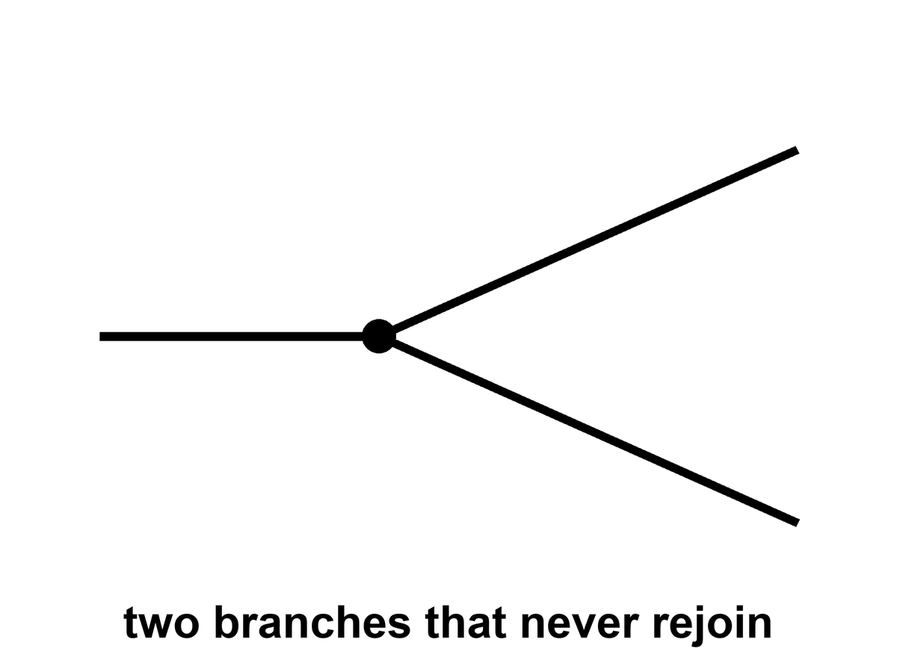
Figure 41. One line splits into two that never rejoin. Every allowed outcome, one worldline each.
Why put this at the core of a book about the universe? Because the block, without it, is only all the times. With it, if you buy the reading, the block is all the times and all the allowed versions. “Everything, everywhere, all at once” is a phrase this book will not treat as a title. It will treat it as a temptation to be made precise. All the times: the block. All the versions: the forks. All at once: a bad kitchen phrase for “equally in the inventory.” Not a permission to walk sideways. Not a permission to hop.
Elsehow is the word to keep when elsewhere tries to steal the scene. A far Hubble volume, if Chapter 39’s extras are granted, is elsewhere: a spacelike other, a tile, a distance. A neighboring bubble, if Chapter 40’s extras are granted, is a ruder elsewhere: other rules, not a destination. A branch is not a place. After decoherence you cannot point at the sky and say “the tails are that way.” There is no that way. There is another term in a sum. The split in Figure 41 never rejoins. Rejoining would be interference, and interference is what the environment spent. The carnival hop would require a door between terms. The equation, taken at Everett’s word, does not build that door. It builds a fork and then a silence.
The practical fact does not budge. The worldline you occupy is the one you can work along. A melt-probe either tastes life or it does not. A library either arrives or it does not. The other outcomes, if they persist, persist without you. That is either a horror or a relief. It is, in any case, not a ticket counter.

Physics vs philosophy: from copies to identity
What physics establishes. Quantum states cannot be perfectly copied (the no-cloning theorem), but a person is not one quantum state; a body is a pattern that replaces most of its atoms over years.
What this book infers. That a perfect duplicate of a person would be a second person, not a continuation of the first. That is a philosophical position about personal identity, not a result of physics.⁸⁰

A loop that calls itself I wants a ruder answer. If the I is a tangle — a translation that stays closed — then a perfect copy of the tangle is a second I, not a hop of the first. Two nests built from the same plan are two cities. They may share a past up to the fork. After the fork they do not share a now, because there is no now. Mara, duplicated by a printer that worked too well, does not “go” into the duplicate. She acquires a twin who will swear, with equal right, that she is the original. That is not Everett. That is logistics plus a loop. Everett is ruder still: the twin is not even elsewhere. She is elsehow.
Consolation is the hire this whole part has been refusing. A far tile where the potatoes lived. A bubble where Λ was kind. A branch where the coin was tails and the person you lost is still in the kitchen. Each, in its drawer, may be a responsible maybe. None of them is a method. None of them is a spare you. The I that wants a spare is asking for an edit, and Chapter 36 already spent edits. A duplicate is a second I. A branch is an elsehow I. Neither is a continuation of this dishwashing, this blight, this fiber paying out into the dark.
The strongest rival here is the uploading view.
Its strongest case. If your neurons were replaced one at a time by functionally identical chips, there seems to be no moment at which you would stop being you, so a gradual upload preserves the person; and Derek Parfit argued that what matters is psychological continuity, not which matter carries it.⁸¹
What it gets right. Identity is a pattern, not a substance, and this book agrees.
Why this book still declines the hop. gradual replacement keeps one continuous process, while a scan-and-copy makes a second process beside the first. Chalmers himself treats gradual uploading as the safer route for that reason. A copy is a successor with your memories, which may matter a great deal, but it is not you arriving somewhere else.
Appendix A41 writes decoherence, the no-signaling theorem, and the loop. You cannot use a fork to send a note to the branch next door. Pairings can be stronger than any local recipe of hidden instructions; Chapter 6 already sat with Bell and Aspect. Stronger is not a telegram. You cannot choose what to do with the coin in a way that writes a bit on the other face’s afternoon. Relativity already denied a frame-independent “at once” in which the two ends could confer. Everett adds a ruder silence: even the terms that share a past up to the flip do not confer after the environment has spent the interference.
Hot: quantum interference is real; decoherence is a calculation; Bell pairings are real; you still cannot telegraph with them. Warm: Everett’s reading, this book’s preferred interpretation and not a result, keeps the leftovers without a collapse postulate, and it fits a block that already refused a single now. Cold: you have photographed the other term, or hopped into it, or mailed it a dish. You have not. The coin lands both ways. You wash one plate.

PART IX — The Filter

42. A Filter, Not a Purpose
If the strong nuclear force were a few percent different, carbon would be rarer, or stars would be ruder, or the leftover helium would be a different lie. If the cosmological constant were a few dozen times larger, the shove would have won before the twitches grew up, and there would be no spirals, no kitchens, no one to notice the shove. If electromagnetism were a little stronger, chemistry would be a smaller menu. These are the dimensionless coincidences, and they have been used to sell both wonder and sermons.
The wonder is allowed. The sermons are a leap.
A dimensionless number is a number with no units left on it, so you can ask, without cheating, why this and not 17. The fine-structure constant α is one: about 1/137, the strength of electromagnetism in the units nature actually uses. Make it a few percent ruder and atoms change size, chemistry loses dishes, stars burn on a different clock. The nuclear coincidences are ruder still. The leftover helium of Chapter 10 is a fossil of a force that let deuterium hold together long enough to cook, then stopped short of burning the workshop to iron. A few percent the other way and the three minutes would have been a different courtroom. Carbon itself sits on a famous resonance — Hoyle’s, predicted because we are made of the stuff and the triple-alpha dance needed a rung — which is either a miracle or a reminder that chemists find themselves in a chemistry that worked. The cosmological constant is the loudest of the lot. Naive vacuum jitters want a monster. The shove we measure is a whisper, off by a joke of tens of zeros. That gap is a real problem. Treating the gap as a love letter is the sermon.
Hot, as coincidences go: the numbers are the numbers. α is 1/137-ish in every lab. The helium fraction is a quarter. The shove is tiny compared with the Planck density. Warm: some of those numbers are fixed by a deeper rule we have not got yet, the way chemistry stopped being a list of miracles once electrons were a wave. Cold: they were dialed for us. The cold claim does not get to wear a lab coat just because the feeling is strong.
We do not have a second universe on the bench to compare. We have one leftover glow, one set of constants, one table of nuclei. In that one, water bends, carbon chains, stars last. The look of arrangement is real as a feeling. As an argument it has a hole: we are the sample. Samples taken from the places that permit samples are biased. That is not cynicism. It is how you do not get fooled by your own lungs.
Dicke said a version of this in 1961,⁸² before the leftover glow had even been named in a journal. Dirac had noticed large coincidences between cosmic numbers and atomic ones and wanted a law that made them change with time. Dicke’s reply was ruder and better: observers made of carbon need a universe old enough for stars to have cooked carbon. They will find themselves in a cosmos whose age is a stellar lifetime, give or take. That is not a prediction of a changing gravity. It is a prediction of a sampling rule. Brandon Carter, a dozen years later, gave the sampling rule a name⁸³ that has been causing trouble ever since: anthropic. The trouble is the noun. Anthropos sounds like a crown. The move is a mesh.
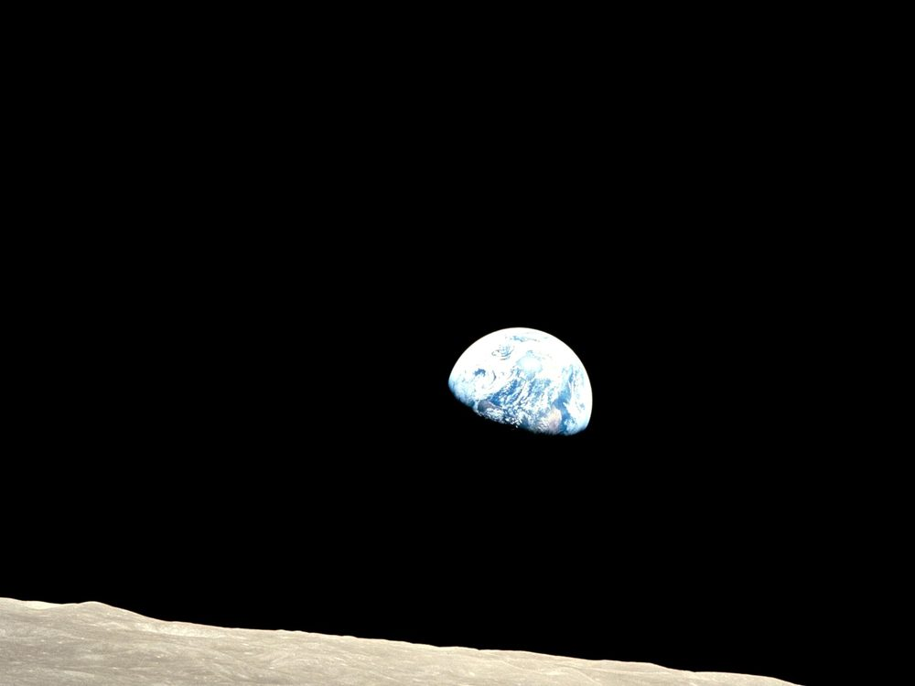
Figure 42. Earth, bright against a dead horizon. A temperate world is where observers find themselves.
Weinberg’s move on the cosmological constant is the rare case where the feeling was turned into a number. If Λ is drawn from a wide range, the observers who measure it should find it small enough for galaxies, and not much smaller than that unless something else is at work. The measured value is near that edge. That is interesting. It is not a proof of a menu. It is what a filter looks like when you bother to write it down.
The year was 1987. Galaxies, in the working picture, grow from the twitches of Chapter 14 only if the shove does not win too early. If vacuum energy is large, the stretch accelerates before the overdensities can collapse, and you get a thin fog with no spirals and no kitchens. Weinberg asked what values of Λ a later observer could possibly report.³¹ The answer was an upper bound: not much larger than the matter density at the epoch when galaxies form. If the prior is wide — if many values are on offer, and nothing else picks — then typical observers should find themselves near that edge, not deep in a valley of needless smallness. Eleven years later the bombs of Chapter 18 found a shove of that order. That is the interesting part. It is not a photograph of other valleys. It is a number that looks like a cut. Hot as a calculation: if you grant the ensemble, the bound is a bound. Warm as a hint: the measured Λ sits where a filter would put it. Cold as a proof that the ensemble exists.
The tidal seas belong here as a humility. We thought “arranged for life” meant a Goldilocks band and a blue marble. Then we found that most of the wet real estate in the solar system might be dark, under ice, squeezed by a giant, uninterested in sunsets. If there is life there, it did not need our sermon. If there is not, the permit was still wider than the sermon. Arrangement, if you must use the word, is sloppy and local, not a tailored suit.
The Weak Anthropic Principle, in a careful wording, is a selection effect: the constants we measure are drawn from the values that permit us to measure them. Carbon chemists need carbon chemistry. They need a universe old enough to have cooked carbon in stars. They need a shove that did not win too early. Saying so is as taut as saying that fish find themselves in water. It is also as useful as that, once you have an ensemble to select from.
Barrow and Tipler, who wrote the big book that put the names in order, said the weak principle this way: the observed values of the constants are not equally probable. They are restricted by the requirement that there be sites where carbon-based life can evolve, and by the requirement that the universe be old enough that it already has. That is a likelihood cut. It is not a cause. It does not cook the carbon. It does not aim the shove. It tells you which draws from a menu you are allowed to be surprised by. Carter’s original wording was in that neighborhood. The later sermons wandered off.
Without an ensemble, the weak principle is a reminder, not an explanation. It stops you from being surprised that the kitchen is not on Venus. It does not tell you why there is a kitchen.
With an ensemble — cheap copies, expensive bubbles, a menu of Λ — the weak principle becomes a cut. You throw away the valleys that have no observers, and you look at what is left. You still need a measure. You still need the ensemble to be more than a catalog from an untestable framework. You do not get to say “the universe wanted us.” You get to say “we could not have found ourselves in the valleys that did not want anyone.”
The Strong Anthropic Principle says the universe must permit life. “Must” is a smuggler. It can mean the tautology, the ensemble, or a purpose. Only the first is safe. The Final Anthropic Principle says intelligent processing must arise and must never die out. That is the Omega Point’s moral clause. Chapter 19 already broke its physics. Its morals were never physics.
Unpack the smuggler. “Must,” in the tautology, means: a universe we are looking at, from inside, is one that permitted looking. Allowed. Empty of news. “Must,” in the ensemble, means: among the valleys, the occupied ones are the ones that permit occupation. That is the weak principle again, wearing a louder coat. “Must,” as purpose, means: the universe was aimed. Aimed by whom, through which channel nature uses, with which leftover in the glow as a serial number? Chapter 35 already asked the watchmaker to clock in. The channel has not spoken. The Final principle is louder still. It does not only want a permit. It wants a forever-mind as a law. The bombs, the leftover glow, and the mixmaster of Chapter 16 declined.
The strong principle, in its purpose reading, still deserves its best case.⁸⁴
Its strongest case. The coincidences are many, independent, and narrow. If one universe is all there is, “we could not have seen otherwise” does not explain why a universe permitting observers exists at all; a firing-squad survivor is right to ask why every shot missed. A purpose, or a law that favors life, would make the coincidences expected rather than lucky.
What it gets right. In a single universe, selection alone is not an explanation; this chapter agrees that the weak principle only explains once an ensemble exists. And the fine-tuning of the cosmological constant is a real problem that physics has not solved.
Why this book still declines it. A purpose that predicts nothing about the helium fraction, the shove, or the next measurement cannot be checked, and the coincidences may yet be fixed by a deeper law, as chemistry’s were by quantum mechanics. Between a deeper law, a selection from an ensemble, and an aim, only the first two can ever lose to data.

Physics vs philosophy: from fine-tuning to anthropic reasoning
What the evidence establishes. The measured constants permit long-lived stars, carbon chemistry, and galaxies, and some of them (notably the cosmological constant) sit in narrow ranges compared with naive expectations.
What is inference. That the narrowness needs explaining at all, and whether the right explanation is a deeper law, a selection from many universes, or a purpose. None of these has been confirmed.
What this book infers. The weak, selection-effect reading is sound reasoning; it becomes an explanation only if an ensemble exists. The strong and final readings go beyond any evidence we have.

A filter is not a purpose. A purpose has an aim. A filter has a mesh. We are what got through, in this valley, on this worldline, with this leftover helium. That is enough to be getting on with. It is not enough to crown us.
Do not crown this species for occupying a temperate crust while dark seas, if they are empty, were always empty without our permission, and if they are not, were never waiting for a sermon. The leftover glow does not have a favorite. The shove does not have a favorite. The mesh does not owe the things that pass through it a parade. You may still be glad the nuclear force was not a few percent ruder. Glad is a local weather. It is not a cosmology.

43. No Cosmic Craftsman
Darwin’s trick, which this book has been circling since the prologue, is that a filter can look like a craftsman if you only see the survivors. The beaks fit the seeds. The fit looks like intent. The intent was death, repeated, in a lot of directions.
The look is not a small look. A living thing is an invoice so long, and so locally paid, that a reasonable person staring at one bird will reach for a someone. Paley’s watch on the heath was that reach, and it was not stupid as a first move. A watch has parts that mesh. A finch has parts that mesh. The difference, which is the whole of the trick, is that watches do not leave a trail of almost-watches that died, and finches do. The trail is the notebook. Skip the notebook and you will hire a craftsman every time. Keep the notebook and the craftsman becomes a mesh you can miss: a pile of deaths that would have looked, from inside any one of them, like a plan that failed.
He did not start with the trick. He started with a notebook. Islands. Barnacles. Pigeons in a shed. A clergyman’s son who could sit still and then refuse the cheap sentence. The beaks were not a revelation in a dream. They were a pile of measurements that would not sit still under “each kind was issued.” Malthus gave him a rate. Breeders gave him a proof that selection can be hurried by a hand. The conclusion — descent with a mesh — was keen because the observations were allowed to kill the other story. A man on the other side of the world, looking at beetles and islands of his own, reached the same mesh without asking permission. That is what this book means by a path: a record you could have missed, then a sentence that can die. The leftover glow is that habit aimed at a fog. The dark sea is that habit aimed at a lid of ice. A craftsman is what you hire when you skip the notebook.
The man on the other side was Wallace. Same mesh, different kitchen, a letter from the Malay Archipelago that arrived in time to make the announcement a joint one. That matters for the method, not for a statue. Two notebooks, two worldlines, one sentence that could have been wrong and was not. Malthus had only meant a sermon about the poor. The rate he named — more mouths than food, if nothing checks — is a filter when you let it run on beaks. Breeders had only meant prettier pigeons. The shed is a proof that a mesh, hurried by a hand, can make a pouter from a rock dove in a career. Nature’s hand is slower and has no taste. The taste is what dies.
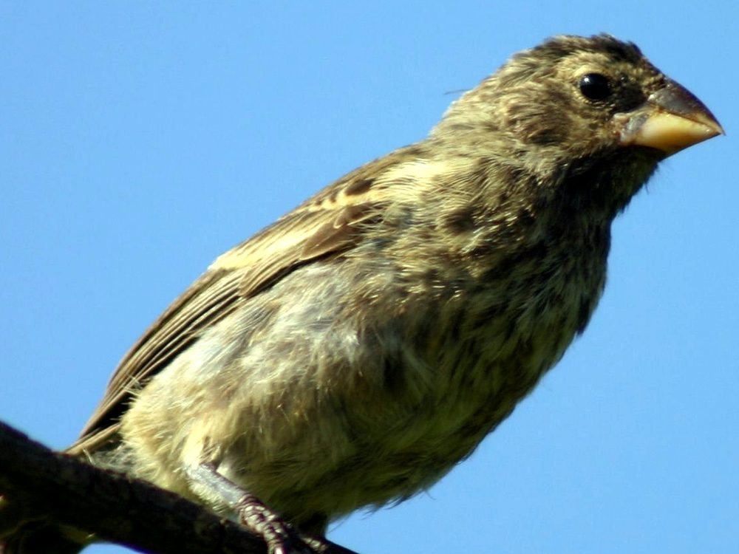
Figure 43. One Galápagos finch on a light ground, beak readable. A filter can look like a craftsman.
The cosmic version is ruder because we cannot see the deaths. If there are dead valleys, they do not send baby pictures. If there are dead tiles, they are out of reach. If there are dead branches, they do not radio. We see a leftover glow that permits spirals, a shove that waited, a nuclear force that permits carbon, a Jupiter that squeezes a moon until a sea stays wet. The craftsman story is the cheap story. The filter story is the one that does not invent a someone.
Hot: this universe permits chemists. Warm: some of the coincidences of Chapter 42 are what a cut looks like, if the draws exist. Cold: a someone numbered the leftover glow. The cold claim has had centuries of poetry and no channel. Beauty is not a serial number. A blue marble is not a signature. A dark sea is a humility, not a second signature. You may still find the glow beautiful. Finding it beautiful is a fact about a worldline. It is not a telegram.
Anthroposophy — a spiritual cosmos arranged around human becoming — is a craftsman story with incense. It does not survive the leftover glow, the three minutes, or the shove. It is not a warm claim that failed. It is a different game. This book does not play it.
Where, then, is God?
If the word means a person who numbered the leftover glow, aimed a river kingdom’s stones, and poured a library into the first ocean — a colleague, larger — then the word is the watchmaker again. The channel nature does not use has not spoken. Beauty is not a serial number. This book will not pretend a gap in the first chemical hour is a detection.
If the word means the reason there is a universe rather than not, the question is honorable and unanswered. Naming the question is not a theory. It does not predict the helium fraction. It does not fix Λ. It does not open a handle. You may keep the name in a kitchen, the way you keep “now.” Do not promote it to a cosmology. Einstein’s habit, when he said God, was often the order itself — Deus sive Natura, a dignity for the metric, not a will. That habit is poetry with a good ear. It still does not give you a prayer that changes a worldline from outside spacetime.
If the word means the laws, you have renamed the equations. Allowed. Empty.
Calling the Friedmann equation God does not make the stretch kinder. Calling the leftover glow a hymn does not change its temperature. Rename if the rename keeps you from treating the mesh as a someone. Do not imagine the rename added a will.
The devil is the same furniture with the sign flipped. A cosmic adversary who wants the host to lose is a craftsman of evil, and Chapter 31 already fired that hire: survival at all cost is a fitness peak, not a personality. Death keeps the score. Entropy is the arrow we borrowed from a smooth beginning, not a being who likes ashes. Suffering is real. It happens on threads. It does not become a second deity because we need someone to blame who is not the filter. You may use the old words for the old dread. The field equation will not countersign them.
What we can be is a local craftsman. The greenhouse is a beak we built for a seed we brought. The melt-probe is a beak for a dark sea. The library is a beak for a future dirt. That is not the universe arranging itself. That is a worldline arranging a room. The difference is the whole moral, if a cosmology book is allowed one: do not wait for the loaf to love you. Do not require the ending to compute you back. Grow the basil. Taste the plume. Send the machine. Admit that it may fail. Call that, if you need a word, meaning — and keep it off the gravitational field equation. Meaning, on this reading, is not scheduled at a crunch and not denied by heat death. It is a project on a thread. Projects can fail. That is what keeps them off the list of destinies.

PART X — What the Future Is Allowed to Be

44. Five Ways It Can End
The leftover glow does not say how the story closes. The shove does most of the talking, and it talks in a low, accelerating voice. Here are five closings, with their temperatures.
Only one of these five is favored by the evidence we have: the supernovae, the leftover glow, and a shove that is winning say the universe fades. The other four are allowed as other valleys or as other readings of w. Katie Mack wrote the tour; Barrow would have walked you to the door of each and then asked which one had a measurement. This chapter does that, with a clock.
Heat death. The working default.⁸⁵ The stretch keeps winning. Bound islands last a long time and then do not: stars burn out, remnants cool, black holes leak (Chapter 23), the islands thin toward a sameness in which no heat can run a trick. Time, as a useful word for change, gets bored. This is Kelvin’s old gloom, updated with dark energy. It is not a crunch. It is a fade. Hot as the track the bombs picked. Warm only in the details no one has photographed.
William Thomson — Kelvin — said it in the nineteenth century, when the leftover glow was not yet a fact and the shove was not yet a bomb. Stars would burn out. The universe would reach a sameness of temperature. No heat engine, no trick, no kitchen. The gloom was thermodynamics applied to a cosmos he could not yet weigh. The update is the shove. Without it, you still had a fight: pull versus stretch, a possible recollapse, a possible tired forever. With it, the fight is over unless the shove is a liar. Isolated lumps stay bound — the Local Group, a while; a galaxy, longer. Between them the dough wins and keeps winning. New stars, after a long career, stop being made. Red dwarfs, the stingy ones, spend on the order of 10¹³ to 10¹⁴ years and then sit as cinders. White dwarfs, neutron stars, brown leftovers: a degenerate era, dimming. Then the holes. A stellar-mass hole leaks on a timescale of order 10⁶⁷ years. A giant, a billion Suns, can last toward 10¹⁰⁰. Chapter 23 already wrote the leak. After the last leak, the islands are a thin of particles and a leftover stretch, too even to run a trick. That is the fade. Hot as a default given the bombs. Warm in the details: we have not photographed year 10¹⁰⁰. We have the equations that got the leftover glow right, pointed forward.
The rip. If the shove is not a constant but a growing rudeness — w less than −1, phantom, a word that should not have survived the committee — then bound things unbind. Galaxies, then stars, then worlds, then you. Finite time. No evidence requires this. The bombs permit a constant. Cold, unless w misbehaves in a future survey.
w is the ratio of pressure to energy density. A cosmological constant sits at w = −1. Acceleration needs w less than −1/3. A rip needs the phantom: w less than −1, and no decay of the field that would let it sit down.⁸⁶ Then the shove grows. Clusters unbind. Galaxies unbind. The Solar System unbinds. Atoms, in the rude versions, unbind. There is a last day, and it is not a metaphor. As of October 2026 the surveys do not require a phantom today. The DESI and Dark Energy Survey results described in Chapter 18 lean, at about three standard deviations, the other way: a shove that is weakening now (w a little above −1), though in their fits it may have sat below −1 in the past.²⁴⁴² A weakening shove makes a rip less likely, not more. None of this has reached discovery strength.
The crunch. Pull wins. The web falls back. The last three minutes are a hot workshop in reverse, then a scramble, then a singularity or a bounce. The bombs and the leftover glow say we are not on this track unless the shove is a liar. Cold as destiny; allowed as a different valley.
Vacuum decay. A jitter somewhere turns the vacuum into a ruder vacuum. A bubble of the new one grows at light, rewriting the laws inside it. No warning: the warning would arrive with the bubble. The leftover glow’s vacuum looks stable enough that we are still here. “Stable enough” is not “stable.” Cold-to-warm; do not lose sleep; do not pretend the risk is zero.
The Higgs vacuum, given the measured masses of the Higgs and the top quark, may be a metastable sit:⁸⁷ not the lowest valley, a ledge. A ledge can tunnel. Coleman and De Luccia wrote the bubbles; the wall, once nucleated, runs at light. You would not see it coming because seeing is a light-speed fact, and the wall is that fact. The estimated lifetime, in the working Standard Model, is vastly longer than the present age — longer, often, than the fade. That is why you should not lose sleep. The estimate depends on numbers we still sharpen and on physics above the energies we have stacked. That is why you should not pretend the risk is zero. If a bubble arrives, there is no project that outruns it.
The bounce. The end is a middle. A crunch becomes a bang, or a dark sea of extra-dimensional branes slaps, or Penrose’s conformal trick glues a thin future to a next beginning. Cyclic, ekpyrotic, conformal: names, papers, no leftover-glow signature that has stuck. Cold.
A bounce needs the pull to win first, or a different high-curvature theory that turns a bang into a rebound, or a pair of branes that collide in a room we have not photographed. Loop-quantum sketches bounce. Ekpyrotic sketches slap. Penrose’s conformal cyclic cosmology glues a thinned, far future to a next fog by a rescaling that makes infinity look like a start. Each of these is an idea for ideas with equations. None of them has a leftover-glow signature that has survived the surveys as a detection.
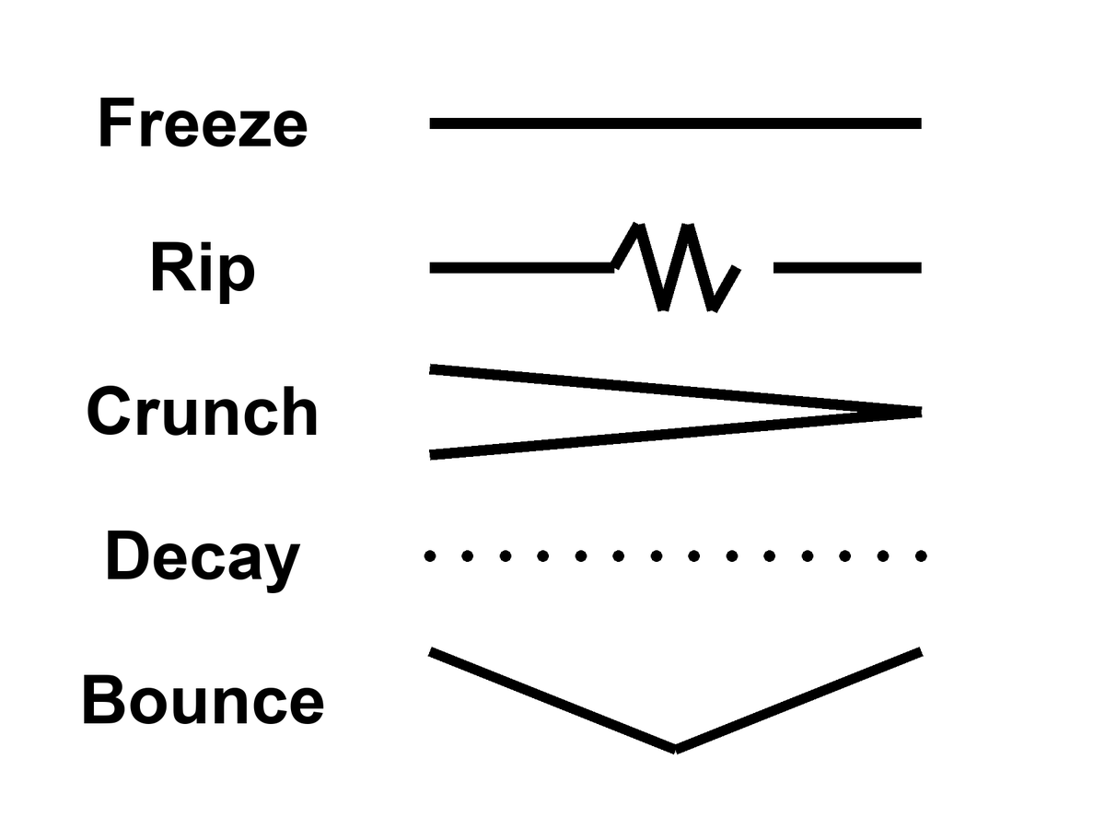
Figure 44. Five rows, one word each: Freeze, Rip, Crunch, Decay, Bounce.
Notice what is not on the list: a required forever-mind. Notice what is on the list, quietly, as a project rather than a fate: a greenhouse, a dark sea, a machine that does not sleep. Those do not close the cosmos. They occupy a few more worldlines before the fade. That is the only closing this book will bless.
Appendix A44 writes w, decay rates, bounce conditions. Here, pick the default without romance: a long accelerating stretch, islands going dark, the leftover glow thinning until even the holes begin to leak. If you want a prettier last page, write it yourself, in a room, while there is still a room.

45. Does Time Exist?
We have used “time” as if we knew.
In the kitchen, time is the clock. In relativity, time is a direction in the loaf, mixed with space, sliced differently by walkers. Proper time is a length of thread. The leftover glow picks out a useful slicing — cosmic time — because the glow is almost the same everywhere and we can watch it cool. That slicing is a convenience the universe approximately offers, not a throne.
The wall clock is still the right tool for a casserole. It is a terrible cosmology. GPS, as Chapter 5 showed, is the grown-up version of the same split: thirty-eight microseconds a day of geometry that a phone must correct to find the street. You do not need a philosophy of time to land a plane. You need the interval. That is the first honest answer, and it is hot.
Does time exist? The honest answers come in flavors.
Yes, as geometry. Spacetime has a metric. Intervals are real. This is the hot answer, and it is enough to run GPS.
Enough, also, to run the twin who comes home younger, the particle that lasts longer in the lab, the radio that answers twenty minutes late. An event is a happening. The interval between happenings is the thing the geometry cares about. Proper time is how much of that interval a particular thread accumulates. “Does time exist?” in this flavor is like asking whether length exists. Length is a relation among events along a ruler. Time is a relation among events along a worldline. The relation is as real as the casserole’s doneness. The throne — a universal now the relations are painted on — is what the kitchen clock invented and relativity retired.
Yes, as an arrow, but the arrow is a boundary. The laws do not prefer a direction. The low-entropy past does. Eggs smash because the beginning was smooth. The Past Hypothesis, David Albert’s name for it, is this sentence in a better suit.⁸⁸ If the past had been a scramble, we would not have a “we.”
The microscopic rules run as well backward as forward. That is not a rumor. It is a feature of the equations that got the three minutes right. The arrow you feel — memory, cause, the way a cup does not unshatter — is not a second law hiding in the metric. It is a fact about the region we call the past: it was special, smooth, low in the kind of mess that would have been a heat death at the start. From a special past, the typical futures are messier. That is the arrow. It is hot as a thermodynamic fact in kitchens and stars. It is warm as a cosmological claim: we do not have a derivation of why the past was special. We have the leftover glow as a photograph of a smoothness, and a name for the postulate that says the smoothness was there. The Past Hypothesis is that name. Without it you do not get observers who remember. With it you do not need a river.
Memory is the arrow made intimate. You remember the special past because the special past left records, and records are a kind of order: a photograph, a scar, a leftover glow, a notebook of beaks. You do not remember the fade because the fade has not left you a fossil of itself in your head. That is not a failure of the brain. It is what a boundary condition looks like from inside a thread. An egg smashes and does not un-smash for the same reason. The laws would allow the un-smash. The past would not. The kitchen already knew this before it had a name. Cosmology’s job was to notice that the leftover glow is the same kind of fact, written on the sky.
Not as a river. There is no glowing NOW moving down the block. Chapters 1 through 6 were that retirement.
Maybe not as a fundamental word. In some attempts to quantize gravity, the wave of the universe does not mention time. The Wheeler–DeWitt equation is a constraint, a “this must add up,” not a “this happens next.” Julian Barbour takes the hint all the way: the inventory is configurations, Nows, a heap. Dynamics is what a heap looks like when it contains records of other heaps. Carlo Rovelli takes a different hint: time is what a system with heat says about itself. Thermal time. A useful word for a useful state.
Wheeler and DeWitt wrote a wavefunction of geometry that sits still:⁸⁹ Ĥ Ψ = 0, no external t on the page. That is the problem of time in quantum gravity, and it is not a slogan. If the whole loaf is the system, there is no clock outside it to say “next.” Time, if it is to be recovered, has to be recovered from inside: a subsystem that can serve as a clock, a semiclassical limit where a geometry becomes classical enough to have a t, a relational fact among degrees of freedom. One family of recoveries, begun by Don Page and William Wootters, says: treat part of the universe as a clock and ask how the rest correlates with it.⁹⁰ Another says: when the geometry is large and gentle, a WKB limit hands you something that looks like the Schrödinger equation in a t that was not fundamental. Warm-to-cold as a research program. No experiment has selected the recovery. The GPS clock does not adjudicate this fight. GPS lives in the limit where the recovery has already succeeded, or was never needed, because the metric is classical enough to land a plane.
Barbour’s heap is the austere version. The world is a pile of Nows — instantaneous configurations — and what we call motion is a correlation: this Now contains records that match that Now, the way a brain contains a memory that matches a room. There is no moving spotlight. There is a heap with internal likenesses. It is a picture that takes “no river” all the way to “no primitive duration.” It is cold. It is the right kind of cold: it does not add a someone, and it does not contradict GPS, which lives in the classical limit where the heap looks like a loaf.
A tempting merger waits here, and Chapter 38 already taught the habit for refusing it. Barbour has a heap of Nows. Everett has a sum of branches. Both say the inventory is bigger than the slice you remember. Put them in one coat and you get a slogan: every possible Now exists, so the multiverse is just the heap. Two drawers, one bench.
Open them one at a time. The heap is configurations: every arrangement the stuff could have, one point per arrangement, whether or not anything in it remembers anything. That is configuration space, a map of the possible. Everett’s branches are not points on that map. A branch is a term in the wave that has decohered from the other terms, a pattern of records that agree with each other about which face the coin shows. Most points in the heap belong to no branch worth the name. They are scrambles with no records at all. A branch is a thin, well-behaved thread through the heap, picked out by decoherence. Not by time. Not by being possible.
Barbour did build a bridge. In his picture the wave of the universe piles its weight on the Nows that hold consistent records, which he calls time capsules. That is a bridge between two drawers, not a fusion of them. It is a proposal about where the weight sits, and nobody has derived it from anything we can test. The GPS clock is no help here either. It lives in that classical limit.
Hot: decoherence is a measured rate. Warm: Everett as a reading of the rule that builds chemistry. Cold: the heap as the fundamental inventory, and the time capsules as its weighting. Colder than any of them: the fused slogan. Possible is not the same word as realized. A map of every arrangement is not a census of worlds.
Rovelli’s thermal time, worked out with Alain Connes, is a different recovery.⁹¹ A system with enough heat, enough statistical mix, can have a flow defined by that mix: time as what equilibrium says about itself. In ordinary kitchens this is overkill. In a quantum gravity where no t is on the page, it is a candidate for where the word comes back. Cold-to-warm. Allowed. Not a photograph.

Physics vs philosophy: from quantum gravity to “time is emergent”
What physics establishes. In the regimes we can test, time is part of a classical spacetime geometry, and clocks agree with relativity to the precision of GPS and optical clocks. Some approaches to quantum gravity produce equations with no external time at all.
What is open research. Whether time is fundamental or emerges from correlations, from heat, or from a large-scale limit of something timeless. None of these proposals has an experimental test yet.
What this book infers. Only the modest part: time exists as relations among events, whatever deeper story recovers it. “Time is an illusion” is not a result of physics; it is a reading of unfinished research.

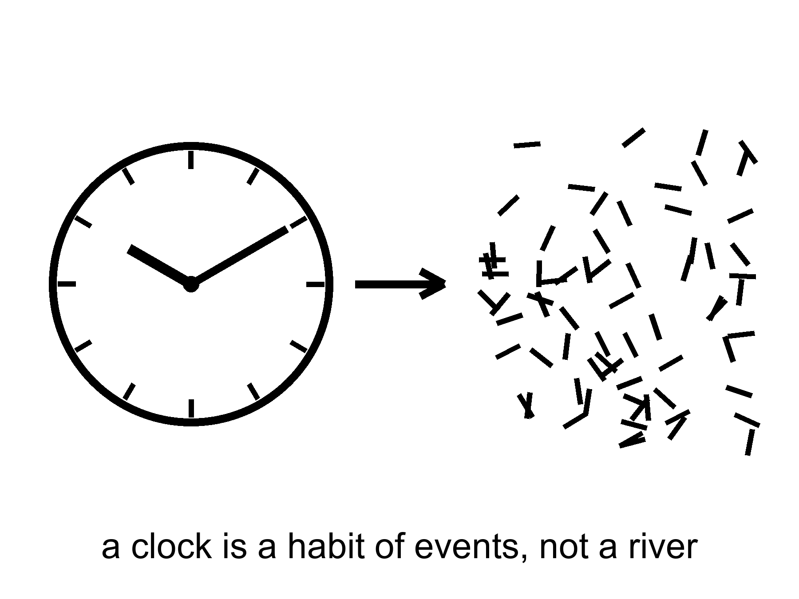
Figure 45. A clock face dissolving into marks. A clock is a habit of events, not a river.
Hartle and Hawking’s no-boundary idea tries to replace⁹² “before the bang” with a rounded-off geometry, time crystallizing only when the universe is large enough to have it. Vilenkin tunnels from nothing, which is a technical nothing, not a kitchen nothing. These are cold, and they are the right kind of cold: they are attempts to stop using a word where the word may not apply.
This book’s working answer, the one that can carry a greenhouse and a dark sea: time exists as relations among events. It does not exist as a stage the events are put down on. It may not exist, in the quantum-gravity limit, as a primitive. The arrow exists because the past was special. You exist as a thread that remembers the special past and cannot remember the fade. That is enough to call it morning.
Hot: intervals, GPS, the arrow as a fact about a smooth past. Warm: the Past Hypothesis as the name of that smoothness; cosmic time as a convenience. Cold: a primitive t in the quantum-gravity wave; a waiting room labeled BEFORE; a river. The working answer sits in the hot and the warm and lets the cold stay cold. That is how this book has used temperatures since the front. It will not stop at the last chapter but one.

46. The Honest Ending
Here is what each recognition lets you do, once it has arrived and stayed.
An event is a happening: so you stop asking where the casserole “is” in time and ask which happenings it is between. “Now” is a slice you draw: so you keep the word for the kitchen and retire it for Andromeda. The past we can rebuild is a region: so the three minutes are not a myth you are being asked to respect, they are a workshop whose tools you still own. Most of what pulls does not shine: so you weigh by lean, not by glow. Most of the budget shoves: so the future is a fade unless the shove is a liar, and a required last mind is a story. A horizon is a one-way fact: so you do not book a door. A handle is a bill: so you do not staff a subway. Copies are four kinds: so you do not fuse them and then sell a ticket. Arrangement is a filter: so you do not crown the fish. Time is a relation: so the wall clock stays a tool. Each of those is a refusal that leaves a project standing. The project is the point of the cash.
And then the part the leftover glow does not owe us:
A dead world can hold a greenhouse if someone bullies the ice and the hours. A frozen moon can hold a sea if a giant squeezes it, and that sea can hold a second origin or an empty kitchen, and the only way to know is to melt and look, without poisoning the answer. A crew that does not sleep can carry a library farther than flesh. The library is a physical object. The project can fail. Failure is allowed. Destiny was the thing that was not allowed.
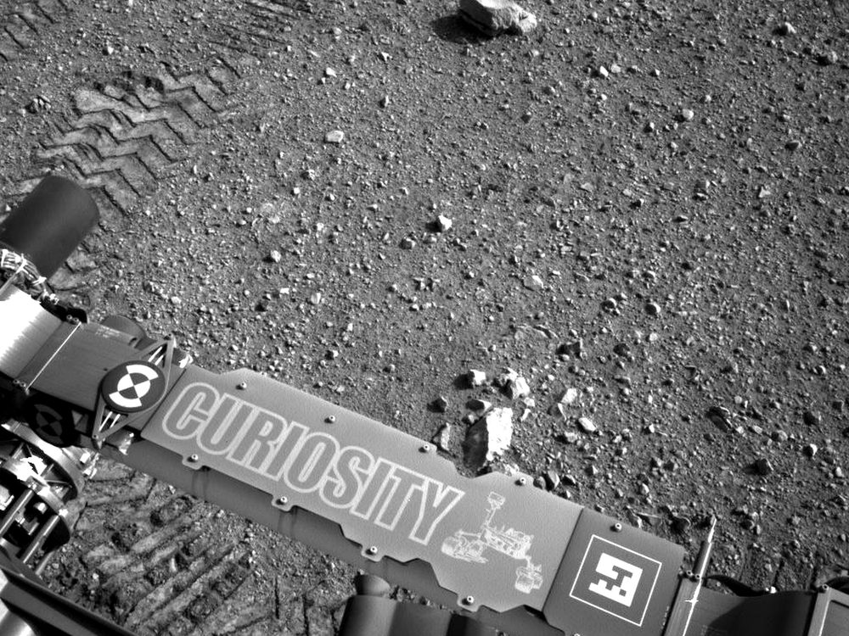
Figure 46. Rover tracks toward a near horizon. Meaning is local, on one worldline.
If every allowed outcome is on the inventory, this outcome is still the one with your hands in it. If the block is real, the basil you log on a cold morning is as real as the leftover helium. If the block is not quite real, if time is a heap of Nows, the heap still includes the smell of a lie in a room of LEDs. You do not need the universe to have a purpose in order to have a purpose in it. You need a permit — water, carbon, a little quiet — and a refusal to wait for the ending to compute you back.
Local, on one worldline. That is the moral the field equation will not write and does not have to. Everett, if you buy the reading, puts other outcomes on the inventory. The cheap copies, if space is that large, put other kitchens out of reach. Neither of them cooks this basil. Grief is still a fact about one thread. So is a project. So is the decision not to plague a dark sea. Meaning that had to be scheduled at crunch was a way of not having to decide. Meaning that is local is a way of having to.
Is there a path to ultimate knowledge?
There is a path. There is no chapel at the end of it, and the word ultimate is a temptation physics itself refuses.
Knowledge, in this book, is a record you could have missed. A prediction that can fail. A fossil that does not need your agreement: the glow, the helium, the stretch, the ring around a hole, a leftover in a navy file that still has no name. The path is the widening of that kind of record — not a feeling, not a collapse of the ocean when you look, not a framework that can survive every outcome and therefore explains none.
Darwin’s notebook was already the whole method. A pile of beaks. A sentence that could die. Wallace’s letter. The leftover glow is that habit aimed at a fog. Weinberg’s three minutes are that habit aimed at a workshop. The bombs of 1998 are that habit aimed at a future that did not want to recollapse. A melt that tastes a sea is that habit aimed at a lid of ice. The path does not change species when the subject changes. It does not become a chapel when the subject is spacetime. It stays a record you could have missed. Lengthen it. Do not crown it. Do not build a last room and call the room God.
Learn the bills. Special relativity: no shared now, no local dash past light, mail that is late on purpose. General relativity: gravity is the loaf; a handle and a bubble are sentences that still owe a stuff we have not stacked. Quantum mechanics: amplitudes, decoherence, pairings without a telegram. The seam where the two great theories do not yet share a kitchen is the largest honest hole we have. Sit in it. Do not furnish it with a visitor or a god of the gaps.
Learn the walls. An event horizon is a fact about influence. A cosmic event horizon is a fact about which galaxies will never get your letter. A branch, if Everett is right, is a fact about a term you cannot enter. “Before the fog” may not be a word. Those are not insults. They are the shape of what a worldline is allowed to know.
Knowing the walls is part of the path. It keeps you from spending a life on a ticket that was never for sale. It also keeps you from despair: the rooms that are in your future cone — a dead world with ice in its bones, a moon with a sea, a dish that can hear a shout — are not small because they are not the whole loaf. They are the part of spacetime a thread can still work.
Refuse what cannot die. A story that fits every leftover glow is not a story. String theory, as it stands, has not named a kill-shot. A craftsman who leaves no channel nature does not use has not clocked in. An observation-creates-life that cannot say what counted as the first observer is a regress, not a path.
Build the next record. A telescope that can smell an oxygen-methane pair and be wrong. A dish that can hear a shout and know the shout was not the ionosphere. A melt that tastes a dark sea without writing over it. A library that is a box, not a sermon. A legislature, even, when it is doing its only smart job: asking whether the leftover in its own air is an adversary, a secret of its own, or a file that still says unidentified. That last is not ultimate knowledge. It is hygiene.
What would ultimate have to mean, if we kept the word? Not a God’s-eye inventory of every branch, every before, every event outside our cone. That inventory, if it exists, is not a destination. Ultimate, for a thread, is asymptotic: more of the universe brought into a record that can fail, fewer sermons in the gaps, a closing of the QM–GR seam if the seam can be closed, a second dictionary under ice or a clean empty, a leftover named or honestly unnamed. You will not finish. The fade, if the fade is coming, will not wait until you finish. The point of the path is not to arrive at a last fact. It is to be the kind of worldline that can tell a last fact from a mood.
Lengthen without a chapel. That is the whole close, if you want it in four words. A chapel is a last room that cannot be wrong. This cosmology has no such room. It has a kitchen clock that is still useful, a leftover glow that is still late, a shove that is still winning, a seam that is still a hole, and a handful of projects that still might fail. That is a richer inventory than a throne. It is also a ruder one.
The clock on the kitchen wall is still lying. Let it. Take the casserole out. Then, if you have the years and the machines and the tact not to plague a dark sea, send a library. Not because the universe requires it. Because you can, and because the fade, if the fade is coming, will not be hurried or helped by your waiting.
That is the honest ending. It is not a door. It is a door you build, on a world that did not ask for one, under a sky that is late on purpose. It is also the only path this cosmology can sign: widen the record, pay the bills, stop at the walls, and do not hire a someone to finish your homework.
Said once, in the plainest words this book has:
Relativity gives us events, intervals, worldlines, and causal limits, not a universal present. Cosmology gives us evidence and open problems, not destiny. Meaning remains local, optional, and real.
Meaning, if you still want the word after forty-six chapters, is local, optional, and real. Optional, because nothing in the field equation requires it. Real, because a project on one worldline is as much an event as the leftover helium. It lives on one worldline, in a room that smells like a lie, under a clock that was never a cosmology. Grow the basil. Log the pH. Melt if you can do it without writing over the answer. Send the box if you have the tact. Admit that the dirt can vote no. That admission is not despair. It is the difference between a project and a destiny, and it is the last recognition this book will cash.

APPENDIX — The Scientific Detail

How to Read These Notes
Each note An twins popular chapter n. Units are SI unless stated. c is the speed of light, G Newton’s constant, ħ the reduced Planck constant, k Boltzmann’s constant. A scale factor a(t) is dimensionless; today a₀ = 1. Cosmological redshift z obeys 1 + z = 1/a for light emitted at a. A gravitational redshift, as in Pound–Rebka, is a different relation.
String theory, whenever it appears: a mathematical framework that cannot currently be tested. It has not produced a unique, risky prediction that would kill the whole idea if the experiment came out otherwise.
These notes are denser than the chapters they twin. They are still this book: short sentences, named measurements, temperatures on the claim. They are not a textbook. If a formula is numbered (1)–(17), the number is a handle, not a homework set. Row (18) is a standing rule, not a formula.

A0. Three Temperatures of Claim
Hot: repeated measurement, used to predict new ones. Warm: best model, real gaps. Cold: allowed by the equations, not selected by the data. A claim can change temperature. The oven is the sky, not the seminar.
Inflation is the cleanest change-of-temperature in this book. In 1981 Guth’s paper was a proposal: a brief early burst of repulsive stretch that could solve the horizon, flatness, and monopole problems the hot bang, taken alone, cannot. The first (“old”) inflation stalled on how to end the burst without emptying the universe of matter. In 1982 Albrecht–Steinhardt and Linde supplied slow-roll exits. That was still a model. What warmed the local burst was later data: a sky that is spatially flat to a percent; a primordial spectrum with n_{s} a few percent below 1 (A14 (in Book 1)); acoustic peaks in the leftover glow that match a nearly scale-invariant twitch stretched outside the Hubble radius and then brought back. Those are not proofs that a particular inflaton exists in a detector. They are reasons the local burst is no longer a 1981 maybe.
A claim can also cool. In March 2014 BICEP2 announced B-mode polarization at degree scales and offered a tensor-to-scalar ratio r ~ 0.2. Primordial gravitational waves from a high-scale burst would have been a trophy. Within a year Planck’s dust maps and the joint BICEP/Keck–Planck analyses showed that Galactic dust, not a primordial tensor background, carried the signal. The measurement was real. The interpretation was not. Current combinations (BICEP/Keck plus Planck) put r ≲ 0.03–0.04 at 95% confidence, depending on the data cut. High-scale inflation of the 2014 headline is colder than it was on announcement day. The local burst is still warm. Eternal inflation — self-reproducing pocket nucleations, a measure problem, no unique risky number — did not inherit the warming. It stays allowed and unselected.
Temperature is a discipline, not a mood. “We have a picture of a black-hole shadow” is hot. “The interior is a bounce into a baby universe” is cold. String landscapes, when named, inherit the standing rule (18). Use the labels in that spirit for the rest of these notes.

A25. Mars Numbers: Δv, Delay, Life Support
These are permit numbers. They are not a colony plan, a city budget, or a sequel.
Earth–Mars light time: ~3 min at closest approach, ~22 min near solar conjunction; one-way. You do not converse. You send, and wait. Hohmann-like transfers: ~6–9 months (a standard 145-day-class fast transfer costs more Δv; a 259-day textbook Hohmann is the cheap ellipse). Synodic window: ~26 months. Miss it and you wait two years.
Δv: LEO to trans-Mars injection ~3.6 km/s; Mars capture and circularization ~2 km/s class for a propulsive orbit, plus a lander budget of several more km/s if you do not aerobrake. Aerobraking and aerocapture trade heat shield for propellant. Surface gravity 0.38 g. Solar constant ~43% of Earth’s. Atmosphere ~6 mbar (6.1 mbar mean), ~95% CO₂, argon and nitrogen in the remainder — a vacuum by kitchen standards, a resource by ISRU standards. Mean surface T near −60 °C; equatorial summer afternoons can sit near 0 °C. Water ice is mapped at mid and high latitudes (Phoenix; SHARAD; neutron spectroscopy); equatorial “dry” is not globally dry at depth.
Perchlorates: Phoenix wet chemistry found ~0.5–1% by mass in the soil, mostly as Mg/Na perchlorate. That is a toxic oxidizer and a hygroscopic brine ingredient, not a mood and not automatically a nutrient. Plant growth needs imported or generated O₂/N₂ buffers, water that has been scrubbed, and radiation shielding. GCR plus solar protons at the surface are lower than in cruise (A32) because of the planet’s bulk, higher than under Earth’s atmosphere and magnetosphere. A greenhouse on a dead world is an engineering permit. It is not a biosphere, not a city, and not a reason to treat Earth as optional.

A26. Particle Horizon vs Cosmic Event Horizon
Particle horizon: comoving integral χ_{p} = ∫₀^{t₀} c dt / a. It is how far a photon has been able to travel since a = 0 (or since the end of a burst, if you cut the integral there). In working ΛCDM, the proper radius of the particle horizon today is ~46 billion light-years — larger than c t₀ ≈ 13.8 Gly because the universe expanded while the light was in flight. That is the radius of the observable universe.
Event horizon (ΛCDM with Λ > 0): χ_{e} = ∫_{t₀}∞ c dt / a, finite when a ~ exp(H_{Λ} t) at late times, H_{Λ} = c √(Λ/3). Galaxies with comoving distance χ > χ_{e} will never receive a signal we send today. The current proper radius of that event horizon is ~16 billion light-years. The Hubble radius c/H₀ is ~14 Gly for H₀ ≈ 70. Three different lengths; three different questions. Do not swap them.
The leftover glow comes from χ just inside the particle horizon (last scattering is not a = 0). Most galaxies we photograph already lie outside today’s event horizon in the sense that our “hello,” sent now, will never arrive — even though their ancient light is still arriving here. That is Chapter 26’s leaving. It is not a door closing on the past cone. It is a door closing on the future cone of this event.

A27. Finding Worlds You Cannot See
Transit depth δ ≈ (R_{p} / R★)². An Earth–Sun transit is (R_⊕ / R_⊙)² ≈ 84 ppm; a Jupiter–Sun transit is ~1.1%. Kepler, TESS, and ground surveys have turned that percent and that 84 ppm into a census. Radial-velocity semi-amplitude K ∝ M_{p} sin i / (M★^{2/3} P^{1/3} √(1−e²)). An Earth at 1 AU on a Sun analog is K ≈ 9 cm/s — at the edge of the best spectrographs. A hot Jupiter is K ~ 50–200 m/s, which is why the first detections were massive and close.
Occurrence: most FGK stars host planets; Kepler’s conservative yield is more than one planet per star on average. Mini-Neptunes (R ~ 2–3 R_⊕) are common; a radius valley near 1.8 R_⊕ separates stripped cores from those that kept envelopes. Earth-size planets in conservative habitable zones of GK dwarfs sit at occurrence ~0.1–0.2 depending on the paper — a rate, not a biosphere count. Direct imaging (GPI, SPHERE, JWST) and microlensing (OGLE; Roman in the future) are rare, complementary, and biased to wide, young, or unaligned systems. Timing of transits and TTVs give densities when you have both R and M; a 5 M_⊕, 1.6 R_⊕ world is not Earth.
Atmospheric transmission spectroscopy measures molecular bands during transit. H₂O, CO₂, CH₄, CO appear in giant and sub-Neptune atmospheres; O₂, O₃, CH₄ as a set are candidate biosignatures, not proofs. Photolysis makes O₂; geology and haze fake CH₄; abiotic CH₄–CO₂ pairs exist. JWST has smelled CO₂ on a transiting sub-Neptune and water on giants. That is chemistry. It is not a second origin. Look first, then name the gas.

A28. Circumstellar Habitable Zones
Kopparapu et al. (approximate, Sun): conservative moist-greenhouse to maximum-greenhouse limits ~0.99–1.7 AU; recent-Venus to early-Mars optimistic limits wider (~0.75–1.8 AU). Insolation S ∝ L / d²; L depends on spectral type and age. A G star at 4.5 Gyr is the hired case. An M dwarf’s HZ sits at ≲ 0.2 AU (TRAPPIST-1’s temperate planets are ~0.03–0.06 AU). Tidal lock is likely; flare and XUV stripping of atmospheres are the invoice; M-dwarf habitability is a research program, not a yes.
HZ is a permit for surface liquid water, given an Earth-like atmosphere and a carbonate–silicate thermostat you should not take for granted. It is not a biosphere detector. The inner edge is a moist-greenhouse runaway: stratospheric water, UV photolysis, hydrogen escape. The outer edge is the maximum greenhouse: CO₂ condenses and the warming saturates. Both edges move if you change surface gravity, N₂ inventory, or rotation. Venus is in a generous optimistic zone and is a 90-bar CO₂ oven at ~735 K. Mars is near the outer edge and is a 6 mbar desert (A25). Moons of giants can sit outside a stellar HZ and still host liquid water on tidal heat (A29). A K dwarf’s HZ is closer in than the Sun’s and quieter than an M dwarf’s; that is why some occurrence papers prefer it. Do not use the cartoon ring as a census of life.

A29. Tidal Heat, Ice Shells, and Dark Seas
Tidal power scales roughly Ė ∝ (G M_{p})² R⁵ e² / (a⁶ μ Q) (order-of-magnitude; e eccentricity, μ rigidity, Q dissipation). Io–Europa–Ganymede 1:2:4 Laplace resonance maintains e. Io’s Ė is measured as heat (~10¹⁴ W); Europa’s is inferred. Europa: ice shell perhaps 10–30 km (thicker in some gravity/induction models), ocean O(100) km. Induced magnetic field (Galileo) already implies a global conductor; Hubble and JWST have argued for plumes and then argued with themselves — plumes remain warm as a claim, not a scheduled geyser. Surface in Jovian belts: O(10²–10³) rem/day (~1–10 Sv/day) — lethal; the ocean is shielded by ice and water column.
Enceladus: south-polar plume (Cassini), salinity, silica nanoparticles (hydrothermal hint), H₂, organics. The plume is a sample without a landing. Ganymede: intrinsic field; possible stacked oceans separated by high-pressure ices. Titan: surface lakes are methane (A31); a deep water–ammonia ocean is a gravity/shape inference, not a beach. High-pressure ices (VI, VII) on larger worlds may limit water–rock exchange — open problem. Rogue planets: radiogenic plus primordial heat under a thick ice blanket can maintain a sea (Stevenson-type thermos). Look-first rule: induced field and plumes before slogans. Oceans are warm-to-hot. Life in them is not a detection.

A30. Second Origins, the Code, and What Life Eats
Sample size N = 1. Operational life: Darwinian replication plus a metabolism on a gradient. Viking LR (1976): labeled-release gas at ~15 °C that did not repeat after a 160 °C heat control, contested then and now as abiotic soil chemistry (peroxides; perchlorates, later measured) versus a metabolism. Biosignature pair O₂+CH₄ is a disequilibrium test, not a verdict.
Universal genetic code on Earth is a LUCA signature (frozen accident ± modest error-minimization), not a cosmic typesetter. Same codon table on a second world: contamination or panspermia, not independent invention. Pairing polymers warm; exact DNA alphabet cold. LUCA, as a node, sits before ~3.5–3.8 Ga on the terrestrial clock; that is a date for this tree, not a cosmic requirement.
Cannibalism: common in metazoa (not a zoological ban). Human near-taboo is a filter, not a field equation. Leading meshes: species-specific pathogens/prions (kuru; BSE from intra-species feed); kin selection; retaliation in social species. Inter-trunk predation (them eating us) is not cannibalism; chirality/code mismatch still makes us a poor default lunch.
Sex is not immortality: soma dies; lineage continues (Weismann). Asexual fission/clones are the common terrestrial default by time and census; sex is costly (two-fold cost of males) and still common in large parasite-exposed taxa. Warm accounts: Red Queen, Muller’s ratchet, recombinational repair — not a unique cosmic requirement. HGT is mixing without meiosis. Individual biological immortality is rare and still mutates. Expect some genome mixing where parasites + time exist; do not expect two sexes and a child-as-afterlife.
Reward, not pamphlet: sexual pleasure as a selected carrot for an expensive shuffle (wanting/seeking vs liking/completion; pair-bond peptides as a warm extra where young are costly). Asexuality and drive variation are lottery outcomes, not cosmic defects. Pornography as supernormal stimulus (Tinbergen): cue louder than the costly act; watchfulness plus cheap infinite images is Pleistocene wiring against an industrial supply (same family as refined sugar, intermittent-reward machines). Not a universal sophont law; warm that any reward loop can be spoofed once recording is cheap. No off-switch labeled “depiction only.”

A31. Other Chemistries, Missing Body Plans
Alternative solvents are papers, not zoos. A solvent must dissolve reactants, permit transport, allow a compartment, spare the polymers, and host a gradient. Water is the hired case, not a cosmic sacrament.
Titan (Cassini; Huygens, 2005): surface T ≈ 94 K, P ≈ 1.47 bar, N₂ air with CH₄ weather; lakes/seas of CH₄/C₂H₆ (radar-dark, north-polar concentration). No biosphere detection. Liquid-methane relative permittivity ε_{r} ≈ 1.7 vs water ε_{r} ≈ 80 at kitchen T — ions poorly solvated; Earth-like acid–base metabolism is mute. Kinetics: Arrhenius suppression at 94 K makes uncatalyzed lake chemistry a statue; upper-atmosphere photochemistry (CH₄ → haze) can still run. Warm papers, not detections: H₂ + C₂H₂ metabolism (McKay–Smith-type fingerprint: depleted H₂ / acetylene). Azotosomes (acrylonitrile vesicles proposed for liquid CH₄; the molecule is in the air) are cold as membranes: the stability case has gone against them. Dragonfly-class in situ is the next measurement, not a verdict in this note.
Ammonia: 1 atm liquid range ≈ 195–240 K (narrower than water unless mixed or pressurized). Polar, H-bonding; NH₃–H₂O eutectics stay liquid colder. Different acid–base inventory; hostile to Earth proteins. Still a paper.
Concentrated H₂SO₄ cloud decks (Venus-class): liquid in a probe-accessible T band; dehydrating to Earth organics. Tougher aromatics get papers. Phosphine claims were a courtroom, not a census. Colder paper than Titan: we have tasted the lakes; we have argued the mist.
Silicon chains as flesh: weak in water (prefer silica / mountains). Silica scaffolds already exist (diatoms, radiolarians) as coating, not metabolism. Homochirality: a second origin may be mirror-life; terrestrial enzymes would fail on it. “Nitrogen-breathing” as a primary metabolism is not an Earth pathway; N₂ fixation is costly (nitrogenase). Rapid morphological ascent through Earth’s taxa in days is fiction. Rapid radiation given short generation time and empty ecospace is ordinary (microbes; post-extinction recoveries). Contingency: Burgess-type body plans show many fired experiments; convergence (eyes, wings, torpedo bodies, cursorial hunters) shows some re-hiring.
Independent humanoid sophonts: cold (ape bauplan is historical). Independent cetacean sophonts as a default: cold; aquatic nervous systems warm. “Colleague with different ears” is a cultural wish, not a morphology forecast. Planetary-scale hyphal/root nets: Earth has sketches (mycelia; plant-mycorrhizal signalling — do not oversell a global brain). Remote-worn local bodies are engineering (Ch. 32), not a second origin.
Brain volume is a weak predictor once you leave a clade. Cetacean brains are large; corvid and parrot pallia are small, dense, and capable (Herculano-Houzel-type neuron counts beat cubic centimeters). Packing, wiring length, the body the wires serve, cumulative culture, and clock time matter more. A ~30 cm soma is neither a law nor a ban. Warm: a small, fast, dense nervous system can outrun a human-scale skull. Whale-scale tissue without that invoice can fail to. Eusocial colonies are distributed-control sketches, not a proof of a planetary hive-person. Miniaturized humanoids remain cold as morphology.
Parasitoid / host-as-nursery specialists: warm (ichneumonids; Ophiocordyceps); “evil” is the host’s word. Large terrestrial bipedal predators: warm convergence (theropod solution). Saurian intelligence: warm (avian dinosaurs already; troodontid EQ). Saurian civilization: extra filters (surplus, cumulative culture, manipulation, often fire) — not forbidden, not an ape downtown. Russell-style “dinosauroid” humanoid: cold as morphology. Alien cities as non-rectilinear lasting rearrangements (rookery, reef, mound, hyphal net, breathing burrow): the search problem is recognition, not physics. Cave/vent/endolith towns: hot as Earth fact (Movile; black smokers; Naica fluid inclusions). Walking photosynthetic macrofauna: warm permission, no Earth hire.
Endo- vs exoskeleton: both hired (vertebrate bone/cartilage; arthropod/mollusc cuticle). Molting vs fracture-healing are the invoices. Fur/pelage as a boundary layer can dump or block heat (camel coats); “no fur on a hot world” is too crude. Husbandry predates humans: ant–aphid trophobiosis; leafcutter fungal agriculture. Technosignature category error: night lights / vehicle herds misread as the organism, organisms as parasites of the machines — a scale mistake symmetric to missing the ant nest.
Missing on Earth as macro habits: wheels with axial blood supply; silicon endoskeletons as default vertebrate habit; photosynthetic herds; terrestrial coleoid dominance; radial large terrestrial predators; several simultaneous intelligent bauplans from one radiation.
Population structure (ecotypes, subspecies, island morphs): hot as a pattern after isolation + selection. Human folk “races” as discrete biological kinds: a poor map of a recently expanded, highly admixed species (most variation within groups; clines). Exobiology should expect local editions, not Earth’s census boxes. Native/non-native is a timestamp, not an essence; introductions can be polite or invasive. Directed seed into an occupied biosphere = invasion (look first). Humans are range-expanders on Earth and would be the non-native on any other world.

A32. Travel Time, Dose, and Autonomous Systems
At v = 0.01 c (3000 km/s), α Centauri (4.37 ly) is a ~437 yr cruise before deceleration; the galaxy is not a weekend. At 0.1 c, ~44 yr plus a deceleration burn that is itself a propulsion problem. Kinetic energy per kilogram at 0.01 c is ~4.5 × 10¹² J/kg (~1 kt TNT per kilogram); at 0.1 c, a hundred times that. Interstellar dust and ionized gas at 0.1 c are an energy hazard: a 10 μm grain at that speed is a bullet. This note is not a starship catalog. Those two speeds are enough to see the invoice.
Dose. Galactic cosmic rays in deep space deposit ~0.3–0.6 Sv/yr behind thin shielding, order of magnitude; cruise measurements (Mars Science Laboratory’s RAD; astronaut TEPC) sit near 0.3–0.5 Sv/yr depending on solar modulation. A career limit of order 1 Sv (age- and sex-dependent regulatory numbers; ICRP and NASA have moved the digit) is a few years of unshielded or lightly shielded interplanetary flesh, not a century. Solar particle events add rare, sharp sieverts unless you have a storm shelter. A planetary surface is better than cruise and worse than Earth. Europa’s surface is a non-starter for flesh (A29). Autonomy is not a slogan: error-corrected memory, rad-hard processors, in-situ repair, and a control loop that still makes sense after decades of bit flips. Present pattern engines are not a century-stable control system. The chapter is the outlook. Form (android versus drill) is interface, not physics.
AI risk, temperatures: (i) misuse and scale-error by human principals — hot as a class; (ii) loss of institutional comprehension when procedures are model-generated — warm; (iii) agentic takeover via stable goals plus instrumental convergence — extra hypotheses, not a thermal-history-grade fact; treat as a design constraint for reactors, weapons, and long cruises. “Better” is task-relative. Mind as computation versus mind as non-algorithmic (the incompleteness wedge; gravity-linked objective reduction): the second is a minority research program. Both morals of incompleteness are in A41. Current pattern engines are not a someone on either reading. Alignment is local control engineering, not an Omega Point.

A33. Genome Information, Synthesis, and Planetary Protection
Haploid human genome ~3 × 10⁹ bases (~0.75 GB uncompressed, far less with compression and redundancy). A typical bacterium is ~10⁵–10⁷ bases. A biosphere archive is orders of magnitude larger than either if you want ecological function, not a mascot. COSPAR planetary protection: the Policy on Planetary Protection published in Space Research Today (January 2026 edition; Bureau approval 7 November 2025) puts icy worlds under one policy, and a landing that can erase A29’s look-first measurement stays in the strict forward-contamination categories. Mars life-detection sites are stricter than a flyby. A restricted Earth return is the invoice if a sample might still be a kitchen. Directed panspermia (Crick and Orgel, 1973, as an idea) is engineering plus ethics, not a detection. A first-ocean seed on the early Earth would be absorbed into the LUCA signature and is not presently distinguishable from a local origin. “Messages in junk DNA” have not survived as a channel nature does not use. Synthesis from sequence requires wet-lab machinery that must itself survive the trip. Eusocial Earth sketches are the scale reminder: competence at nest-size is not a colleague. Look first. Seed later. A library poured into a sea that already copies is a conquistador. The same library, on a world whose exam has already been graded empty, is a greenhouse.
A closed ecology is a queue, not a portrait: a pioneer film, then a dirt that film makes, then a rooted producer that needs the shade and the soil it did not arrive with. Shipping the last organism without the first is a corpse with a pedigree. The useful first print is an assay — a metabolism whose waste you can see from outside the room (a gas, a pigment, a pH shift) — so a dead printer, a refusing room, and a corrupted recipe are three different failures. Keep at least two copies of the archive in two radiation environments, plus a key a person can still sound out when the catalog’s format has died. Do not pack a mirror biosphere “for completeness” (A31). An empty exam gets the chemistry we have run. An occupied sea gets the box left shut.

A34. Einstein–Rosen vs Traversable Throats
ER bridge: Kruskal throat, non-traversable, pinches in finite proper time (A22 (in Book 1)). Morris–Thorne (1988): static, spherically symmetric, flaring-out condition at the throat requires ρ + p_{r} < 0 in the appropriate frame (exotic). Mouths appear as spheres, not holes in a floor. A traversable throat is a metric you write down, not a tunnel you have dug.
Energy Conditions and Quantum Inequalities
(17) NEC: T_{μν} k^{μ} k^{ν} ≥ 0 for all null k. Traversable throats need NEC violation near the throat. Ford–Roman inequalities bound the magnitude × duration of negative energy in a given volume. Macroscopic, long-lived throats are likely forbidden; not a theorem covering every QFT-on-curved-space loophole.
Alcubierre (1994): a shift vector that contracts the loaf ahead and expands it behind; the cabin can have small tidal forces; the ship’s local four-velocity stays timelike and subluminal. Effective superluminal arrival vs a long-way light signal is a global, not a local, fact. The bubble wall requires T_{μν} that violates the WEC/NEC (exotic). Energy estimates have been reduced by wall-shaping (van den Broeck; Natário; later “warp shells”); they remain enormous and still exotic. The forward wall is typically outside the cabin’s causal past — you do not control or ignite the geometry from inside without pre-arranging the path (or a receiver). Krasnikov tube: modify g_{μν} along an outbound worldline so the return is short; still exotic, still paving. Superluminal effective travel in GR can be arranged to yield CTCs; chronology protection (A36) is the same unpaid insurance as for wormhole mouths. No laboratory metric-engineering. “Warp” laboratory claims to date are not an Alcubierre drive.

A35. What Would Count as Evidence of Intervention
A message in a channel nature does not use (narrowband, prime-modulated, a sightline that is not geochemistry). A correlation in the CMB that is not a Gaussian twitch plus foregrounds. “It looks pretty” is not a test. Absence of such signatures is not a proof of absence; it is why the craftsman stays cold.
Old Kingdom Egypt: cardinal alignment of Khufu’s pyramid to true north at the few-arcminute level; Sirius/Sopdet heliacal rising tied to the civil/flood year; decanal star clocks; surveyed cubit architecture (seked slopes). Worker villages, quarry logistics, Wadi el-Jarf papyri: terrestrial workforce, not a missing physics. Orion-correlation / “encoded π as a telegram” claims are selection plus later reading; not a testable intervention channel. Precession as a named phenomenon is Greek (Hipparchus); Egyptian sky-work does not imply a forgotten FLRW cosmology. The obvious residual is competence. The visitor is the sermon.
UAP residuals (public): 2004 Nimitz / Princeton — the stubborn file: Aegis radar tracks + two-pilot visual + ATFLIR on a wingless, plume-less object; 2014–15 Roosevelt “Gimbal” / “GoFast” (single-sensor IR; prosaic accounts exist and may be right); 2017 reporting; 2020 DoD authentication of the tapes; 2021 ODNI (most cases data-poor; a minority unusual); NASA UAP study (2023) and AARO historical record (2024): no confirmed extraterrestrial technology, some later-identified U.S. programs, no verified exotic wreckage in the public record. That is not the same sentence as “nothing was there.”
Single-sensor IR without range cannot fix size or speed; camera rotation and parallax mimic miracles. Multi-platform leftovers still require a prior: classified terrestrial (own or adversary) is the least-new-physics fit and is already an admission of remarkable hardware if true. “I don’t know” is the correct residual for the best public cases. What would name the residual: range-complete multi-sensor kinematics that exceed on-board energy; physical samples with non-terrestrial isotopic/microstructural signatures; a communicative channel that can be missed.
Visitor hypotheses vs this book’s physics: future-us requires CTCs or a sideways foliation (A36–A37; chronology protection warm-to-cold). Everett branches do not admit hops or signals (A41). Interstellar arrival is a Chapter 32 project, not a dogfight. Traversable “beam-in” still owes the exotic-matter bill (A34) or a local assembler (A33). Telepathy: no established extra information channel; still bounded by carriers we already have.
Congressional UAP sequence (public): 2017 reporting on AATIP; 2020 DoD video authentication; FY2021 intelligence authorization → 2021 ODNI preliminary assessment; 2022–24 hearings; Schumer–Rounds UAP disclosure language (thinned). Institutional motives that do not require an extraterrestrial conclusion: air-domain awareness (UAS, adversary systems), SAP/oversight ambiguity, stigma as an operational defect, reports near strategic sites. Witness claims of non-terrestrial retrieval remain claims until the hardware tests above are met.
Light-Travel Contact and Information Bounds
Round-trip time 2d/c: 8.7 yr for α Cen, ~4,000 yr for a star on the far side of the Galaxy’s disk, ~5 Myr for M31. Drake’s equation N = R* × f_{p} × n_{e} × f_{l} × f_{i} × f_{c} × L is a parameterization of ignorance, not a measurement; several factors are still N = 1 or an occurrence rate from A27, not a communication census. Information capacity of a noisy channel is Shannon’s C = B log₂(1 + S/N). A 1 Hz carrier with a miserable signal-to-noise still needs photons, a dish, and a time slot; a biosphere under ice (A29) may have no EM leakage at all. SETI is a search in a thin slice of the habitable map — radio and some optical, a fraction of the sky, a fraction of the duty cycle. That thinness is why a null is not a proof of emptiness. It is also why a headline “we heard them” owes a channel nature does not already use.

A36. Worldlines and Self-Consistency
Novikov principle: the probability of events on a closed timelike curve (CTC) is consistent; paradoxical histories have measure zero. This is a consistency condition on the block, not a dynamics that “prevents” edits. There are no edits. If a CTC exists, the solution of the field equations plus matter is already a loop. You do not climb into it and change Tuesday. You discover that Tuesday was always the loop.
Metrics That Admit CTCs
Gödel (1949): a rotating dust universe with Λ < 0 (or an equivalent tension) and vorticity ω tied to the density so that 4πGρ = ω² in the original normalization. Every event lies on CTCs. Angular velocity of the matter is not a small Lense–Thirring twist; it is the geometry. Our universe is not Gödel’s. Planck-scale vorticity limits and the leftover glow’s isotropy (10⁻⁵) do not permit a Gödel rotation at cosmological scale. The metric is an existence proof in GR, not a map.
Kerr: CTCs appear inside the inner (Cauchy) horizon in the analytic extension, in the r < 0 region through the ring. The inner horizon is unstable (Poisson–Israel mass inflation): infalling radiation blueshifts and the idealized extension does not survive. Traversable wormhole plus time-shifted mouths (Morris–Thorne plus a twin-paradox boost of one mouth): after a finite operation the mouths become a CTC. Alcubierre and Krasnikov shortcuts can be arranged to the same end (A34). None of these are observational geometries. None are a visitor hypothesis that this book will cash (A35).
Chronology Protection and Cauchy Horizons
Hawking 1992 (Phys. Rev. D 46, 603): as a chronology horizon forms — the first closed null curve, the Cauchy horizon that would become a CTC factory — vacuum stress-energy of quantum fields diverges. The back-reaction is expected to destroy the would-be time machine. That is a conjecture, not a theorem. It has been checked in 2D models and in some 4D examples; loopholes (cut-and-paste, compact extra dimensions, trans-Planckian excuses) get papers. A Cauchy horizon is already a loss of global predictability: the future of the surface is not determined by data on it. Chronology protection, if true, keeps the popular “edit” dead and the “consistent loop” unbuilt. If false, the block can contain loops and still contain no edits. Either way, Tuesday is not a hallway (A37).

A37. Foliations: Why a Stack Is Not a Hallway
A foliation is a stack of 3-surfaces: a time function t whose level sets are the leaves. CMC slices, Gaussian-normal slices, cosmic-time slices in FLRW — different jobs, different stacks. A foliation is bookkeeping. It is not a dimension you can walk with a rocket. Proper time is along a worldline, tangent to the 4-velocity, not along the normal from leaf to leaf as if the normal were a corridor.
“Walking the time direction” is a category error unless new structure is added: a fifth direction, a CTC (A36), a traversable handle (A34), or a second copy of the manifold. Each of those additions brings instabilities or exotic stress-energy or both. Gödel’s CTCs are not a walk across the leaves of a cosmic time; they are worldlines that are already closed, inside the manifold. Hawking 1992’s chronology horizon is what you meet if you try to build a closed worldline from a previously causal stack. FLRW cosmic time t is a convenient foliation because the slices are homogeneous; it is still not a hallway, and a rocket that “goes back to recombination” is a rocket that aims at our past light cone, not at a previous leaf. The popular picture of pages in a book that you flip at will is a picture of a foliation plus a privilege this book does not grant (A4 (in Book 1), A6 (in Book 1)). You may choose a stack to write H(z). You may not treat the stack as a transit system.

A38. Four Claims That Must Not Be Fused
Tegmark’s levels, as a filing cabinet this book will use and then distrust:
Level I: more FLRW volume than our particle horizon — more of the same laws, same a(t), beyond χ_{p} (A26, A39). Level II: other post-inflation vacua, other low-energy constants, pocket universes (A15 (in Book 1), A40). Level III: Everett branches of a universal wavefunction (A41). Level IV: other mathematical structures as equally real worlds.
I and II are cosmological hypotheses. They can, in principle, leave fossils (a bubble wall in the leftover glow; a curvature or Λ we can bound). They have not. A bubble collision would be a disk-like temperature or polarization feature with a specific profile; Planck searches have not named one that survived foregrounds. III is an interpretation of quantum mechanics. It does not add new constants and it does not let you hop (A41). Calling III “a parallel universe you could visit” is a Level I sentence in the wrong filing cabinet. IV is metaphysics: if every consistent math is a world, no measurement selects. Dark matter and dark energy are not levels. They are ingredients in this FLRW inventory (A17 (in Book 1)–A18 (in Book 1)). Fusing “the extra pull” with “a branch” or “a landscape vacuum” is a category error that makes every noun unfalsifiable at once. Give the levels separate temperatures, or do not use the cabinet.

A39. Infinite FLRW and Repeated Hubble Volumes
If the spatial slice is infinite and conditions are ergodic — the same statistical ensemble of Hubble-volume states realized over infinite 3-volume — then a finite Hubble-volume configuration recurs. A Hubble volume has a finite number of modes below a cutoff. Holographic finite-state counting (area of the de Sitter horizon; A23 (in Book 1)) makes “finite” precise: ~exp(10¹²²) states is still finite. Recurrence of a volume as detailed as “you, reading this sentence” is then a Level I expectation at distances so large they are not a travel plan.
Whether the slice is infinite is unproven. Ω_{k} consistent with 0 does not prove infinite extent: a 3-torus can be flat and finite; a closed 3-sphere can have radius far larger than c/H₀ and look flat. Planck-like |Ω_{k}| ≲ 0.01 still allows a 3-sphere with radius tens of Hubble lengths. Topology searches in the leftover glow (matched circles; Cornish–Spergel–Starkman) have not found a small universe; the fundamental domain, if finite, is at least of order the diameter of the last-scattering surface (~20–30 Gpc comoving). That is a lower bound, not an infinity. Ergodicity can fail: inflation can leave residual gradients; a landscape (A40) can make distant volumes not the same ensemble. Level I is a maybe that follows from infinity plus sameness. Both premises are unproved. Recurrence, if it happens, is not a destination and not a copy you can greet (A26, A32).

A40. Landscapes, Measures, and Untestable Frameworks
String compactifications are often said to yield ~10⁵⁰⁰ vacua (and larger numbers in later counts). This is not a tested census. It is a report about the size of a construction in a framework that cannot currently be tested (18). A framework that can accommodate any low-energy constants after the fact is not, so far, falsifiable. Extra dimensions and a “landscape” of possible laws inherit that status. They may be mentioned because popular physics mentions them. They are not results.
Eternal inflation’s measure problem (A15 (in Book 1)) blocks quantitative “prediction” of Λ beyond order-of-magnitude anthropic cuts (A42). Even if you grant the landscape as a menu, you do not have a way to take attendance. Volume weighting, pocket weighting, and observer weighting disagree; some produce Boltzmann-brain domination that no one treats as a success. Other frameworks offer other menus, or one valley. The leftover glow has not chosen. Compactification moduli, if they exist, have not been seen as light scalars in the Solar System or as extra damping in the CMB. Until a unique, risky, framework-level prediction exists — a number that would kill the whole construction, not one vacuum — this book will not pay rent with a catalog. Row (18) is the standing rule, not a formula and not a footnote.

A41. Decoherence and Why Branches Are Not Destinations
Decoherence: entanglement with an environment suppresses interference between pointer states on a calculable timescale; no mind is required. A dust grain at room temperature decoheres its center-of-mass superposition in ~10⁻¹³ s or faster once photons and air molecules correlate with position. “Observer,” operationally: any degree of freedom that holds an effectively irreversible record (pointer–environment correlation). Conscious observers are a late subset: a strange loop / tangled hierarchy (self-referential symbol system; meaning as inter-level isomorphism). Colony-as-mind vs worker-as-neuron is the eusocial sketch. Incompleteness has two morals in this book: (a) as a wedge that minds are not algorithms; (b) as the mechanism by which a formal system talks about itself and an “I” appears. Neither moral is a thermal-history-grade fact. A duplicate loop is a second person, not travel.
Consciousness-causes-collapse (von Neumann–Wigner) is an extra postulate without a distinct kill-shot; this book does not use it. EPR/Bell: spacelike correlations violate local hidden-variable bounds (Aspect et al.; later loophole-closing runs). The no-signaling theorem still forbids using the pairing as a channel. Relativity already denies a frame-independent “at once.” Participatory creation of a pre-biotic chemistry by later minds is not a mechanism; weak anthropic selection explains why chemists inhabit a worked chemistry, not how nucleotides polymerized.
Everett: the global state remains a superposition; each decohered term includes observers who see one outcome. No-signaling: local operations cannot send messages between terms. There is no hop. Branches are not destinations. They are terms in a decomposition you do not climb.

A42. Dimensionless Coincidences and Weinberg’s Λ Bound
Fine-structure α ≈ 1/137.036; proton-to-electron mass m_{p}/m_{e} ≈ 1836; the primordial amplitude δ_{Q} ~ 10⁻⁵ (A_{s} in A14 (in Book 1)); ρ_{Λ} / ρ_{Planck} ~ 10⁻¹²³. Many “coincidences” are selection-biased: you notice the numbers that look tuned and ignore the ones that do not. Some are genuine sensitivity: if α or the light-quark masses move by tens of percent, nuclear binding and chemistry change. How much they may move is a model of an ensemble you do not possess.
Weinberg’s galaxy-formation bound (1987) is the cleanest anthropic number: ρ_{Λ} cannot sit much more than an order of magnitude or two above the matter density at the epoch when the first galaxies collapse, or linear growth freezes too soon. Observed ρ_{Λ} is within that window. It still needs an ensemble to be an explanation rather than a consistency check. WAP (below) is that check, done honestly. SAP and FAP (A43) are the check, promoted to a purpose.
The Weak Anthropic Principle as Selection
WAP (Carter; Barrow–Tipler’s wording): observed constants are restricted by the requirement that carbon-based life can evolve and that the universe is old enough that it has. This is a likelihood cut, not a cause. You do not observe from a universe that cooked no chemists. Useful only once priors over an ensemble exist. Without an ensemble, WAP is a reminder not to be surprised that the numbers permit you. With an ensemble, it is how you weight the menu. This book keeps WAP. It does not promote it to a designer.

A43. Why Strong and Final Anthropic Claims Fail
SAP — “the universe must permit life” — is either tautological (it did, so it must have been able to), ensemble-selection (WAP with a capital letter), or teleology (a purpose in the laws). The first is empty. The second is WAP again. The third is not a physical model. This book does not hire SAP.
FAP — “intelligence must arise and never die out” — plus the Omega Point (Tipler) requires a recollapse, horizon-free control of the geometry, and infinite computation in finite proper time. Each requirement fails a measurement or a theorem this book already has: Ω_{Λ} > 0 and q₀ < 0 (A18 (in Book 1)–A19 (in Book 1)); Bekenstein / de Sitter area counting (A23 (in Book 1), A26); BKL chaos on the approach to a crunch (A16 (in Book 1)). The Omega Point as required law stays failed. A required final mind is not a physical model. A late mind that computes forever is a wish the shove will not sign.
What remains: WAP as a cut if an ensemble exists (warm as a method, not as a proof the ensemble is real). A future that stays habitable in pockets (stars for 10¹² yr; white-dwarf cooling; tidal seas) is allowed and unpromised. Destiny is not a Friedmann equation.

A44. w, Vacuum Decay, and Bounce Conditions
w = p/ρ. A cosmological constant: w = −1 exactly, ρ fixed, p = −ρ. Acceleration of the scale factor requires w < −1/3 for the dominant component (Raychaudhuri / second Friedmann). Phantom energy: w < −1 with no decay of the field; ρ grows as the universe expands and a Big Rip can form in finite time. Planck combined with supernovae and BAO gave w = −1.03 ± 0.03 for a constant w. As of October 2026, DESI and DES fits that let w vary prefer w slightly above −1 today and below −1 in the past, at about 3σ (A18 (in Book 1); Notes, Chapter 18). That is a possible warming of “not exactly Λ.” It is not a Rip, and it is not a recollapse.
Metastable vacuum: a field trapped in a false minimum decays by bubble nucleation. Decay rate per four-volume Γ ~ A exp(−S_{E}), where S_{E} is the Euclidean bounce action. Expected lifetime of a Hubble volume ~ 1/(Γ V). The Standard Model Higgs potential, taken at face value with the measured m_{H} ≈ 125 GeV and m_{t} ≈ 173 GeV, appears to sit near a metastability boundary; published lifetimes are typically ≫ t₀ (Andreassen, Frost, and Schwartz 2018 estimate about 10¹⁶¹ yr, with an exponent uncertain by tens of orders and dependent on Planck-scale physics you do not know). That is not a clock you can set. It is a reminder that w = −1 today does not prove the vacuum is the final one. A decay into a negative-Λ phase would eventually recollapse; a decay into a deeper positive well would shove harder. Neither is a detection.
Bounce: a passage from contraction to expansion requires NEC violation (17) or a new high-curvature theory that invalidates the singularity theorems. Loop-quantum-cosmology bounces and ekpyrotic scenarios get papers. No established CMB signature has been named that this book will call a detection: a specific B-mode shape, a specific non-Gaussian template, a specific relic gravitational-wave spectrum, all remain optional. A bounce is allowed by some equations. It is not selected by the leftover glow.

A45. The Problem of Time in Quantum Gravity
Wheeler–DeWitt: Ĥ Ψ = 0 — the Hamiltonian constraint of canonical GR, imposed as an operator on a wavefunctional of 3-geometries. There is no external t in the equation. The Schrödinger equation iħ ∂_t Ψ = Ĥ Ψ is what you write when a background time already exists. Here the background is the thing being quantized. That is the problem of time: the fundamental equation does not contain the variable the chapters used for H(z).
Recovered time is always extra structure. Semiclassical WKB: when Ψ peaks on a family of classical 3-geometries, a phase gradient can play the role of t and matter can obey an approximate Schrödinger equation. Relational clocks: a degree of freedom (a scalar field; a dust; the leftover glow’s temperature) is promoted to a clock, and the rest of the universe is “changing with respect to” it. Thermal time (Rovelli): a state plus the Hamiltonian defines a flow; equilibrium is special. Configuration-space geodesics (Barbour): best-matching of 3-geometries, duration as a derived length. None of these is a laboratory selection. All are attempts to get t back out of a timeless constraint.
Hartle–Hawking no-boundary: a path integral over compact 4-geometries with no past boundary; time as we use it emerges for large 3-geometries when the wavefunction becomes oscillatory. Vilenkin’s tunneling proposal is a cousin with a different contour. Both are cold-to-warm. They do not restore a kitchen-time “before” the bang, and they do not pick an inflaton. Loop quantum gravity and string cosmology offer other recoveries. String recoveries inherit (18). The mismatch between QM and GR is a real gap. It is not a permit for a first tick you can stand in, a hop between branches, or a craftsman.

A46. Inventory of Claims, by Temperature
Hot: expansion, including the Hubble–Lemaître linearization at low z; CMB blackbody at T₀ = 2.72548 K plus ΔT/T ~ 10⁻⁵ anisotropies and acoustic peaks; BBN light elements (Y_{p}, D/H) at the order the third minute predicts; Ω_{b}, Ω_{c}, Ω_{Λ} to tens of percent; horizons of the Schwarzschild/Kerr kind (orbits, shadows, ringdowns); no universal now (Hafele–Keating; GPS; muon γ); accelerating expansion (Type Ia; BAO; CMB).
Warm: a local inflationary burst as the source of the tilt and the flatness; CDM as a collisionless fluid whose particle is unspecified (LZ/XENON nulls); Λ as the shove rather than a slow field; Hawking radiation as a calculation not yet photographed; WAP as a cut if an ensemble exists; tidal oceans on icy moons (Europa/Enceladus evidence strong for oceans, not for life); H₀ tension as a real discrepancy without a named winner; chronology protection as a conjecture that keeps edits dead.
Cold: required Omega Point; SAP/FAP as physics; traversable wormholes or Alcubierre bubbles as engineering; hops between Everett branches; string landscape as an explanation (18); a proven beginning “before” which there was kitchen-time; BICEP2’s r ~ 0.2 as primordial tensors; a white hole in the catalog of the sky; a craftsman in the leftover glow.
A claim can change temperature (A0). This list is the book’s oven reading on publication day, not a creed. New digits — a tensor background, a WIMP, a w(z) that refuses −1, a vacuum-decay product — would move lines. They would not restore a universal now, a required final mind, or a hallway through a horizon.

Equations at a Glance
Rows (1)–(17) are formulas. The last row is a rule this book refuses to disguise as one.
# | Relation | Role
(1) | ds² = −c² dt² + dℓ² | Interval
(2) | ds² = 0 | Light
(3) | t′ = γ (t − v x/c²) | Slice tilt
(4) | v = H₀ d, 1+z = 1/a | Stretch
(5) | ρ_{c} = 3H₀²/8πG | Critical density
(6) | ρ_{Λ} = Λ c²/8πG | Shove as constant
(7) | H(z) Friedmann | History of the stretch
(8) | T ∝ 1/a | Cooling
(9) | Y_{p} ≈ 2(n/p)/(1+n/p) | Helium mass fraction
(10) | D bottleneck T ≲ 0.1 MeV | Why three minutes
(11) | N = ∫ H dt ~ 50–60 | E-folds
(12)–(13) | P_{R}(k), n_{s} ≈ 0.965 | Seeds
(14) | r_{s} = 2GM/c² | Horizon scale
(15) | dτ = dt √(1−r_{s}/r) | Well clocks
(16) | S = kA/4ℓ_{P}² | Area counting
(17) | NEC; ρ + p_{r} < 0 at throat | Wormhole bill
(18) | Standing rule, not a formula: a string-theory test would be a unique, risky, framework-level prediction that experiment could kill. None is in hand. | Untestable

Further Reading (tiered)
Years and publishers are here so a shelf can be fetched. The notes cite papers in place, with the year and the venue, and that citation is the bibliography entry. This list is the next reading, not a second copy of those notes. Together they are the shelf.
Named in the text: Albert A. Michelson and Edward W. Morley, “On the Relative Motion of the Earth and the Luminiferous Ether,” American Journal of Science 34 (1887): 333–345. Henri Poincaré, “La mesure du temps,” Revue de métaphysique et de morale 6 (1898): 1–13. Albert Einstein, “On the Electrodynamics of Moving Bodies,” Annalen der Physik 17 (1905): 891–921. Hermann Minkowski, “Space and Time,” lecture, Cologne, 21 September 1908, Physikalische Zeitschrift 10 (1909): 104–111. J. C. Hafele and Richard E. Keating, “Around-the-World Atomic Clocks,” Science 177 (1972): 166–170. C. W. Rietdijk, “A Rigorous Proof of Determinism Derived from the Special Theory of Relativity,” Philosophy of Science 33 (1966): 341–344. Hilary Putnam, “Time and Physical Geometry,” Journal of Philosophy 64 (1967): 240–247. Neil Ashby, “Relativity in the Global Positioning System,” Living Reviews in Relativity 6 (2003): 1. The Andromeda walk is in Roger Penrose, The Emperor’s New Mind (Oxford University Press, 1989), also on the loops shelf below. Adam G. Riess and colleagues, “Observational Evidence from Supernovae for an Accelerating Universe and a Cosmological Constant,” Astronomical Journal 116 (1998): 1009–1038. S. Perlmutter and colleagues, “Measurements of Omega and Lambda from 42 High-Redshift Supernovae,” Astrophysical Journal 517 (1999): 565–586. Steven Weinberg, “Anthropic Bound on the Cosmological Constant,” Physical Review Letters 59 (1987): 2607–2610. Planck Collaboration, “Planck 2018 results. VI. Cosmological parameters,” Astronomy & Astrophysics 641 (2020): A6 (in Book 1). J. B. Hartle and S. W. Hawking, “Wave function of the Universe,” Physical Review D 28 (1983): 2960–2975. Alexander Vilenkin, “Creation of Universes from Nothing,” Physics Letters B 117 (1982): 25–28. DESI Collaboration, “DESI 2024 VI: Cosmological Constraints from the Measurements of Baryon Acoustic Oscillations,” arXiv:2404.03002 (2024), where the drifting-w conversation began; superseded by DESI DR2 (arXiv:2503.14738, 2025) and the 2026 analyses listed in the Notes and Sources for Chapter 18 and A44.
Start here: Steven Weinberg, The First Three Minutes (Basic Books, 1977; updated edition 1993). John D. Barrow, The Origin of the Universe (Basic Books / Science Masters, 1994). Barbara Ryden, Introduction to Cosmology, 2nd ed. (Cambridge University Press, 2017). Katie Mack, The End of Everything (Astrophysically Speaking) (Scribner, 2020).
Next: Alan Guth, The Inflationary Universe (Addison-Wesley, 1997). Sean Carroll, From Eternity to Here (Dutton, 2010). Simon Singh, Big Bang (Fourth Estate, 2004). Andrew Liddle, An Introduction to Modern Cosmology, 3rd ed. (Wiley, 2015).
Heavier: P. J. E. Peebles, Principles of Physical Cosmology (Princeton University Press, 1993). Viatcheslav Mukhanov, Physical Foundations of Cosmology (Cambridge University Press, 2005). Edward W. Kolb and Michael S. Turner, The Early Universe (Addison-Wesley, 1990). Steven Weinberg, Cosmology (Oxford University Press, 2008). Roger Penrose, The Road to Reality (Jonathan Cape, 2004), for the singularity theorems in a heavier key.
Icy worlds: F. Nimmo and R. T. Pappalardo, “Ocean Worlds in the Outer Solar System,” Journal of Geophysical Research: Planets 121 (2016): 1378–1399. J. R. Spencer and colleagues, “Cassini Encounters Enceladus: Background and the Discovery of a South Polar Hot Spot,” Science 311 (2006): 1401–1405. COSPAR Panel on Planetary Protection, “Policy on Planetary Protection,” Space Research Today, January 2026 edition (Bureau approval 7 November 2025); the Panel’s page is cosparhq.cnes.fr/cospar-policy-on-planetary-protection/.
Second origins: Stephen Jay Gould, Wonderful Life: The Burgess Shale and the Nature of History (W. W. Norton, 1989). Francis Crick, “The Origin of the Genetic Code,” Journal of Molecular Biology 38 (1968): 367–379. A. G. Cairns-Smith, Genetic Takeover and the Mineral Origins of Life (Cambridge University Press, 1982).
Loops, selves, and the two incompleteness morals: Douglas Hofstadter, Gödel, Escher, Bach (Basic Books, 1979) and I Am a Strange Loop (Basic Books, 2007) — tangled hierarchies, the nest as a mind, incompleteness as self-reference. The opposite moral, mind as not a program, is Roger Penrose, The Emperor’s New Mind (Oxford University Press, 1989) and Shadows of the Mind (Oxford University Press, 1994). This book’s own statement of both morals is Appendix A41. Hugh Everett III, “Relative State Formulation of Quantum Mechanics,” Reviews of Modern Physics 29 (1957): 454–462. John S. Bell, “On the Einstein Podolsky Rosen Paradox,” Physics 1 (1964): 195–200.
Avoid as physics: Tipler’s Omega Point as required law; any string text that forgets the standing rule numbered (18), which is not a formula.

Glossary
Event. A happening with a location in spacetime.
Worldline. An object’s chain of events.
Block. All the events, with no moving edge called now. The loaf is the picture of the block used in this book.
Loaf. The block, drawn as bread: events are the crumb, a life is a thread through it, “now” is a slice you draw.
Leftover glow. The microwave background, a blackbody near 2.725 K, light from when the fog lifted.
Bombs. Type Ia supernovae used as standard candles. Chapter 18 names them. Later chapters keep the word.
Proper time. Length of a timelike worldline.
Interval. Invariant ds² in (1). The split into space and time is not invariant.
Simultaneity. Two events called the same time. Observers in relative motion do not share the distant ones. Chapter 1. The one-way speed used to set the clocks is a convention. The disagreement, once both kitchens use that convention, is not.
Ether. The resting stuff nineteenth-century optics wanted light to wave in. The 1887 Cleveland experiment did not find it.
Timelike. A separation a slower-than-light signal can cross. Everyone agrees on the order.
Lightlike. The edge of that permission. Only light makes the trip.
Spacelike. Too far apart for light. Order is not agreed. Elsewhere.
Light cone. Past cone: events that can affect you. Future cone: events you can affect. The rest is elsewhere. Chapter 3.
Geodesic. The straightest path the geometry allows. Free stones and free clocks follow one.
Singularity. A boundary where those paths stop and the equations stop describing what happens next. Geodesic incompleteness, not a glowing point with a brand name.
Horizon (black hole). One-way null surface. Events inside do not reach the outside.
Particle horizon. The past edge: how far light has had time to travel to you since the hot early universe. Patches outside each other’s particle horizon have not exchanged a signal yet.
Cosmic event horizon. The future edge: galaxies that will never receive a letter you send now, if the shove keeps winning. Not the same edge as the particle horizon, and not a black-hole horizon.
FLRW. The smooth, expanding geometry this book uses for the hot past and the leftover glow: Friedmann, Lemaître, Robertson, Walker. The scale factor a lives on its slices.
Scale factor a. Dimensionless stretch of those slices; a₀ = 1 today.
Redshift z. For cosmological stretch, with a₀ = 1, 1 + z = 1/a at emission. A photon climbing out of a well (Chapter 5, Pound–Rebka) also loses energy; that is a gravitational redshift, not this formula.
Inflaton. The unnamed field whose temporary repulsive stretch is the working preface to the hot bang. Not a particle in a tank.
Inflation. That brief early stretch. Local burst: warm. Eternal froth: colder.
E-fold. One factor of e (about 2.7) in a. Some 50–60 e-folds are the working burst. A doubling is a different count.
Past Hypothesis. The boundary fact that the early universe was absurdly ordered. David Albert’s name; Sean Carroll popularized it. It is why there is an arrow.
Dark matter. Extra pull; not atoms; not the shove.
Dark energy. Extra shove; not the pull. The working fit looks like a cosmological constant.
w. Pressure over density. Λ sits at w = −1.
Decoherence. Entanglement with an environment that makes interference go away on a calculable time. No mind required.
Everett / branch. The reading that keeps every outcome the equation allows, after decoherence, as a term you do not occupy. Warm. Not a destination. Elsehow, not elsewhere.
Elsehow. This book’s word for a branch: not a place you could point at.
Omega Point. A hoped-for final crunch in which life computes forever. Cold as required law.
Bekenstein bound. Entropy of a region scales with area, not volume. Chapter 23 and equation (16).
Chronology protection. Hawking’s conjecture that a would-be time machine destroys itself. Not a theorem. Appendix A36.
NEC. Null energy condition. Traversable throats need it violated. Equation (17).
Habitable zone (stellar). Band where starlight permits surface liquid water.
Tidal habitable environment. Liquid water under ice, heated by flex or trapped heat.
WAP. Weak anthropic principle: a selection effect, not a purpose.
SAP / FAP. Strong and final anthropic claims. Not hired.
CTC. Closed timelike curve. A loop in the block, not an edit.
FIRAS. COBE spectrometer that made the leftover glow a blackbody to parts in 10⁵.
Shove. This book’s name for the accelerated stretch, the working fit being a cosmological constant. Not the pull.
Pull. This book’s name for the extra gravity that does not shine. Not the shove.
Permit. A world you can weigh, close enough that delay, dirt, and a date are the invoice. Chapter 25. Not a downtown, and not a handle.
Look first. Taste the plume, or melt the hole, before you open the library. Seed later. Chapter 33.
Pattern engine. A machine that completes a phrase, folds a protein, or aims a tool. Not, by that talent, a century-stable crew. Chapter 32.
Azotosome. A proposed membrane for a cold methane lake. The case that those skins would hold has gone against them. Cold. Chapter 31.
Technosignature. A leak a civilization did not mean as a letter: waste heat, a gas out of balance, a radio we already know how to make. Not a hello.
Exotic matter. Stuff that, in some frames, has negative energy density, so a throat can stay open. We can write it. We have not stacked it. Equation (17).
Kruskal. The diagram in which the Einstein–Rosen throat pinches before anything useful crosses. A drain you cannot climb. Appendix A22 (in Book 1).
LUCA. Last universal common ancestor. The bottleneck every cultured lineage on Earth still shares. One grandmother on this rock, not a cosmic typesetter.
Biosignature. A disequilibrium that wants a story: two gases that should have eaten each other and have not. “It looks green” is not one.
Panspermia. A seed that traveled, sloppy or on purpose. Our exact dictionary under someone else’s ice would be this, or contamination. Chapter 33.
Frozen accident. Crick’s name for a working code that later edits would break all at once, because every protein in the house depends on the dictionary.

NOTES AND SOURCES
Notes are numbered in reading order. Each number in the text links here, and each note links back to its first place in the text. Where a source is cited again later, the same number is reused. Every link was checked on 3 October 2026; claims marked “as of October 2026” describe a field that is still moving.

Notes
49. Recession faster than light, horizons, and the Hubble sphere, explained carefully. T. M. Davis and C. H. Lineweaver, “Expanding Confusion: common misconceptions of cosmological horizons and the superluminal expansion of the Universe,” Publications of the Astronomical Society of Australia 21, 97–109 (2004); arXiv:astro-ph/0310808.
50. 51 Pegasi b; the 2019 Nobel Prize. M. Mayor and D. Queloz, “A Jupiter-mass companion to a solar-type star,” Nature 378, 355–359 (1995).
51. The Huygens probe landed on 14 January 2005 and measured a surface temperature of 93.65 ± 0.25 K and a pressure of 1,467 ± 1 hPa. M. Fulchignoni et al., “In situ measurements of the physical characteristics of Titan’s environment,” Nature 438, 785–791 (2005).
52. The “bridge” later called a wormhole. A. Einstein and N. Rosen, “The Particle Problem in the General Theory of Relativity,” Physical Review 48, 73–77 (1935).
53. Traversable wormholes and the exotic matter they need. M. S. Morris and K. S. Thorne, “Wormholes in spacetime and their use for interstellar travel,” American Journal of Physics 56, 395–412 (1988).
54. The warp metric; it requires negative energy density. Miguel Alcubierre, “The warp drive: hyper-fast travel within general relativity,” Classical and Quantum Gravity 11, L73–L77 (1994).
55. Self-consistent billiard-ball trajectories through a wormhole time machine. J. Friedman et al., “Cauchy problem in spacetimes with closed timelike curves,” Physical Review D 42, 1915–1930 (1990).
56. Gödel’s rotating universe with closed timelike curves. Kurt Gödel, “An Example of a New Type of Cosmological Solutions of Einstein’s Field Equations of Gravitation,” Reviews of Modern Physics 21, 447–450 (1949).
57. Mass inflation at the inner horizon. E. Poisson and W. Israel, “Internal structure of black holes,” Physical Review D 41, 1796–1809 (1990).
58. Turning a wormhole into a time machine. M. S. Morris, K. S. Thorne, and U. Yurtsever, “Wormholes, Time Machines, and the Weak Energy Condition,” Physical Review Letters 61, 1446–1449 (1988).
59. The chronology protection conjecture; a conjecture, not a theorem. S. W. Hawking, “Chronology protection conjecture,” Physical Review D 46, 603–611 (1992).
60. A careful survey of what physics does and does not allow. Stanford Encyclopedia of Philosophy, “Time Travel and Modern Physics”.
61. Deutsch’s quantum treatment of closed timelike curves. David Deutsch, “Quantum mechanics near closed timelike lines,” Physical Review D 44, 3197–3217 (1991).
62. Searches for matched circles in WMAP data found none. N. J. Cornish et al., “Constraining the Topology of the Universe,” Physical Review Letters 92, 201302 (2004).
63. The four-level multiverse taxonomy. Max Tegmark, “Parallel Universes” (2003), arXiv:astro-ph/0302131.
64. Counting string vacua, the origin of “10⁵⁰⁰”-type estimates. Michael R. Douglas, “The statistics of string/M theory vacua,” JHEP 0305, 046 (2003); arXiv:hep-th/0303194.
65. The case against relaxing testability. George Ellis and Joe Silk, “Scientific method: Defend the integrity of physics,” Nature 516, 321–323 (2014).
66. A sceptic’s case on the multiverse. George F. R. Ellis, “Does the Multiverse Really Exist?” Scientific American 305(2), 38–43 (2011).
67. Everett’s relative-state formulation. Hugh Everett III, “‘Relative State’ Formulation of Quantum Mechanics,” Reviews of Modern Physics 29, 454–462 (1957).
68. Decoherence and einselection. W. H. Zurek, “Decoherence, einselection, and the quantum origins of the classical,” Reviews of Modern Physics 75, 715–775 (2003).
69. The Copenhagen family of views. Stanford Encyclopedia of Philosophy, “Copenhagen Interpretation of Quantum Mechanics”.
70. Many-worlds, including the probability problem. Stanford Encyclopedia of Philosophy, “Many-Worlds Interpretation of Quantum Mechanics”.
71. Bohr’s reply to Einstein, Podolsky, and Rosen. N. Bohr, “Can Quantum-Mechanical Description of Physical Reality be Considered Complete?” Physical Review 48, 696–702 (1935).
72. QBism. C. A. Fuchs, N. D. Mermin, and R. Schack, “An introduction to QBism with an application to the locality of quantum mechanics,” American Journal of Physics 82, 749–754 (2014).
73. Pilot-wave theory. David Bohm, “A Suggested Interpretation of the Quantum Theory in Terms of ‘Hidden’ Variables. I,” Physical Review 85, 166–179 (1952).
74. Bohmian mechanics. Stanford Encyclopedia of Philosophy, “Bohmian Mechanics”.
75. Spontaneous-collapse dynamics (GRW). G. C. Ghirardi, A. Rimini, and T. Weber, “Unified dynamics for microscopic and macroscopic systems,” Physical Review D 34, 470–491 (1986).
76. Gravity-induced state reduction. Roger Penrose, “On Gravity’s role in Quantum State Reduction,” General Relativity and Gravitation 28, 581–600 (1996).
77. Collapse theories and their tests. Stanford Encyclopedia of Philosophy, “Collapse Theories”.
78. Gran Sasso germanium detector; the parameter-free Diósi–Penrose model ruled out. S. Donadi et al., “Underground test of gravity-related wave function collapse,” Nature Physics 17, 74–78 (2021; published online 2020).
79. Consciousness-triggered collapse made precise. David J. Chalmers and Kelvin J. McQueen, “Consciousness and the Collapse of the Wave Function” (2021), arXiv:2105.02314.
80. Personal identity, including fission cases. Stanford Encyclopedia of Philosophy, “Personal Identity”.
81. Chalmers discusses gradual and destructive uploading and Parfit’s view (Parfit, Reasons and Persons, Oxford University Press, 1984). David J. Chalmers, “Uploading: A Philosophical Analysis” (2014).
82. Dicke’s observer-selection argument. R. H. Dicke, “Dirac’s Cosmology and Mach’s Principle,” Nature 192, 440–441 (1961).
83. Carter names the anthropic principle (IAU Symposium 63, Kraków, 1973). Brandon Carter, “Large Number Coincidences and the Anthropic Principle in Cosmology,” IAU Symposium 63, 291–298 (1974).
84. Fine-tuning arguments and replies. Stanford Encyclopedia of Philosophy, “Fine-Tuning”.
85. Philosophy of cosmology, including the measure problem. Stanford Encyclopedia of Philosophy, “Philosophy of Cosmology”.
86. Phantom energy and the Big Rip. R. R. Caldwell, M. Kamionkowski, and N. N. Weinberg, “Phantom Energy: Dark Energy with w < −1 Causes a Cosmic Doomsday,” Physical Review Letters 91, 071301 (2003).
87. Electroweak vacuum lifetime estimate about 10¹⁶¹ years, with very large uncertainty. A. Andreassen, W. Frost, and M. D. Schwartz, “Scale-invariant instantons and the complete lifetime of the Standard Model,” Physical Review D 97, 056006 (2018).
88. The Past Hypothesis (named by David Albert in Time and Chance, Harvard University Press, 2000). Stanford Encyclopedia of Philosophy, “Thermodynamic Asymmetry in Time”.
89. The Wheeler–DeWitt equation and the “problem of time.” Bryce S. DeWitt, “Quantum Theory of Gravity. I. The Canonical Theory,” Physical Review 160, 1113–1148 (1967).
90. Time as correlation with a clock subsystem. D. N. Page and W. K. Wootters, “Evolution without evolution: Dynamics described by stationary observables,” Physical Review D 27, 2885–2892 (1983).
91. The thermal time hypothesis. A. Connes and C. Rovelli, “Von Neumann algebra automorphisms and time-thermodynamics relation in generally covariant quantum theories,” Classical and Quantum Gravity 11, 2899–2917 (1994).
92. The no-boundary proposal. J. B. Hartle and S. W. Hawking, “Wave function of the Universe,” Physical Review D 28, 2960–2975 (1983).

Bibliography by Chapter
Sources are listed under every chapter that cites them, in order of first citation.
Front matter and Prologue
• Neil Ashby, “Relativity in the Global Positioning System,” Living Reviews in Relativity 6, 1 (2003) — note 1
Chapter 26. Most of the Universe Has Already Left
• T. M. Davis and C. H. Lineweaver, “Expanding Confusion: common misconceptions of cosmological horizons and the superluminal expansion of the Universe,” Publications of the Astronomical Society of Australia 21, 97–109 (2004); arXiv:astro-ph/0310808 — note 49
Chapter 27. Other Suns, Other Worlds
• M. Mayor and D. Queloz, “A Jupiter-mass companion to a solar-type star,” Nature 378, 355–359 (1995) — note 50
Chapter 31. Forms Earth Never Hired
• M. Fulchignoni et al., “In situ measurements of the physical characteristics of Titan’s environment,” Nature 438, 785–791 (2005) — note 51
Chapter 34. Handles, and the Bill
• A. Einstein and N. Rosen, “The Particle Problem in the General Theory of Relativity,” Physical Review 48, 73–77 (1935) — note 52
• M. S. Morris and K. S. Thorne, “Wormholes in spacetime and their use for interstellar travel,” American Journal of Physics 56, 395–412 (1988) — note 53
• Miguel Alcubierre, “The warp drive: hyper-fast travel within general relativity,” Classical and Quantum Gravity 11, L73–L77 (1994) — note 54
Chapter 36. Time Travel Is Not an Edit
• J. Friedman et al., “Cauchy problem in spacetimes with closed timelike curves,” Physical Review D 42, 1915–1930 (1990) — note 55
• Kurt Gödel, “An Example of a New Type of Cosmological Solutions of Einstein’s Field Equations of Gravitation,” Reviews of Modern Physics 21, 447–450 (1949) — note 56
• E. Poisson and W. Israel, “Internal structure of black holes,” Physical Review D 41, 1796–1809 (1990) — note 57
• M. S. Morris, K. S. Thorne, and U. Yurtsever, “Wormholes, Time Machines, and the Weak Energy Condition,” Physical Review Letters 61, 1446–1449 (1988) — note 58
• S. W. Hawking, “Chronology protection conjecture,” Physical Review D 46, 603–611 (1992) — note 59
• Stanford Encyclopedia of Philosophy, “Time Travel and Modern Physics” — note 60
• David Deutsch, “Quantum mechanics near closed timelike lines,” Physical Review D 44, 3197–3217 (1991) — note 61
Chapter 37. If You Could Walk Sideways Through When
• A. A. Abdo et al., “A limit on the variation of the speed of light arising from quantum gravity effects,” Nature 462, 331–334 (2009) — note 15
Chapter 39. More of This Universe
• N. J. Cornish et al., “Constraining the Topology of the Universe,” Physical Review Letters 92, 201302 (2004) — note 62
• Max Tegmark, “Parallel Universes” (2003), arXiv:astro-ph/0302131 — note 63
Chapter 40. Other Rooms, Other Rules
• Michael R. Douglas, “The statistics of string/M theory vacua,” JHEP 0305, 046 (2003); arXiv:hep-th/0303194 — note 64
• George Ellis and Joe Silk, “Scientific method: Defend the integrity of physics,” Nature 516, 321–323 (2014) — note 65
• Steven Weinberg, “Anthropic Bound on the Cosmological Constant,” Physical Review Letters 59, 2607–2610 (1987) — note 31
• Max Tegmark, “Parallel Universes” (2003), arXiv:astro-ph/0302131 — note 63
• George F. R. Ellis, “Does the Multiverse Really Exist?” Scientific American 305(2), 38–43 (2011) — note 66
Chapter 41. Every Allowed Outcome
• Hugh Everett III, “‘Relative State’ Formulation of Quantum Mechanics,” Reviews of Modern Physics 29, 454–462 (1957) — note 67
• W. H. Zurek, “Decoherence, einselection, and the quantum origins of the classical,” Reviews of Modern Physics 75, 715–775 (2003) — note 68
• J. S. Bell, “On the Einstein Podolsky Rosen Paradox,” Physics Physique Fizika 1, 195–200 (1964) — note 18
• B. Hensen et al., “Loophole-free Bell inequality violation using electron spins separated by 1.3 kilometres,” Nature 526, 682–686 (2015) — note 20
• Stanford Encyclopedia of Philosophy, “Copenhagen Interpretation of Quantum Mechanics” — note 69
• Stanford Encyclopedia of Philosophy, “Many-Worlds Interpretation of Quantum Mechanics” — note 70
• N. Bohr, “Can Quantum-Mechanical Description of Physical Reality be Considered Complete?” Physical Review 48, 696–702 (1935) — note 71
• C. A. Fuchs, N. D. Mermin, and R. Schack, “An introduction to QBism with an application to the locality of quantum mechanics,” American Journal of Physics 82, 749–754 (2014) — note 72
• David Bohm, “A Suggested Interpretation of the Quantum Theory in Terms of ‘Hidden’ Variables. I,” Physical Review 85, 166–179 (1952) — note 73
• Stanford Encyclopedia of Philosophy, “Bohmian Mechanics” — note 74
• G. C. Ghirardi, A. Rimini, and T. Weber, “Unified dynamics for microscopic and macroscopic systems,” Physical Review D 34, 470–491 (1986) — note 75
• Roger Penrose, “On Gravity’s role in Quantum State Reduction,” General Relativity and Gravitation 28, 581–600 (1996) — note 76
• Stanford Encyclopedia of Philosophy, “Collapse Theories” — note 77
• S. Donadi et al., “Underground test of gravity-related wave function collapse,” Nature Physics 17, 74–78 (2021; published online 2020) — note 78
• David J. Chalmers and Kelvin J. McQueen, “Consciousness and the Collapse of the Wave Function” (2021), arXiv:2105.02314 — note 79
• Stanford Encyclopedia of Philosophy, “Personal Identity” — note 80
• David J. Chalmers, “Uploading: A Philosophical Analysis” (2014) — note 81
Chapter 42. A Filter, Not a Purpose
• R. H. Dicke, “Dirac’s Cosmology and Mach’s Principle,” Nature 192, 440–441 (1961) — note 82
• Brandon Carter, “Large Number Coincidences and the Anthropic Principle in Cosmology,” IAU Symposium 63, 291–298 (1974) — note 83
• Steven Weinberg, “Anthropic Bound on the Cosmological Constant,” Physical Review Letters 59, 2607–2610 (1987) — note 31
• Stanford Encyclopedia of Philosophy, “Fine-Tuning” — note 84
Chapter 44. Five Ways It Can End
• Stanford Encyclopedia of Philosophy, “Philosophy of Cosmology” — note 85
• R. R. Caldwell, M. Kamionkowski, and N. N. Weinberg, “Phantom Energy: Dark Energy with w < −1 Causes a Cosmic Doomsday,” Physical Review Letters 91, 071301 (2003) — note 86
• DESI Collaboration, “DESI DR2 Results II: Measurements of Baryon Acoustic Oscillations and Cosmological Constraints” (2025), arXiv:2503.14738 — note 24
• DES Collaboration, “Constraints on Dynamical Dark Energy from Multiple Probes in the Full Dark Energy Survey” (2026), arXiv:2605.27221 — note 42
• A. Andreassen, W. Frost, and M. D. Schwartz, “Scale-invariant instantons and the complete lifetime of the Standard Model,” Physical Review D 97, 056006 (2018) — note 87
Chapter 45. Does Time Exist?
• Stanford Encyclopedia of Philosophy, “Thermodynamic Asymmetry in Time” — note 88
• Bryce S. DeWitt, “Quantum Theory of Gravity. I. The Canonical Theory,” Physical Review 160, 1113–1148 (1967) — note 89
• D. N. Page and W. K. Wootters, “Evolution without evolution: Dynamics described by stationary observables,” Physical Review D 27, 2885–2892 (1983) — note 90
• A. Connes and C. Rovelli, “Von Neumann algebra automorphisms and time-thermodynamics relation in generally covariant quantum theories,” Classical and Quantum Gravity 11, 2899–2917 (1994) — note 91
• J. B. Hartle and S. W. Hawking, “Wave function of the Universe,” Physical Review D 28, 2960–2975 (1983) — note 92
If this book gave you something, a laugh, an idea, or a better question, I’d love to hear about it. A short review on Amazon, even a sentence or two, helps other curious readers find it, and I read every one.

ABOUT THE AUTHOR
Lothar J. Musiol is a graduate of Munich University of Applied Sciences who spent more than forty years in the semiconductor industry, first at Germany’s largest company in the field, then at a string of American start-ups. He studied physics alongside all of it, seriously enough to know exactly how much he is simplifying. Dual citizenship, put to its most sensible use, lets him split his time between San Clemente, California, and Passau, Bavaria, where Austria begins at the garden fence. The household includes one married daughter, one grumpy Teacup Pomeranian named Gucci, and eleven chickens, listed in order of seniority rather than volume.
He writes to make complex ideas clearer and more engaging than most treatments manage, without ever pretending they are simpler than they actually are.

ALSO BY LOTHAR J. MUSIOL
Physics, Actually
• Physics, Actually, Volume 1: Motion, Forces, Time, and Relativity
• Physics, Actually, Volume 2: Gravity, Cosmology, and the Limits of Spacetime
• Physics, Actually, Volume 3: The Standard Model, Chaos, and the Edge of Knowledge
• Life, Actually: From the First Cell to the Edited Genome and the Search for Life Elsewhere
More Actually Books
• Gravitation, Actually: A Short Book on Gravity
• The Universe, Actually: What Humanity Currently Understands About Reality
Math, Actually
• Math, Actually, Volume 1: From Arithmetic to Calculus
• Math, Actually, Volume 2: From Multivariable Calculus to Set Theory & Logic
• Math, Actually, Volume 3: From Differential Equations to Abstract Algebra
• Math, Actually, Volume 4: From Category Theory to the Frontier
Quantum, Actually
• Quantum, Actually, Volume 1: Questions and Answers from the Double Slit to the Superconducting Wire
• Quantum, Actually, Volume 2, Part 1: A QED Course — From Light to Classical Fields
• Quantum, Actually, Volume 2, Part 2: A QED Course — From Quantum Fields to Deep QED
Science Sparks
• Science Sparks: Physics, Life, and Mathematics — The Same Few Rules, Told in Highlights
Look First
• Look First, Volume 1, Book 1: The Universe Has No Now — No Now, No Centre
• Look First, Volume 2: A Trip Is Not a New Life
Electrical Engineering Series
• Foundations of Electronics (Book 1)
• Circuits, Components, and Control (Book 2)
• Semiconductor Physics and Devices (Book 3)
• RF, Microwave, and Transceivers (Book 4)
• Communications, Wireless, and SDR (Book 5)
• Power and Energy (Book 6)
• Packaging, Layout, EMC, and Test (Book 7)
History
• The Dolphins' View of History
Fiction
• The Murder That Hadn't Happened Yet (The Relativistic Investigation Bureau, Book 1), Lothar J. Musiol writing as Spezala Genara Relavi (S.G.R.)
• The Warning That Was Sent Too Late (The Relativistic Investigation Bureau, Book 2), Lothar J. Musiol writing as Spezala Genara Relavi (S.G.R.)
• Schrödinger's Paperwork (Lolly Wren's Curious Science Adventures, Book 1), Lothar J. Musiol writing as Quentin Edmund Darling (Q.E.D.)
• The Permitted Options (Lolly Wren's Curious Science Adventures, Book 2), Lothar J. Musiol writing as Quentin Edmund Darling (Q.E.D.)
• Protocol Flamingo (The Invasion Storybooks, Book 1), Lothar J. Musiol writing as George Herbert Fontaine
• In Love with Murder, Actually: A Comic Mystery, Lothar J. Musiol writing as Romuald Livingston
In German
• Auswandern – Ab in die USA, Kanada, Australien oder Neuseeland?

